

FISCAL POLICY MONITORING
(MEDIUM TERM EXPENDITURE FRAMEWORK/FISCAL STRATEGY PAPER AND BUDGET REVIEW AND ANALYSIS -2011-2021)

PREPARED AND COMPILED
BY
FRC TECHNICAL WORKING COMMITTEES

June 2023
TABLE OF CONTENTS
CONTENT PAGE
TITLE PAGE
TABLE OF CONTENTS
EXECUTIVE SUMMARY
INTRODUCTION
CHAPTER 1: ANALYSIS OFREVENUE FORECAST
CHAPTER 2: ANALYSIS OF EXPENDITUREFORECAST
CHAPTER 3: ANALYSIS OF PUBLIC DEBT SUSTAINABILITY
CHAPTER 4: COMPUTATION AND ANALYSIS OF MACRO – FISCAL FORECASTS ERROR
CHAPTER 5: FISCAL RISK ANALYSIS
CHAPTER 6: GENERAL RECOMMENDATIONS AND CONCLUSION

EXECUTIVE SUMMARY
“A nation cannot achieve macroeconomic stability without fiscal policy. Fiscal Policy is required for economic growth and stabilization. It can be used to control the production and consumption of particular goods, services, and products. The government increases aggregate demand by stabilizing taxes and increasing expenditure. It also boosts demand through tax cuts and increased transfer payments. These measures increase average household incomes and encourage consumer spending. In addition to regulating the demand side of the economy, fiscal policy influences aggregate output and employment by raising the level of infrastructure spending. Overall, fiscal policy can be deployed to correct economic imbalances in periods of recession and depression” (CBN, 2017).
The aggregate of government’s short-term policies is usually expressed and contained in the annual budget. The annual budget reflects the developmental priorities of government over a short period. Whether the policy priorities and targets set out in the budget may be achieved depends on several factors including but not limited to accurate macroeconomic and fiscal forecasts and their underlying assumptions contained in the budget.
To ensure consistency and continuity of public policies for economic stability, the Fiscal Responsibility Act, 2007 provides for a medium-term expenditure framework as the basis for the preparation and execution of the annual budget. And for purpose of smooth and effective implementation of the provisions of the Act, it established the Fiscal Responsibility Commission to monitor and enforce the provisions of the Act. It is this all-important mandate of the Commission that necessitated this exercise to assess the efficiency and impact of the macroeconomic and fiscal forecasts on the national economy between 2011 and 2021.
Generally, the period under review has witnessed intense global economic fluctuations owing to several factors resulting in global economic crunch of high impacts. Expectedly, all developing economies, Nigeria inclusive, had their fair share of missing policy targets within the period. However, the impacts differ from country to country due to several peculiar, intrinsic factors including accurate or inaccurate macro-fiscal forecasting. This underscores the importance of conducting a review of the macroeconomic and fiscal forecasts and their associated risks in relation to the achievement of policy targets in Nigeria from 2011 to 2021.
Macroeconomic risks have been the subject of increasing attention over the last two decades. The financial crisis of the 1990s, the extensive use of guarantees by transition economies, the global insecurity and sovereign debt crisis have all shown that even apparently sound budget and debt positions can be subject to large hidden risks from off-budget or off-balance sheet fiscal activities and implicit liabilities (Petrie, 2013). Pressure to reduce budget deficit and debt continue to induce some governments to shift activities of off-budget or off-balance sheet in ways that often increase cost or risk.
During the past two years, Nigeria economy and public finances have felt the consequences of a global health crisis caused by Covid-19, a global security crisis sparked by Russia’s invasion of Ukraine, and a global energy crisis brought about by both (Price, 2022). Furthermore, the world faced perhaps the still greater economic and fiscal challenges of addressing climate change and managing these pressures and risks against a backdrop of potentially weak productivity growth, higher level of public debt, and rising interest rate.
Fiscal risks are deviations from fiscal outcomes expected at the time of budget formulation (World Bank, 2023). These deviations create significant impact on government finances and impair the capacity of governments to thrive. Fiscal risks cause fiscal outcomes to differ from expectations and it is needed to ensure sound public finances and macroeconomic stability as well as fiscal transparency in the economy of a country.
Examining the last two decades, it shows that fiscal risk realizations can be costly, happen frequently and begin from different sources. Macroeconomic shocks, financial crises, commodity price shocks, natural disasters and bailouts of public enterprises have all pressurized public finances across high and low- income countries. In the most recent times is the COVID-19 pandemic that triggered the largest fiscal risk situations that has led to policy responses and in many cases caused additional fiscal risk exposures for economies around the world, sparing none.
Nigeria as a country was not exempted from the effects of the COVID-19 pandemic which is still lingering till date. Some of the factors that are identified with Fiscal Risks have been vividly present since the pandemic started such as:
- Unemployment or underemployment, which is the greatest risk factor worldwide
- Cyber-attacks
- Energy price shock
- Failure of national governance
- Fiscal crises etc.
Pressures to reduce budget deficits and debt continue to induce some governments to shift activities off-budget in ways that often increase cost and risk, hence the need for Fiscal Risk Management to reduce fiscal risk.
Another critical factor that affects the achievement of policy objectives and targets is debt. A country’s debt may or may not be sustainable. Debt sustainability is widely acknowledged as the ability of a country to meet its financial obligation without being subject to external rescue or undue adjustment that may jeopardize growth and development. The Debt Management Office (DMO) in conjunction with other stakeholders, namely: the Federal Ministry of Finance, Budget and National Planning (FMFBNP), Central Bank of Nigeria (CBN), Budget Office of the Federation (BOF), National Bureau of Statistics (NBS), and the Office of the Accountant-General of the Federation (OAGF) adopted Market Access Country-Debt Sustainability Analysis (MAC-DSA) Framework to conduct its debt sustainability exercise in 2021, with the World Bank providing technical assistance. The 2021 MAC-DSA is a comprehensive overview of public debt, “based on the macroeconomic assumptions outlined in the 2022 Appropriation Act and the Medium-Term Expenditure Framework (MTEF) 2022-2024 and Fiscal Strategy Paper (FSP), as well as Medium-Term National Development Plan, 2021-2025. The MAC-DSA covers a 10-year historical period (2011-2020), and a 6-year projection (2021- 2026), under various Macroeconomic Assumptions and Stress Test Scenarios”.

“The MAC-DSA Framework applies to countries in Advanced Economies and Emerging Markets, which have significant access to market financing. The reason for the adoption of the MAC-DSA Framework was based on the reclassification of Nigeria as a Lower-Middle-Income country, which means limited funding access from concessional borrowing, thus, more reliance on market-based financing. In other words, 70.48% of FGN’s Total Public Debt stock as of December 31, 2020 was market-based debt, which comprised Domestic Debt with a share of 55.42% and External Debt accounting for 15.06%. Of the External Debt portion, Eurobond accounted for 33.49% in 2020. Furthermore, Nigeria increased its visibility in the International Capital Market (ICM) with the issuance of USD4.0 billion Eurobonds in three tranches of 6.25% USD1.25 billion (7-year), 7.35% USD1.5 billion (12-year) and 8.25% USD1.25 billion (30-year) in 2021”.

This exercise, which also covers the period 2011 – 2021, is an appraisal of the Nigerian fiscal policy environment against the backdrop of the provisions of the Fiscal Responsibility Act (FRA) 2007. Therefore, this exercise shall analyse the:
- Revenue Forecast
- Expenditure Forecast
- Public Debt Sustainability
- Macro – Fiscal Forecasts
- Fiscal Risk

INTRODUCTION
Rule based fiscal management is a global panacea for rapid social-economic development. It is in recognition of this that the global community led by the World Bank and the International Monetary Fund (IMF) have developed different strategies and frameworks to set globally applicable standards for effective fiscal management for all countries of the world. These rules and strategies are reduced into local legal frameworks with appropriate modifications to sooth each country’s peculiarities. And since such legislations are a ratification and an extension of the recommended international good practice, strict or substantial compliance with the rules set therein becomes unavoidably inevitable; and the efficiency or otherwise of the public financial management of every economy can be measured against the backdrop of these standards.
As earlier stated at the outset of this exercise, the main legal framework besides the Constitution, regulating budgeting and budget implementation in Nigeria is the Fiscal Responsibility Act, 2007. This Act copiously reflects the major principles contained in the PEFA/FTC Frameworks for transparent, prudent and efficient financial management system in Nigeria. The enactment of this Act in the first place, reflects Nigeria’s will to subscribe to workable international dynamic strategies for responding to the fast-changing global economic order and the resultant challenges. Therefore, the need to comply with the provisions of the FRA, 2007 in the preparation and implementation of budget cannot be overemphasized.
This is because all macroeconomic parameters underpinning every annual budget are rooted in the fiscal policy guide contained in the FRA, 2007 designed to address fiscal imbalances in the economy.

CHAPTER 1

1.0 ANALYSIS OF REVENUE FORECAST
1.1 FGN REVENUE INFLOWS
A review of Federal Government Revenue inflows to fund the National Budget was undertaken. The objective of this review was to gain insight into the pattern created by the deviations from budgeted revenue. Actual revenues against budgeted revenues contained in the Budget Implementation Report were analysed. The analysis revealed a pattern of actual revenue forecasts having a minimal negative deviation from budgeted revenue from year 2011 to 2015. The gap between Actual revenue and Budgeted revenue increased between 2016 and 2021 as highlighted in the table 1.1 below.
Table1.1 COMPARATIVE ANALYSIS OF BUDGET AND ACTUAL REVENUE, 2011 - 2021
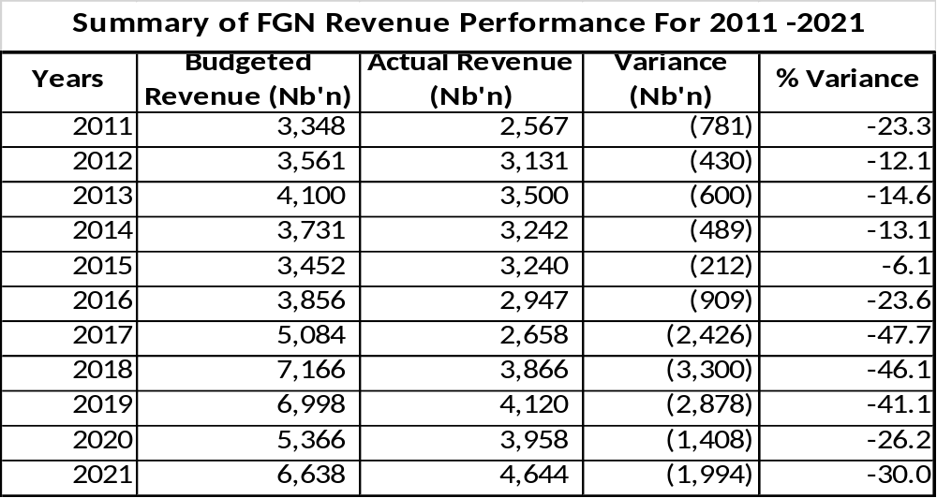
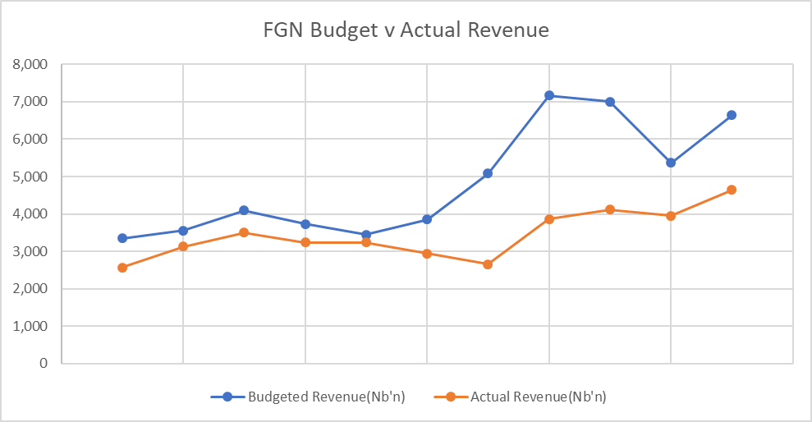
Figure 1.1
Source: FGN Budget Inflows, BIR (2011-2021)

The table 1.1 above shows the FGN Budgeted inflows varied by 23% in 2011 with 12%, 15% and 13% in years 2012, 2013 and 2014 respectively. The variance had its minimum value in 2015 at 6%. Variance increased in 2016 to 24% , and to an all-time high of 48% in 2017, before easing off to 26% in 2020. It later rose slightly to 30% in year 2021.

2.2 ANALYSIS OF ACTUAL REVENUE OUTTURNS AGAINST BUDGETS
Revenue budget outturns measures deviations of budgeted revenue against actual as a percentage of GDP. From the general review of the budget performance, an analysis of the reason for the budget outturns was conducted using the figures contained in the BIR for the period. Table 1.2 and figure 1.2 show the revenue Outturns for 2011 to 2021 Budget.

Table1.2 REVENUE OUTTURNS 2011 – 2021 BUDGET
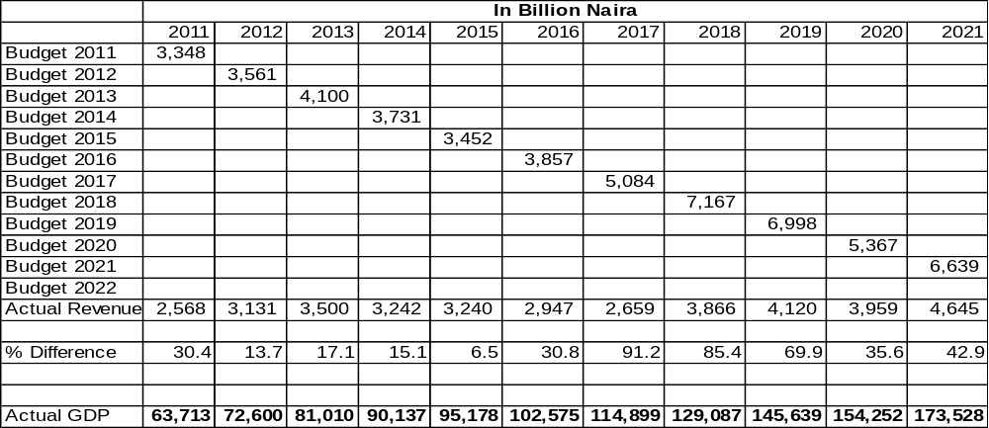
Source: Budget Implementation Report

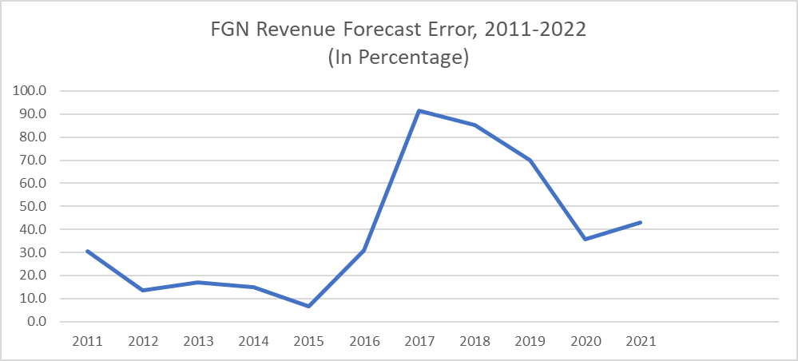
Figure 1.2

Table1.3 REVENUE FORECAST AND OUTTURN, BUDGET 2011-2021
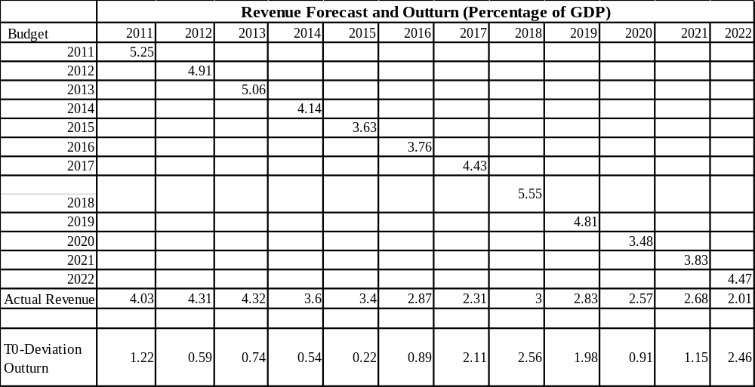

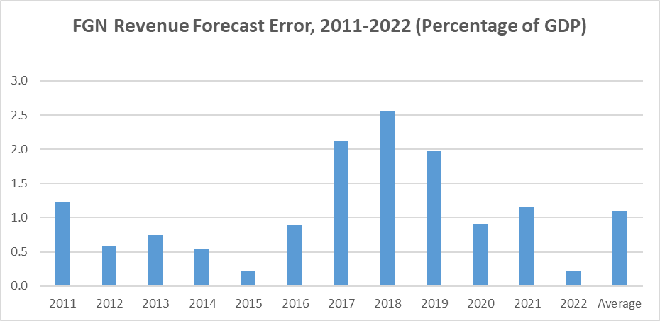
Figure 1.3

1.3 ANALYSIS OF FACTORS RESPONSIBLE FOR BUDGET DEVIATIONS (OIL REVENUE)
- Over-estimated Oil Production benchmark: Oil revenue accounts for a substantial portion of FGN revenue budget projections. Oil production, which is measured at million barrels per day (mbpd) is dependent on a quota system determined by OPEC and other market forces. Projected oil production from actual production has been largely attributed to supply disruptions by oil theft in the Niger Delta. Taking a closer look at oil production from 2011 to 2022 a pattern of production over-estimation can be seen.

Table1.4 OIL PRODUCTION (PROJECTION VS ACTUAL)
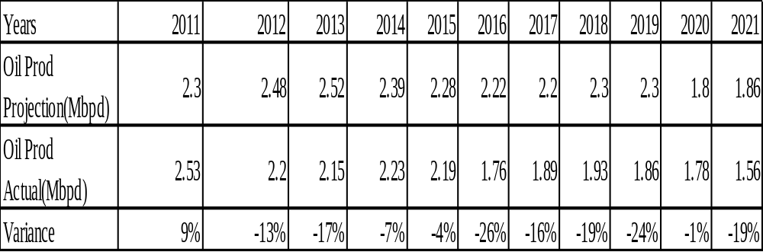
Source: FGN BIR 2011-2021

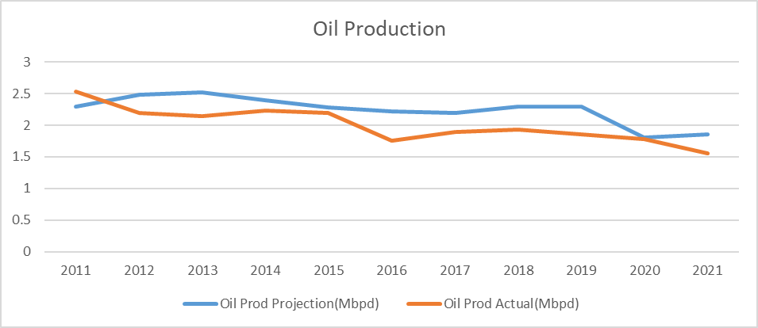
Figure 1.4
Actual Oil production has been below projection from 2012 at -13% with its lowest in 2016 at -26% and 2019 at -24%. In 2020 the gap eased to -1% largely due to global economic slowdown occasioned by the Covid-19 pandemic. This factor contributed to the widening budget outturns from 2016 to 2020.
- Volatile Oil Price: Like oil production, oil price is a determining factor in FGN budget. Since oil price is determined by the global oil market and world events, it is subject to volatility which in turn affects FGN revenue projections. From the standpoint of actual oil price to projected oil price, the figure below presents a positive outlook for oil prices. This is because of FGN budgeting policy of pegging oil price based on world market outlook below OPEC global prices when preparing the budget and saving any positive difference in Excess Crude Account. The table and figure below show a positive estimation of prices. However, in 2015, actual price fell below projected price by 14% and in 2019 it only increased by 6%. That was before the economic slowdown occasioned by Covid-19.

Table 1.4 PROJECTIONS AND ACTION OIL PRICE, 2011 - 2021
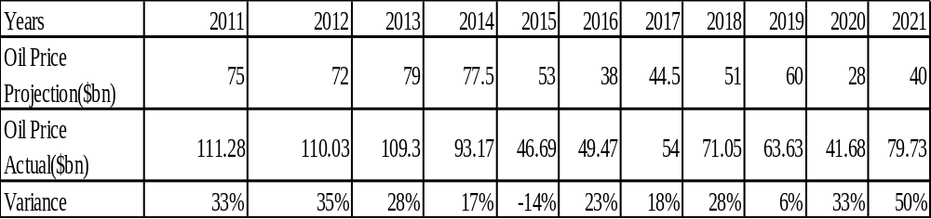
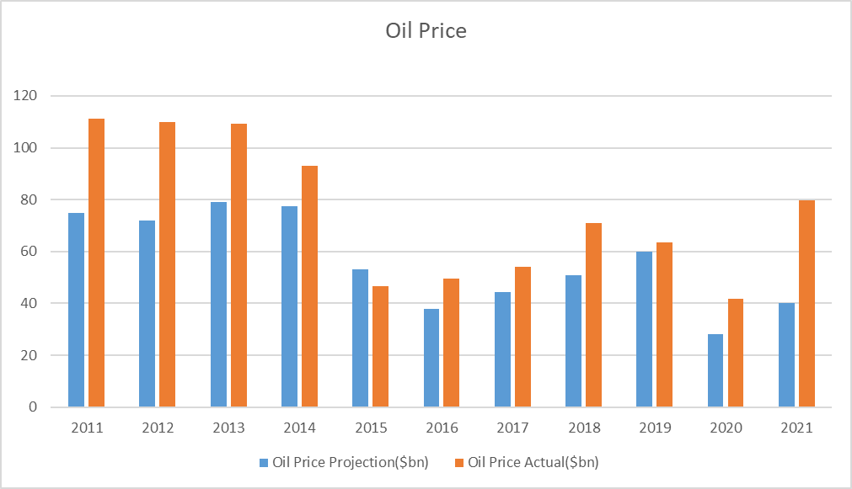
Figure 1.5 Oil Price 2011 - 2021

3 Global Exchange Rate: Any fluctuation in the value of US Dollar will invariably affect revenue derivable from crude oil of countries and Nigeria is not an exception.
4. Environmental issues: Oil exploration which comes with its attendant environmental issues such as oil spillage, waste disposal, air pollution, etc. this incurs expenditures that drain revenue available to government.
5. Security threats and Pipeline Vandalism: Security threats and pipeline vandalism lead to stoppage/reduction in oil production which in turn affects the ability of the government to meet its revenue target.

Table1.5 ANALYSIS OF FACTORS RESPONSIBLE FOR BUDGET DEVIATIONS (NON-OIL REVENUE)
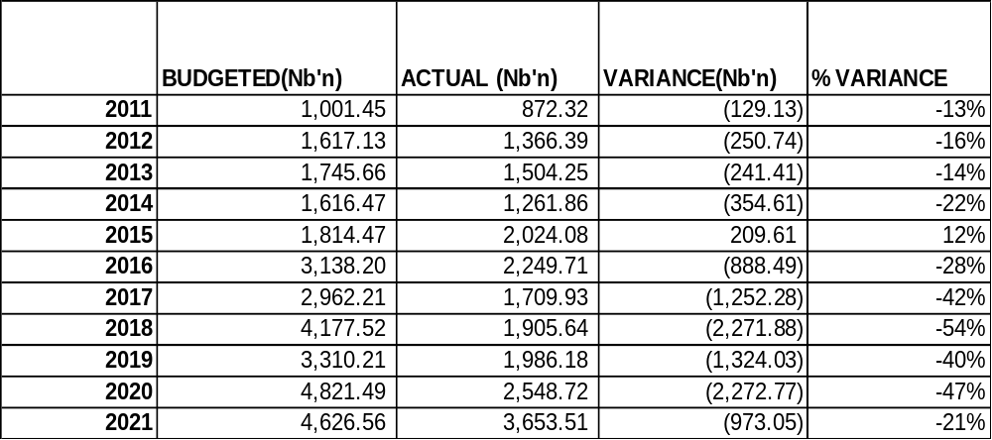

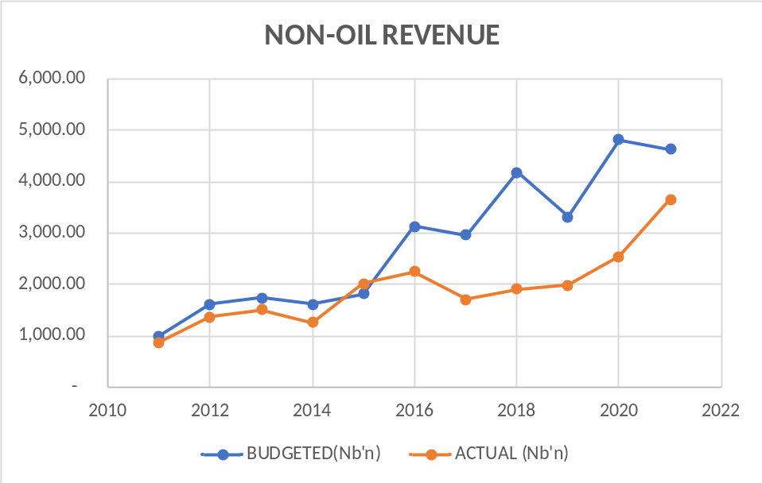
Figure 1.5 Non-Oil Revenue 2011 - 2021

Table 1.6 BUDGET AND ACTUAL REVENUE TARGET FOR GOEs
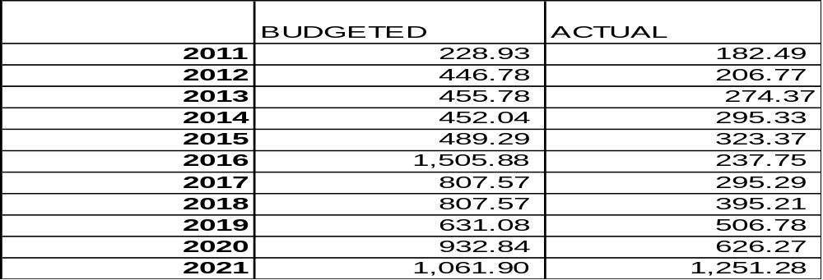
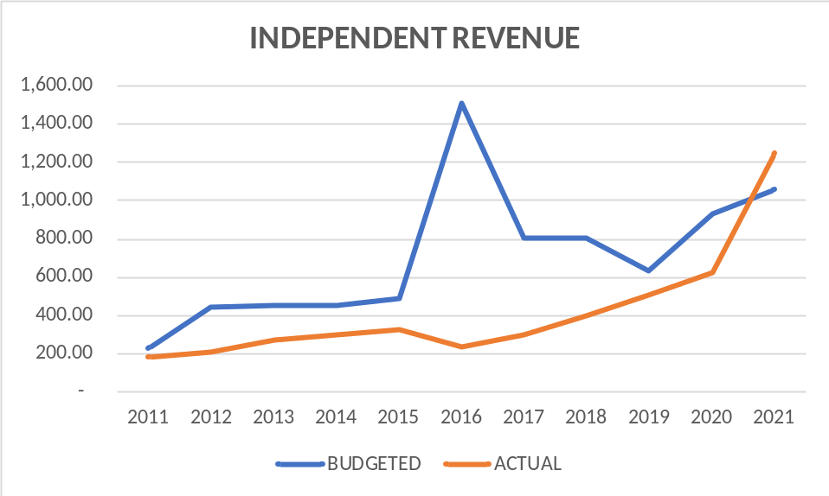
Figure 1.6 Budget and Actual Independent Revenue for GOE’s

- Unrealistic Internally Generated Revenue Target placed on government agencies including GOEs

- Revenue leakages- There are lack of proper internal control in the revenue generation/ collection processes of government revenue, which include revenues from taxes, excise duties, etc. It can be observed that, it’s only in year 2021 that revenue from Tax did relevantly better than the budgeted.

- Concessions/PPP: Despite several signed concession agreements with the private sector especially in the Transportation Sector and the appreciable revenue expected from these PPP agreements, regrettably the Government has not been able to determine the exact income accruing to it from such contracts. About 51 known concessions worth over N3.2 trillion generated estimated revenue of over N124.27 billion only. This is a far cry from what is being generated from PPP contracts.
Despite the creation of Special Concession Account (SCAs) - separate and distinct from the CRF- to warehouse all anticipated revenue accruing from PPP contracts, most MDAs failed to remit the Federal Government share to the account.
Table 1.7 SPECIAL ACCOUNTS/LEVIES
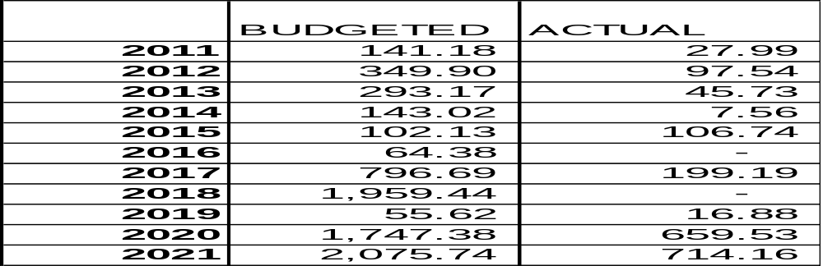
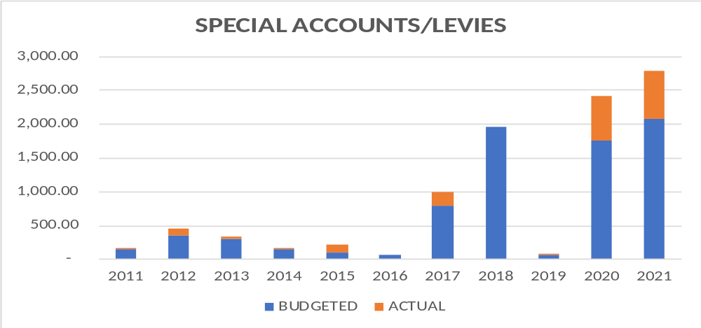
Figure 1.7 Budget and Actual, Special Levies 2011 – 2011

- Reliance on Contingent Revenue- For government to be budgeting with revenue from contingencies, such as revenue from whistle blower policy, privatization proceeds, etc. there is a big draw back on its ability to meet its target. Revenues from such sources should be brought into the budget only when it has been realised.

Table 1.8 OTHER FINANCING REVENUE
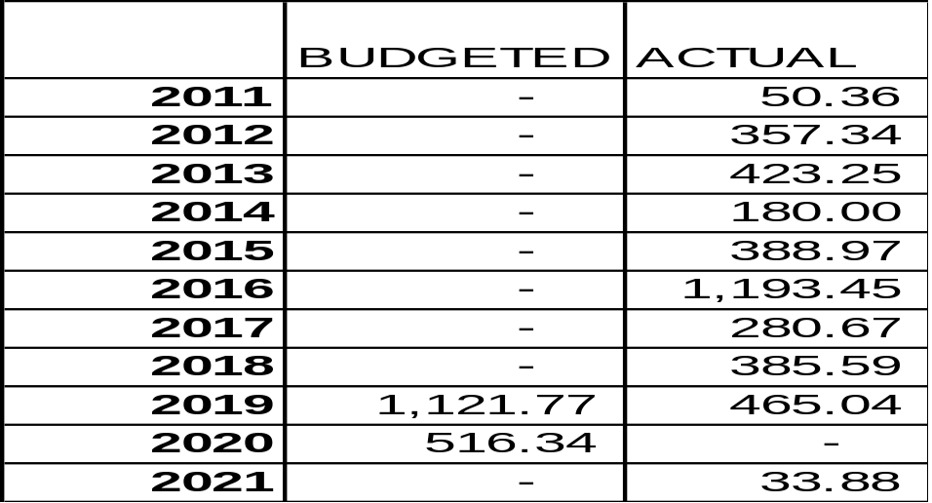

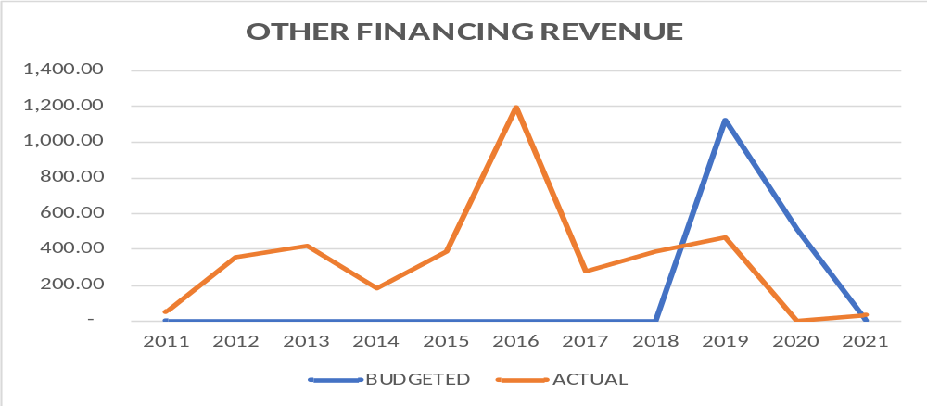
Figure 1.8

- Lack of proper exploitation of the solid minerals sector of the Economy. Solid mineral exploration has been left in the hands of unprofessional practitioners thereby making harnessing revenue from it difficult.

1.4 RECOMMENDATIONS
- FGN revenue budget should be based on realisable forecast. The FGN should develop a more reliable revenue forecast model with all key stakeholders involved to reduce revenue outturns.
- FMBNP should ensure that revenue forecast from special accounts, independent revenue and other financing sources are realistic. These budget financing options should be properly assessed before including them in the FGN budget.
- Expand Tax base: FGN should expand the tax base to bring in more revenue to fund the budget. The country’s tax to GDP ratio is still very low compared to countries in sub-Saharan regions.
- FGN should invest in the security of the nation’s critical oil assets like pipelines to reduce cases of illegal oil theft which adversely affect the FGN revenue. Also there should be punishment for oil theft to serve as a deterrent to other potential oil thieves.
- The government should amend the Fiscal Responsibility Act 2007 to allow for sanctions where there are infractions to the law, especially for agencies of government that generate independent revenue.
- Expand the Tax Net- this will put government in a very good position towards meeting its revenue target. Taxes on unoccupied buildings, luxurious lifestyle, etc. should be seriously considered.
- The government should step up efforts in diversifying its revenue sources through the exploration of other sectors of the economy such as the solid minerals, agriculture, telecommunications, and digital economy, among others.

CHAPTER 2
2.0` ANALYSIS OF EXPENDITURE FORECAST
2.1 INTRODUCTION
It is common knowledge that Budgeting and Financial Forecasting is very important to a nation, and this cannot be over emphasized.
“The term budget refers to an estimation of revenue and expense over a specified future period of time and is usually compiled and re-evaluated on a periodic basis” (Investopedia). It is the act/process of keeping track of how much you earn and spend, and you will have greater control over your finances. So, any entity or government that earns and spends money, and at the same time wants to have control over its finances, must engage in budgeting.
Every year, the Federal Government of Nigeria through the Honourable Minster of Finance, Budget, and National Planning makes a public presentation of its Approved Budget pursuant to the provisions of FRA, 2007; the Fiscal Responsibility Commission has a duty to compile and re-evaluate these budgets, most importantly, to test for accuracy of Macro-Fiscal Forecasts.
This segment of the exercise therefore focuses on the Expenditure aspect of the Budgets. That is, the Expenditure Forecasting Analysis of accuracy of expenditure forecasts within the period under review.

2.2 2023-2025 MEDIUM TERM EXPENDITURE FRAMEWORK AND FISCAL STRATEGY PAPER (MTEF/FSP)
2.2.1 Introduction
The FRA, 2007 established the FRC to among other things monitor and enforce the provisions of the FRA, 2007 and by so doing, promote the economic objectives contained in Section 16 of the constitution of the Federal Republic of Nigeria. Section 11(1a) of the FRA, 2007 provides that, not more than four months before the commencement of the next financial year, the Federal Government after consultation with the states shall, cause to be prepared a Medium Term Expenditure Framework and Strategy Paper (MTEF/FSP) for the 3 financial years in effect, the 2022-2024 MTEF/FSP is to precede the proposed 2023-2025 MTEF/FSP already approved by the National Assembly.
Successive MTEF/FSP in Nigeria serve as the Pre- budget statement. It is prepared as a multi-year planning tool to communicate the development aspirations of government. It is also a measurable framework for translating plan to public goods and services, and forms the basis of the annual budget, which sets out the resource requirements for implementing government’s programs and projects, while maintaining fiscal discipline in resource allocation, and ensuring macro-economic stability. This practice has been consistently followed since 2007, underscoring a strong nexus between development planning and budgeting.
The 2023-2025 MTEF/FSP is designed to accentuate the implementation of National Development Plan 2021-2025 (NDP 2021-2025). As envisioned in the NDP 2021-2025, the 2023-2025 MTEF/FSP is framed to implement policies and programs aimed at unlocking the potential in all sectors of the economy for a sustainable holistic and inclusive national development. The key objectives include achieving economic diversification, increased investment in infrastructure, improved security and good governance, investment in education and health and social investment to alleviate poverty.
The MTEF/FSP has improved efficiency in public financial management (PFM) in Nigeria. The 3-year rolling structure acts as an embedded mechanism to update the projections and reduce divergence between plan/forecasts and outturns.

2.2.2 Medium- Term Macroeconomic Framework: Parameters and Targets for 2023-2025
Macroeconomics projections
The key parameters driving the Medium-Term Revenue and Expenditure Framework reflect Nigeria’s multiple domestic challenges and the fragile recovery of the global economy due to the vintages of the Covid-19 pandemic compounded by the Russian-Ukraine war.
Table 2.1. MACROECONOMIC PROJECTIONS 2023-2025
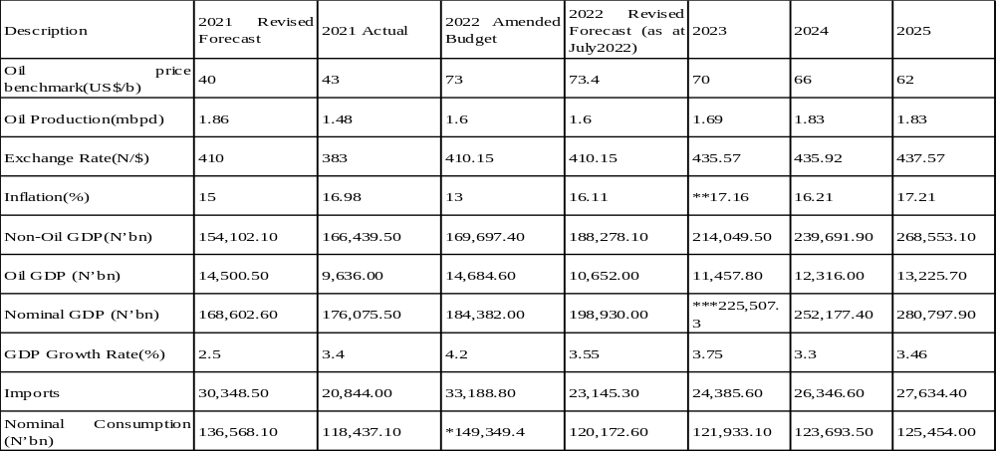Source: Ministry of Finance, Budget Planning; BOF, NBS.
Note: The initial projection is not likely to be achieved based on current trends.

2.2 THE 2023 FEDERAL GOVERNMENT BUDGET
The 2023 Budget termed ‘’Budget of Fiscal Consolidation and Transition’’ set out below the assumptions and highlights of the 2023 budget, as signed by the President.

Table 2.2.2023FGN BUDGET PARAMETERS
Benchmark | $ 75
Oil production | 1.69mbpd
Inflation rate | 17.16%
Exchange rate | ₦ 435.57/$
GDP growth | 3.75%
Statutory Transfer | ₦ 967,486,010,536
Debt Service | ₦ 6,557,597,611,797
Recurrent Expenditure | ₦ 8,329,370,195,637
Capital Expenditure | ₦ 5,972,734,929,421
Total Revenue | ₦ 10.49 trillion
Total Expenditure | ₦ 21. 83 trillion
Fiscal Deficit | ₦ 11.34 trillion
Source: HMFBNP 2023 Approved Budget Presentation final
Note: Total Revenue; includes the gross revenues of 63 GOEs totalling ₦3.87 trillion

Table2.3. COMPARATIVE ANALYSIS OF 2022 AND 2023 BUDGET ESTIMATES

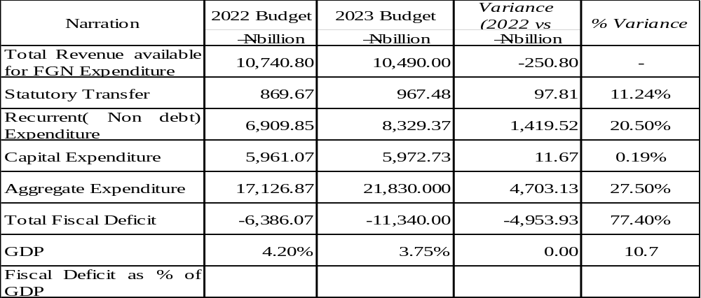
Source: HMFBNP 2023 Approved Budget Presentation final
2.3 COMPARATIVE ANALYSIS OF 2022 AND 2023 BUDGET ESTIMATES

- Oil Benchmark is USD 75.00 per barrel in the 2023 budget, as against USD 62.00 per barrel in the 2022 budget. This is an increase of USD 13.00.
- Crude oil production volume estimated at 1.69mpbd is achievable. This is because Nigeria’s total production capacity is 2.5mpbd and no major disruption to crude oil production (such as pipe vandalism) is envisaged in 2023.
- The Projected inflation rate of 17.16% for 2023 is possible, considering the current effort of the Government in tackling insecurity in the country. Improvement in the security situation will boost food production and lead to reduction in food prices.
- The estimated fiscal deficit for 2023 is ₦11.34 trillion as against ₦6.39 trillion in 2022, translating to increase of ₦4.95 trillion.
- The total revenue of ₦10.49 trillion is projected for 2023 fiscal year. Compared to the budgeted revenue of ₦10.74trillion in 2022 budget, resulting to decrease of ₦0.25 trillion.
- Recurrent (non- debt) expenditure in 2023 is projected at ₦8.33 trillion as against ₦6.91 trillion in the 2022 budget, resulting in an increase of ₦1.42 trillion or 20.5%
- The sum of ₦5.97 trillion is budgeted for capital expenditure in 2023. This amount is ₦11.67 billion or 0.19% higher than ₦5.96 trillion budgeted for the same purpose in 2022.
- Debt service is projected at ₦6.56 trillion in 2023. If weighed against the allocation of ₦3.61 trillion in the 2022 budget, it signposts an increase of ₦2.95 trillion.

The budget estimate as approved and the key assumptions in it show the serious intention of Government to overcome the challenges that led to two recessions the economy was engulfed in recent times. The 2023 Budget is expected to further accelerate the recovery of the country’s economy and facilitate the completion of critical projects as well as improve the general standard of living of the citizens.
Generally, the 2023 approved budget estimate is rather a pro poor one. This is in the sense that, the allocation of government expenditures is considered a key instrument for government to promote economic growth and reduce poverty in the country.

2.4 FGN EXPENDITURE PERFORMANCE
- Immediate Past Year, 2022
It is worthy of note that the 2022 Aggregate FGN Expenditure dropped by a 5.4% (₦732.75billion) from its projected amount, that is a decrease in actual expenditure incurred.

Table 2.4 2022 EXPENDITURE PERFORMANCE 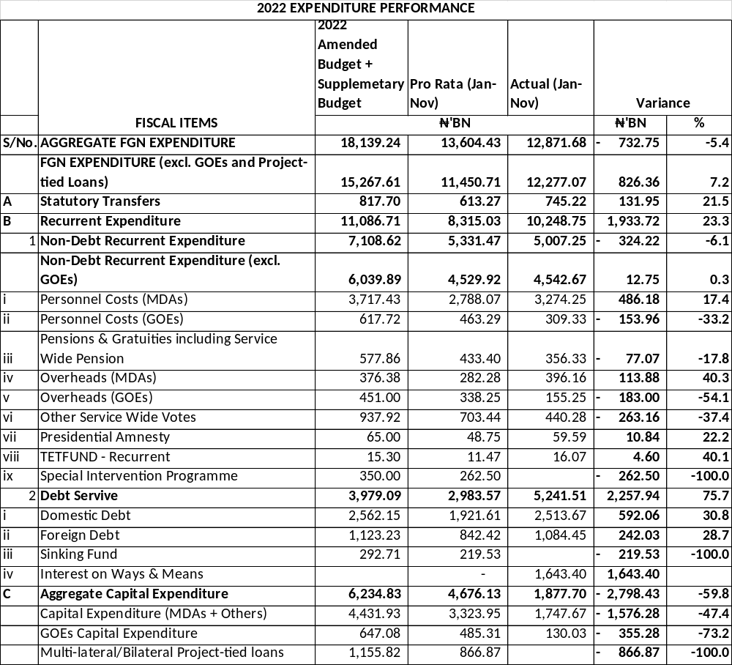
Source: HMFBNP 2023 Approved Budget Presentation final

The aggregate budgeted expenditure for 2022 (inclusive of the supplementary budget of ₦819.5billion) was ₦18.14 trillion, with a pro - rata spending target of ₦16.63 trillion at the end of November.
▪ the actual spending as of November 30 was ₦12.87 trillion. Of this amount,
▪ ₦5.24 trillion was for debt service.
▪ ₦3.94 trillion for Personnel costs, including Pensions.
▪ Statutory Transfers, Overhead and Service Wide Votes expenditures totalled₦1.81 trillion; and
▪ ₦1.88 billion was released for capital expenditure.

Table 2.5 COMPARATIVE ANALYSIS OF 2022 APPROVED EXPENDITURE BUDGET WITH THAT OF 2023
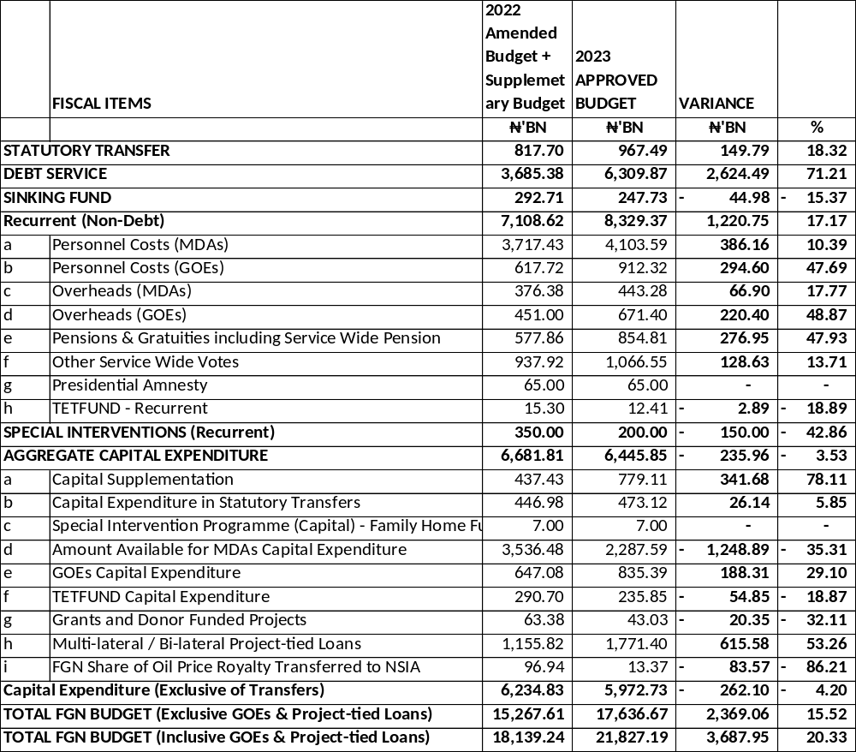
Source: HMFBNP 2023 Approved Budget Presentation final

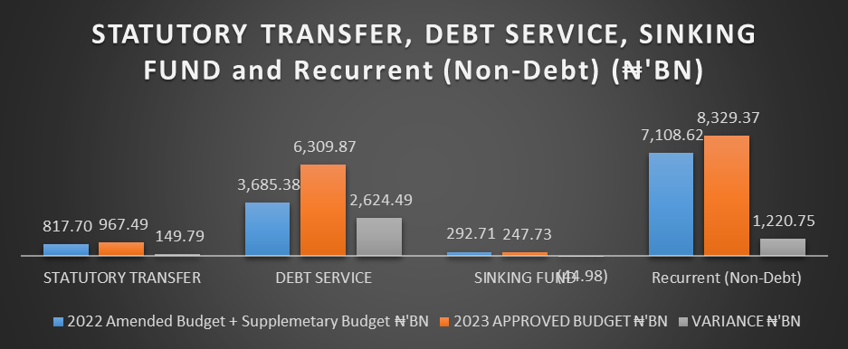

Figure 2.1
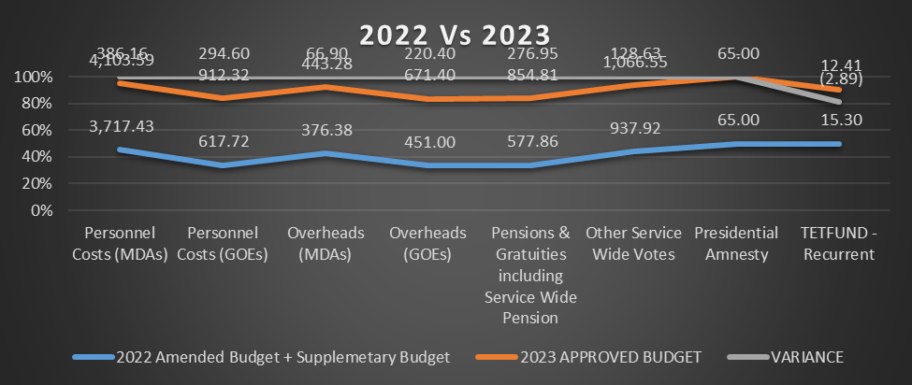
Figure 2.2
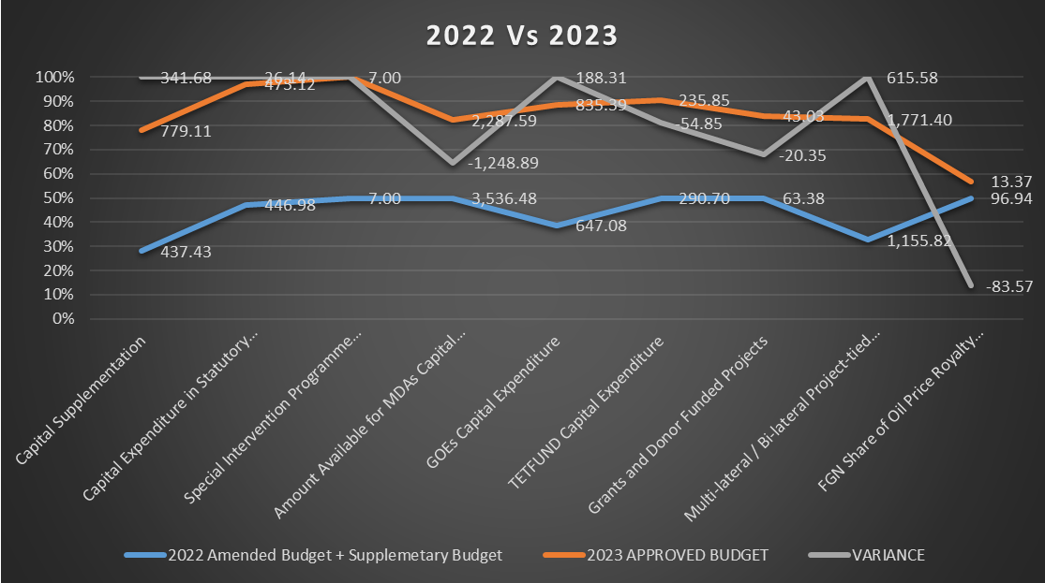
Figure 2.3

- FGN Budgeted Aggregate Expenditure for 2012-2022
In this section, we will be looking at the variance between a year’s budgeted aggregate expenditure with its immediate succeeding year’s. Using the average variance trend, ceteris paribus, to estimate or determine the forecast error for FY 2023.

Table 2.6 COMPARATIVE ANALYSIS OF FGN BUDGET EXPENDITURE 2012 -2022
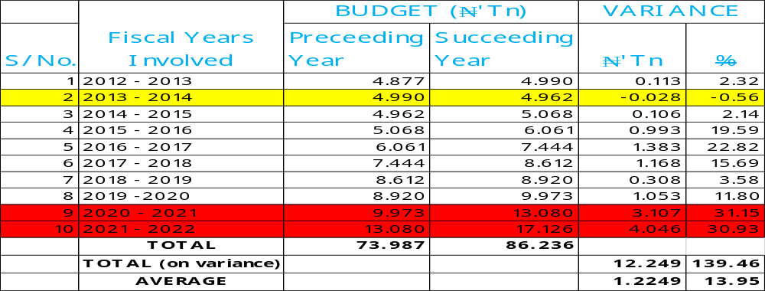
Source: BIR 2012 – 2022

2.5 Observations
From the tables (2.4, 2.5 and 2.6), the following can be deduced:
- In FY2022 as at November ending, the general actual performance on expenditure was 5.4% lesser than the budgeted. According to National Bureau of Statistics, the general price level was 0.32% higher in December 2022 relative to November 2022. Nigeria’s inflation rate eased to 21.34% in December from 21.47% in November 2022; first drop in about 11 months. Focus Economics Consensus Forecast Panellists expect inflation to average 18.5% in 2023, which is from last month’s forecast.
Therefore, it is expected based on the above that the budget for FY2023 should at least be at par with that of FY2022 if not less. Inflation is expected to be lesser and the actual performance for last year 2022 was lesser than budgeted.

- The FGN has budgeted to spend ₦6,445.85bn on aggregate capital expenditure in FY2023 which is 3.53% lesser than the budgeted amount in FY2022.
It is therefore expected that since less is budgeted for capital development, by and large, less should be budgeted on general expenditure. If not, borrowing will be on the high side without plans to invest in areas that will generate adequate return on investment. Just as we can see in table (2.1) where Debt Service performed 75.7% higher than budgeted in FY2022.

- Also, comparing FY 2023 budgeted figure (on Debt Service), it is 71.21% higher than the budgeted figure in FY2022 while Capital Expenditure is reducing.

- From table 2.3, only in FY 2014 was there a decrease in the Approved Budget as against its preceding FY, 2013. Every other year from 2015 had an increased Approved Budgeted figure when compared with its previous. The worst of those periods was 2020 - 2021with the percentage of 31.15% that is, over ₦3.1 trillion increase.
Despite this, considering the ten fiscal years ahead of 2023; there had been an average increase of 13.95% which is slightly above One Trillion Naira.
Following this trend and looking at the 2023 Approved Budget, its deviation is quite large. It has a 20.33% deviation from that of 2022 Approved Budget, which is over Three Trillion Naira variance.
It can therefore be said to be a poor forecast. More so, the increase in 2023 budget is totally away from capital expenditure.

Table2.7DEBT SERVICE AND STATUTORY TRANSFERS
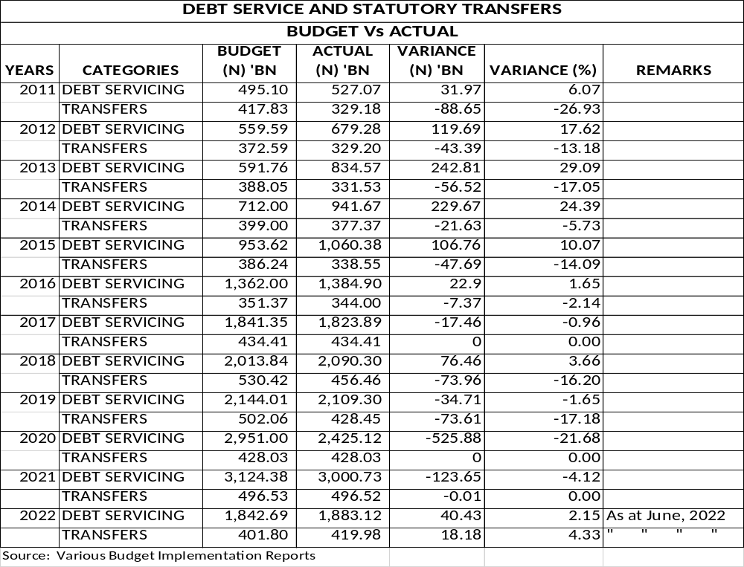

In assessing debt servicing and statutory transfers, a negative variance is such that actuals are less than the amount budgeted. A positive variance means the account is overspent (bad).
The actual performance by debt servicing varied positively from the budgeted with worst case scenario in 2013 (29.09%) which perhaps could be due to high risks and uncertainties resulting in higher servicing of debt than the planned, except for financial years 2017 & 2019 – 2021.
While otherwise could be said for the statutory transfers. That is, actual transfers are lesser than the budgeted, except in the following years; 2017, 2020 & 2021 - with zero (0) expenditure or no variance recorded and suddenly, it had a positive variance for the half year 2022 recorded (partly attributable to half-year results).
This also shows increased government commitment to debt servicing when compared to statutory transfers.

Table2.8. FGN EXPENDITURE FORECAST ERROR
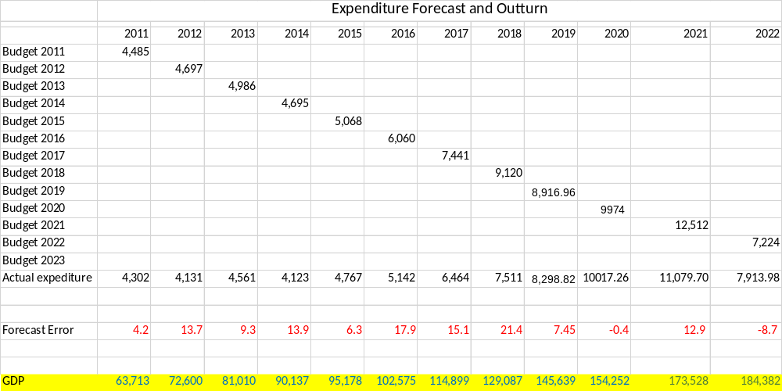

Table2.9. FGN EXPENDITURE FORECAST ERROR
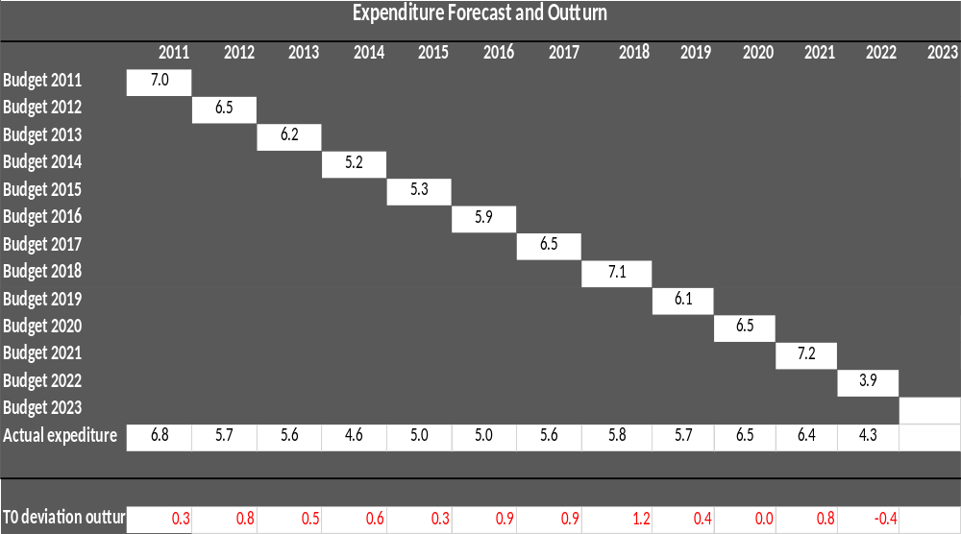
In this section, we will be expressing both the FGN Expenditure Forecast and Actual Expenditure in percentage of GDP. We want to know what percentage they covered in the GDP.
For instance, in year 2011 (figs in Billion):
Amount Budgeted for Expenditure = ₦4,485.
Actual Expenditure Incurred = ₦4,302.
GDP = ₦63,713.
Therefore, from the spreadsheet, expressing Budget as a percentage of GDP is 7.039% while Actual is 6.752%. That is, a deviation/forecast error of 0.287; approximately 0.3 and so it occurred in all the years considered (2011 – 2022), positive deviations, except in year 2022 where the reverse was the case. Though the figures used were half year figures.
Away from GDP, it can also be observed from the Spreadsheet that Actual Expenditure Performances for 2011 – 2022 were below the Budgeted Expenditure Amounts, except for years 2020 and 2022.
Reasons could be interpreted to be:
FY 2020 – COVID 19 and
FY 2022 – Information available is half year report.

Table2.10. FGN CAPITAL SPENDING FORECAST ERROR
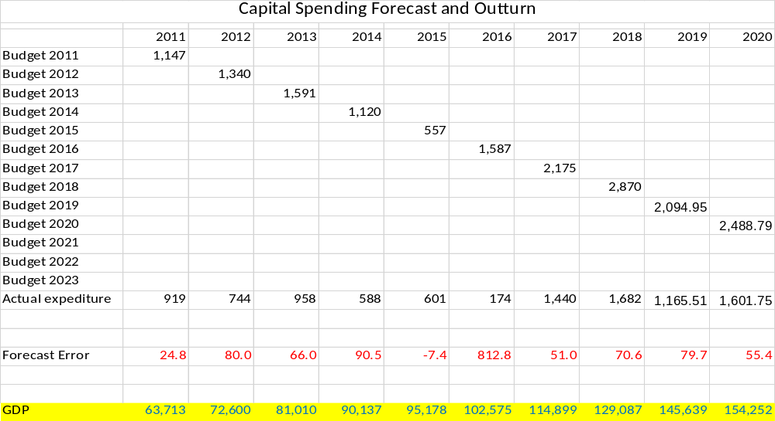

Table2.11. FGN CAPITAL SPENDING FORECAST ERROR
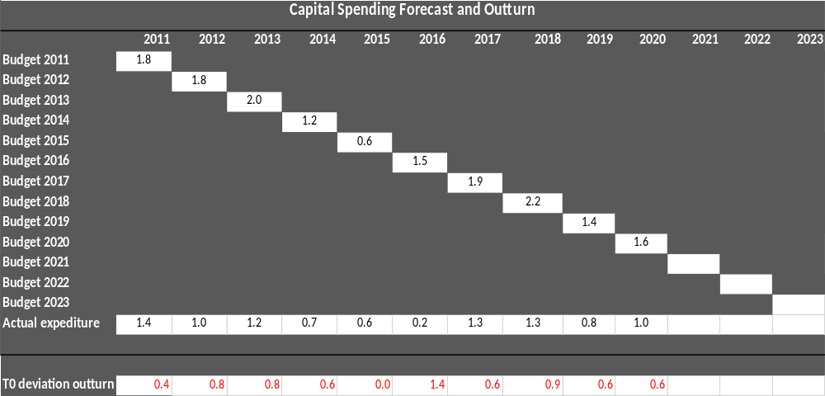

Now while taking a separate look at Capital Expenditure Performances (as a standalone), the general trend as captured in the Expenditure forecast above; also occurred here. Only in the year 2015 was the Actual Amount Expended greater than the Budgeted.
It is shown in the earlier analysis that the year 2023 performance may not be far from this trend of below-the-budget performances. This therefore supports our initial analysis/assumptions of a forecast error.

2.6 RECOMMENDATIONS
Based on the Expenditure Forecast Analysis Report for 2023 Financial Year, the following recommendations were made for improvement in the Federal Budget and the Nigerian economy at large.
- Government should investigate the wasteful components in the Expenditure Budget and undertake a rigorous rationalization of the expenditures, because the current rising recurrent expenditure is not sustainable.
- There is urgent need for an aggressive revenue drive to meet up with the ever-increasing expenditure aspect of the budget.
- Government should encourage more inclusion of the private sector in national economic development plan process to achieve inclusive growth of the economy. It is more sustainable to empower the private sector to create jobs while the government creates a thriving business environment (this is very key). The Public Private Partnership Initiative should be boosted to reduce infrastructure deficit.
- The government should consider low-interest-bearing loans and assets securitization as a new model of growing the debt stock as this will reduce our debt servicing burden.
- The government should identify and block existing revenue leakages to boost revenue mobilization, enhance tax compliance and reduce tax evasion. This is possible by leveraging technology and automation and reducing the human interface between government agencies and business operators.
- Government should integrate States and Federal Budgets to have a representative budget for Nigeria that is comparable among emerging economies in Africa.
- The Fiscal Responsibility Act 2007 should be reviewed to create a more robust budget policy framework and provide sanctions for defaulters.

CHAPTER 3
3.0 PUBLIC DEBT SUSTAINABILITY
3.1 INTRODUCTION
Debt sustainability is widely acknowledged as the ability of a country to meet its financial obligations without being subject to external rescue or undue adjustment that may jeopardize growth and development. The Debt Management Office (DMO) in conjunction with other stakeholders, namely: the Federal Ministry of Finance, Budget and National Planning (FMFBNP), Central Bank of Nigeria (CBN), Budget Office of the Federation (BOF), National Bureau of Statistics (NBS), and the Office of the Accountant-General of the Federation (OAGF) adopted Market Access Country-Debt Sustainability Analysis (MAC-DSA) Framework to conduct its debt sustainability exercise in 2021, with the World Bank providing technical assistance. The 2021 MAC-DSA is a comprehensive overview of public debt, “based on the macroeconomic assumptions outlined in the 2022 Appropriation Act and the Medium-Term Expenditure Framework (MTEF) 2022-2024 and Fiscal Strategy Paper (FSP), as well as Medium-Term National Development Plan, 2021-202. The MAC-DSA covers a 10-year historical period (2011-2020); and a 6-year projection (2021- 2026), under various Macroeconomic Assumptions and Stress Test Scenarios”.

“The MAC-DSA Framework applies to countries in Advanced Economies and Emerging Markets, which have significant access to market financing. The reason for the adoption of the MAC-DSA Framework was based on the reclassification of Nigeria as a Lower-Middle-Income country, which means limited funding access from concessional borrowing, thus, more reliance on market-based financing. In other words, 70.48% of FGN’s Total Public Debt Stock as at December 31, 2020 was market-based debt, which comprised Domestic Debt with a share of 55.42% and External Debt accounting for 15.06%. Of the External Debt portion, Eurobond accounted for 33.49% in 2020. Furthermore, Nigeria increased its visibility in the International Capital Market (ICM) with the issuance of USD4.0 billion Eurobonds in three tranches of 6.25%, USD1.25 billion (7-year), 7.35% USD1.5 billion (12-year) and 8.25% USD1.25 billion (30-year) in 2021”.

This exercise, which covers 2012 – 2021, is not a parallel Debt Sustainability Analysis but an appraisal of the Nigerian fiscal environment within the context of the DMO report against the backdrop of the provisions of the Fiscal Responsibility Act (FRA) 2007. Consequently, much emphasis and reliance shall be placed on the technical findings (data), opinions, conclusions, and recommendations in the 2021 DMO MAC-DSA with appropriate modifications, if any, to constrict the exercise to the mandate of the Commission under the provisions of the FRA, 2007.
Therefore, this exercise shall:
- Evaluate the fiscal significance of the country’s debt based on the current standing at 40% public debt to GDP.
- Examine/evaluate the FGN’s Debt Service to revenue ratio.
- Evaluate the FGN’s borrowings vis-à-vis capital spending to ascertain if it is in line with the provisions of FRA 2007.
- Analyse/evaluate the Budget Deficit to GDP ratio to ascertain if it is in line with the provisions of FRA, 2007, and
- Evaluate the annual performance of fiscal deficit financing items contained in the annual budgets within the period under review.

3.2 DEBT TO GDP RATIO: 2012 - 2021
According to DMO, Nigeria’s Total Public Debt-to-GDP ratio increased to 21.61% in 2020 from 19.00% in 2019, reflecting the contraction in output with the real GDP growth rate of -1.9% and a larger fiscal deficit arising from the decline in revenue, due to the adverse effect of the Covid-19 pandemic. The Total Public Debt-to-GDP ratio was projected to increase to about 25.5% in 2021 and gradually decrease to 23.6% in 2026.
During the period under review, there was a progressive, steady increase in debt to GDP ratio from 10.40% in 2012 to 22.80% in 2021. Table 3.1, Figures 3.1 and 3.2 below show FGN’s Debt to GDP ratio from 2012-2021:

Table 3.1 FGN’s DEBT TO GDP RATIO: 2012 -2021
YEAR | ACTUAL TPD(₦Bn) | ACTUAL GDP(₦Bn) | %DEBT TO GDP
2012 | 7,550.00 | 72,599.60 | 10.40
2013 | 10,044.20 | 81,010.00 | 12.40
2014 | 11,243.12 | 90,137.00 | 12.47
2015 | 12,603.71 | 95,177.70 | 13.24
2016 | 17360.01 | 102,575.40 | 16.92
2017 | 21,725.77 | 114,899.20 | 18.91
2018 | 24,387.07 | 129,086.90 | 18.89
2019 | 27,401.38 | 145,639.10 | 18.81
2020 | 32,915.51 | 154,252.30 | 21.34
2021 | 39,556.03 | 173,528.00 | 22.80
Source: CBN Statistical Bulletin, 2020, BIR, DMO.

Note: The debt stock of some States was not up to 31st December of the years; see DMO website for the details of the outstanding data for the affected States

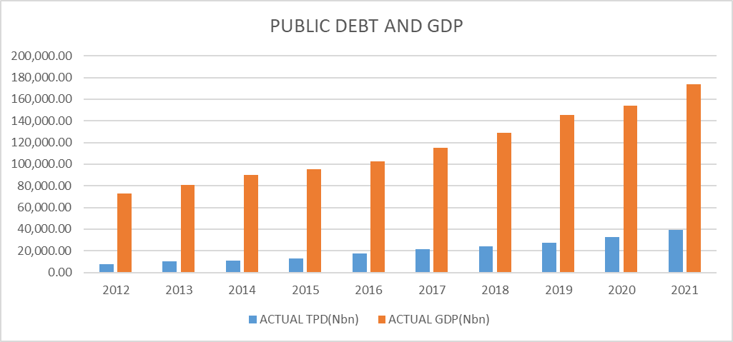

Figure 3.1

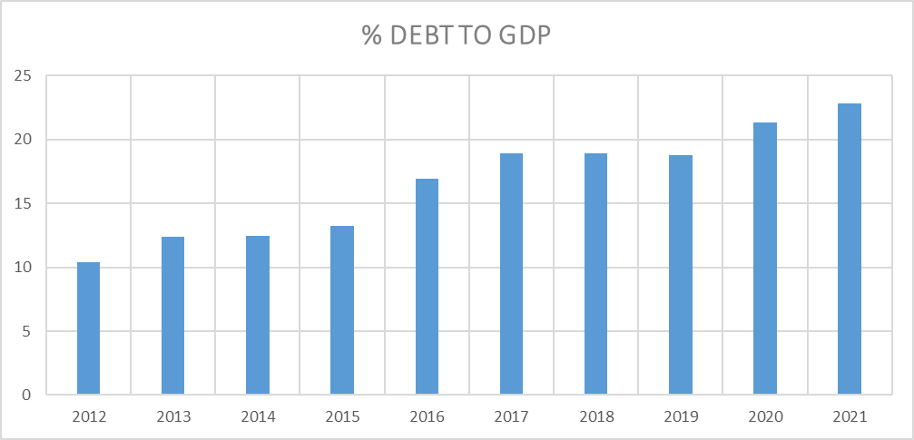

Figure 3.2

3.3 COUNTRY CLASSIFICATION AND RISK ASSESSMENT

Under MAC-DSA Framework, a country is either Advanced Economy or Emerging Market Economy based on the World Economic Outlook classification by the IMF. Nigeria is classified as Emerging Market. Table 3.2below shows the countries’ classification based on their public debt burden indicators and benchmarks.

S/N | Indicators | Advance Economy | Emerging Markets
1 | Debt-to-GDP (in Percent) | 60 | 50
2 | Gross Financing NeedstoGDP (in Percent) | 15 | 10
Table 3.2 PUBLIC DEBT BURDEN BENCHMARKS

Source: DMO, MAC-DSA 2021.

Note: Gross Financing Needs are defined as fiscal deficit and other transactions that require financing plus payment on debt (interest and principal).

The Borrowing Limit for 2022 in the MAC-DSA was determined based on the Country Specific Debt Limit of 40% (up to 2023) for Public Debt-to- GDP ratio; and given that the highest Debt to GDP was 21.34% in 2020 and 22.80% in 2021 respectively, the least fiscal space available for borrowing was 28.66% in 2020 and 27.20% in 2021. This clearly supports the finding of the DMO in the 2021 MAC-DSA that “Nigeria’s Total Public Debt is sustainable in the medium-term”. The Debt Level and Gross Financing Needs show low risk to debt sustainability as all the debt burden indicators are below the Baseline and Shock scenarios.

The Total Public Debt-to-GDP ratio was below the MAC-DSA’s benchmark of 70% for the Emerging Markets at 25.5%, 26.1% and 25.8% in 2021, 2022 and 2023, respectively, and thereafter will decline to 23.6% in 2026. Similarly, the Gross Financing Needs are high but lower than the MAC-DSA’s benchmark of 15% at 3.8%, 3.1% and 2.4% in 2021, 2022 and 2023, respectively. The financing needs are met by domestic financing through the issuance of FGN securities in the domestic financing market. External financing would be from the concessional and semi-concessional sources, as well as market financing by the issuance of Eurobonds in line with the Nigeria’s Medium-Term Debt Management Strategy, 2020-2023”.

According to the DMO, based on the assessment of risk to debt sustainability, a country may be treated as either Lower Scrutiny or Higher Scrutiny. A Lower Scrutiny status requires a country to conduct a Basic Debt Sustainability Analysis (DSA) by comparing the baseline assumptions with alternative scenarios; while a Higher Scrutiny rating requires a country to conduct the Basic DSA with additional risks identification and analysis (Realism of Baseline Scenario, Vulnerability of Debt Profile, Sensitivity to Macro-Fiscal Risks and Contingent Liabilities), and risk reporting (Heat Map, Fan Charts and Writeup).Table 3.3 shows the risk indicators for the Emerging Market Debt Profile and their respective benchmarks.

Table 3. 3 EMERGING MARKET DEBT PROFILE AND THEIR BENCHMARKS
S/n | Indicators | Risk Measure | Low Risk | Moderate Risk | High Risk
1 | Bond Spread (basis points) | Liquidity/Refinancing | Below 200 | Between 200 and 600 | Above 600
2 | External Financing Requirements (% of GDP | Liquidity/Refinancing | Below 5 | Between 5 and 15 | Above 15
3 | Share of Public Debt in Foreign Currency (in Percent of Total Public Debt) | Exchange rate | Below 20 | Between 20 and 60 | Above 60
4 | Share of Debt held by Non-residents (in Percent of Total Public Debt) | Exchange Rate | Below 15 | Between 15 and 45 | Above 45
5 | 5 Share of Short-term in Total Public Debt (in Percent of Total Public Debt) | Refinancing | Below 0.5 | Between 0.5 and 1.0 | Above 1.0

The above table justifies the conclusion that Nigeria’s debt is sustainable. However, the DMO acknowledged and enumerated the following as constituting moderate risks and mitigations:
- Market Perception,
- Share of Debt held by Non-Resident and Foreign Currency Denominated Debt, which may undermine debt sustainability in the medium-term.
- Risk arising from market perception measured by Bond Spread at 315 basis points crossed the early warning threshold of 200 basis points, but below the 600 basis points for upper early warning threshold.
- The issuance of USD4.0 billion Eurobonds in 2021 increased the exposure of the Total Public Debt profile to foreign exchange risk, which is mitigated by the domestic currency denominated debt, which accounted for 61.40% of the Total Public Debt as at December 31, 2020.
- Refinancing risk minimized by longer maturities of the Eurobonds and the spread of maturities to prevent the bunching of maturities, thus, achieving a smooth redemption profile.
- The volatility of oil prices, as well as enhanced short-term debt vulnerabilities and the cost of debt servicing arising from CBN financing.
- The sustained implementation of economic initiatives and reforms by the Government aimed at stimulating growth and boosting revenue are expected to moderate these shocks and financing pressures in the medium-term. In addition, if the CBN financing through Ways and Means Advances is re-structured into long term debt.

3.4 FGN DEBT SERVICE TO REVENUE RATIO

3.4.1 FGN Debt Service to Revenue Ratio 2012 – 2021
Debt Servicing is an obligation of the borrowing country to repay loans obtained over a certain period. Debt Servicing is key to debt sustainability, not only because payment on existing debt determines the ability to incur debt in the future, but it has also serious effects on revenues and or foreign exchange that could have been used in the provision of social services which may result in macroeconomic instability. High debt service could deplete revenues to a level which achieving economic growth may be slim even with the best economic reforms; especially, external borrowing could expose a country to debt over-hang, external shocks, and macroeconomic crisis.
Debt service to revenue ratio, therefore, looks at the ability of a country’s revenue to cover its debt service obligations without foregoing socio-economic development. In the past decades, the federal government continued, year-in, year out, to borrow from within and outside Nigeria to finance budget deficits, thereby accumulating and growing the external and domestic debt stock to ₦15,855 billion and ₦23,701billionrespectively as at December 2021. The repayment obligation, except in cases of restructuring (which is even more of recycling debt and liability, and project-tied concessional loans), invariably takes a huge toll on the FGN revenue.
The impact of debt service becomes more excruciating on the economy as naira continues to slide downwards against other currencies, especially, the dollar. This exercise highlights the relationship between the actual annual aggregate revenue of the federal government and the quantum of debt service per year from 2012 – 2021.
We shall advance our analysis against the backdrop of the IMF Debt Sustainability Framework (DSF). The DSF provides a methodology for assessing debt sustainability, which is guided by indicative, country-specific debt burden thresholds based on the relative strength of a country’s policies and institutions. Under the DSF, countries are categorized into strong, medium, and weak, using World Bank’s Country Policy and Institutional Assessment (CPIA). It is our opinion that Nigeria falls in the category of ‘medium’ as per Table 3.4 below.

Table 3.4 DEBT BURDEN THRESHOLDS UNDER THE IMF’S DSF
 | NPV of Debt as % of |  |  | Debt Service as % of
 | Export | GDP | Revenue | Export | Revenue
Weak | 100 | 30 | 200 | 15 |  | 25
Medium | 150 | 40 | 250 | 20 |  | 30
Strong | 200 | 50 | 300 | 25 |  | 35
Source: World Bank
From Table 3.4 above, the thresholds corresponding to strong policy performers are highest, showing that countries under this category have strong institutions and good policies that shape their economies thereby having the capacity to service the accumulated debt better than the others with lower thresholds. This means that in countries with strong institutions and good policies, debt accumulation is less risky and, vice versa. Table 3.5 below shows actual revenue and actual debt service from 2012-2021.

Table 3.5 FGN’S ACTUAL REVENUE AND ACTUAL DEBT SERVICE
YEAR | DEBT SERVICE(₦Bn) | ACTUAL REVENUE(₦Bn) | %DEBT SERVICE TO REVENUE
2012 | 679.28 | 3,131.09 | 21.69
2013 | 1,197.16 | 3,500.47 | 34.20
2014 | 941.67 | 3,242.30 | 29.04
2015 | 1,060.38 | 3,240.24 | 32.73
2016 | 1,313.46 | 2,947.49 | 44.56
2017 | 1,636.93 | 2,657.67 | 61.59
2018 | 2,090.30 | 3,866.49 | 54.06
2019 | 2,109.67 | 4,120.09 | 51.20
2020 | 2,425.12 | 3,418.30 | 70.95
2021 | 3,000.73 | 4,645.21 | 64.60

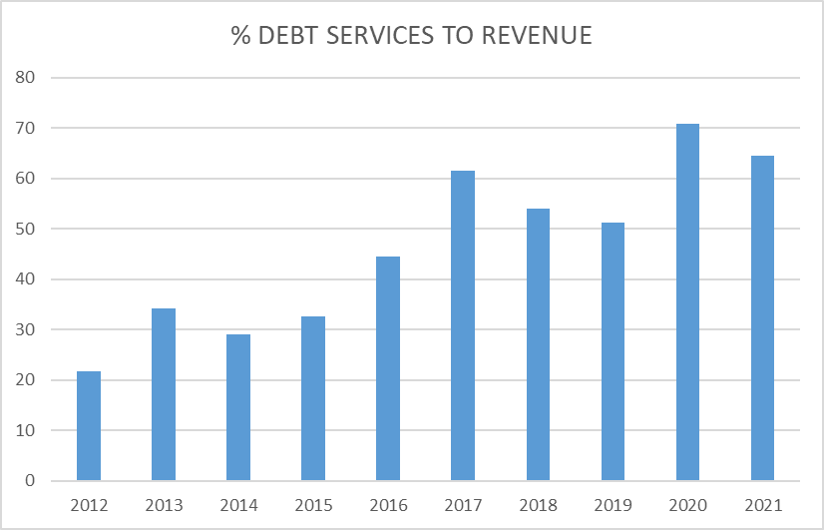

Figure 3.3
Source: CBN Statistical Bulletin, 2020, Budget Implementation Reports

The above Table 3.5 and Figure 3.3 clearly show that, for the period under review, the lowest debt service to revenue ratio was in 2012 when the actual aggregate annual revenue was ₦3,131.09billion, and the corresponding debt service ₦679.28billion representing 21.69%, which is within the threshold of “Weak” countries. The ratios for 2013, 2014, 2015 and 2016 are slightly above the threshold of weak countries based on the IMF’s DSF at 34.20%, 29.04%, 32.73% and 44.56% respectively.
The highest debt service to revenue was in 2020 when the aggregate annual revenue stood at ₦3,418.30billion and debt service ₦2,425.12billion, representing 70.95%. Followed by 2021, when annual revenue was ₦4,645.21billion and debt service ₦3,000.73billion, being 64.60%; and 2017 when the revenue was ₦2,657.67billion and debt service ₦1,636.93billion representing 61.59% of the aggregate annual revenue, above the IMF recommended threshold ratios of 25% and 30% for “Weak” and “Medium” countries respectively. This rising debt service exerts tremendous pressure on revenue generated and, by implication, adversely affects the economy.

3.4.2 Observations
- The Debt Profile is exposed to risks associated with the volatility of oil prices, as well as enhanced short-term debt vulnerabilities and cost of high debt servicing.
- The debt service to revenue ratio exceeded the IMF’s DSF recommended threshold throughout the years except for only two years (2012 and 2014) within the period under review.
- In the year 2012 and 2014, debt service to revenue ratio of 21.09% and 29.14% respectively, clearly show that Nigeria was within the threshold of the “Medium” countries but exceeded the threshold for all other years under review.

3.5 FGN’s BORROWINGS AND CAPITAL EXPENDITURE

By the provisions of Section 41(1) (a) of Fiscal Responsibility Act (FRA), 2007 “Government at all tiers shall only borrow for capital expenditure and human development, provided that such borrowing shall be on concessional terms with low interest rate and with a reasonably long amortization period subject to the approval of the appropriate legislative body where necessary’’. By this provision, the Federal Government (or any other tier of government) is expected to apply borrowed funds exclusively to capital expenditures and human development. This exercise examines the extent of compliance with the FRA, 2007 by the FG during the period under review. Table 3.6 below shows the FGN’s borrowing and the capital expenditure from 2012 - 2021.

Table 3.6 FGN’S BORROWING AND CAPITAL EXPENDITURE (ACTUAL)
Year | Borrowing(₦bn) | Capex (₦bn) | Variance(₦bn)
2012 | 744 | 744 | 0.00
2013 | 707 | 958 | +251
2014 | 624 | 588 | -36
2015 | 330 | 601 | +271
2016 | 300 | 174 | -126
2017 | 2,503 | 1440 | -1,063
2018 | 1,742 | 1682 | -60
2019 | 913 | 1165 | +252
2020 | 2,058 | 1601 | -457
2021 | 4,519 | 2343 | -2,176

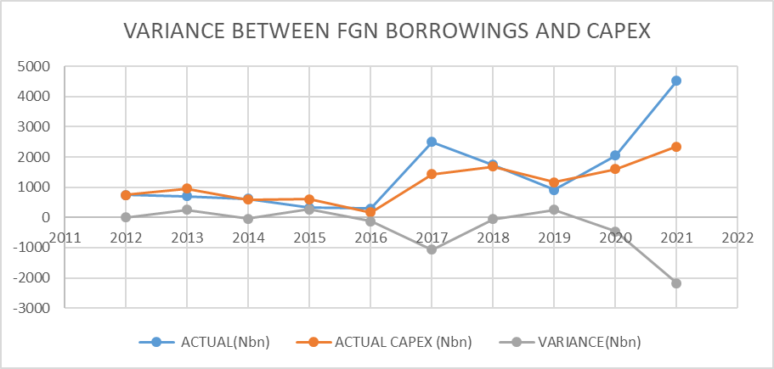

Figure 3 4
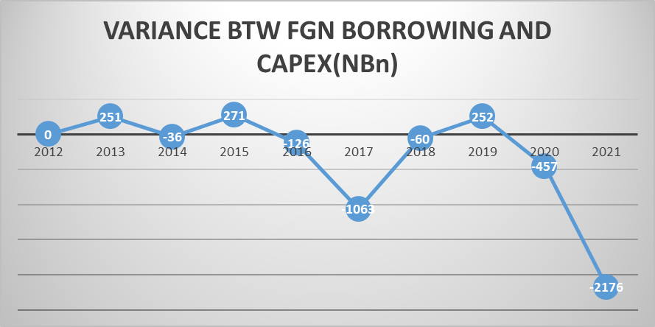

Figure 3.5
Source: Budget Implementation Reports

Table 3.6 and figure 3.5show that in 2012, the federal government borrowed the sum of ₦744.00billion and applied the same amount on the capital expenditure for the year. This means that no part of the loan was expended on recurrent or other expenditure in line with the provision of S. 41(1)(a) of the FRA, 2007. On the other hand, in 2013, 2015 and 2019 the FG borrowed the sum of ₦707.00 billion, ₦330.00billion and ₦913.00 billion but expended ₦958 billion, ₦601 billion and ₦1,165 billion on capital expenditure respectively. This implies that the capital expenditure was higher than the amount borrowed to the tune of ₦251.00 billion in 2013, ₦271.00 billion in 2015 and ₦252.00 billion in 2019 respectively, positively indicating that capital projects were partly funded from other revenue (sources) than borrowing but the borrowed funds were not deployed to fund non-capital expenditures.

Regrettably however, there seemed to be a flagrant breach of S. 4(1)(a) of the FRA in 2014, 2016, 2017, 2018, 2020 and 2021 where the capital expenditures were lower than the amounts borrowed, suggesting that borrowed funds were deployed to fund projects other than capital expenditures. Table 3.6 above shows that in 2014, the sum of ₦624.00 billion was borrowed while the capital expenditure was ₦588.00 billion, leaving a balance of ₦36.00 billion. In 2016, ₦300.00 billion was borrowed and only ₦174 billion was expended on capital expenditure, the difference was ₦126.00 billion. In 2017, ₦2,503.00 billion was borrowed but only ₦1,440 billion was expended on capital expenditure, the balance was ₦1,063.00 billion. In 2018, ₦1,742.00 billion was borrowed and only ₦1,682 billion was expended on capital expenditure, the difference was ₦60.00 billion. In 2020, ₦2,058.00 billion was borrowed and only ₦1,601 billion was expended on capital expenditure, leaving a balance of ₦457.00billionwhile in 2021, ₦4,519.00 billion was borrowed but only ₦2,343 billion was expended on capital expenditure, the balance was ₦2,176.00 billion.

The foregoing figures indicate that borrowings were deployed to fund non-capital expenditures in 2014, 2016, 2017, 2018, 2020 and 2021 in clear breach of S.41(1)(a) of the FRA, 2007.

3.6 FGN BUDGET DEFICIT TO GDP RATIO
In order to enhance budget reliability and fiscal sustainability, it is expected that, the aggregate expenditure and the aggregate amount appropriated by the National Assembly for each financial year should not be more than the estimated aggregate revenue inclusive of deficit, which according to S. 12 (1) of the FRA 2007, should not be more than 3 (three) percent of the estimated GDP or any sustainable percentage as may be determined by the National Assembly. Table 3.7and figure 3.6 below shows the Nigeria’s fiscal deficit to GDP ratio from 2012 to 2021.

Table 3.7.FGN’S BUDGET DEFICIT AS PERCENTAGE OF GDP FROM 2012 TO 2021
YEAR | ACTUAL DEFICIT(₦Bn) | GDP(₦Bn) | %DEFICIT TO GDP
2012 | 1000.14 | 72,599.60 | 1.4
2013 | 1060 | 81,010.00 | 1.3
2014 | 881 | 90,137.00 | 1.0
2015 | 1527.12 | 95,177.70 | 1.6
2016 | 2194 | 102,575.40 | 2.1
2017 | 3806 | 114,899.20 | 3.3
2018 | 3645 | 129,086.90 | 2.8
2019 | 4179 | 145,639.10 | 2.9
2020 | 5978.17 | 154,252.30 | 3.9
2021 | 6436 | 173,528.00 | 3.7
Source: CBN Statistical Bulletin, 2020, Budget Implementation Reports

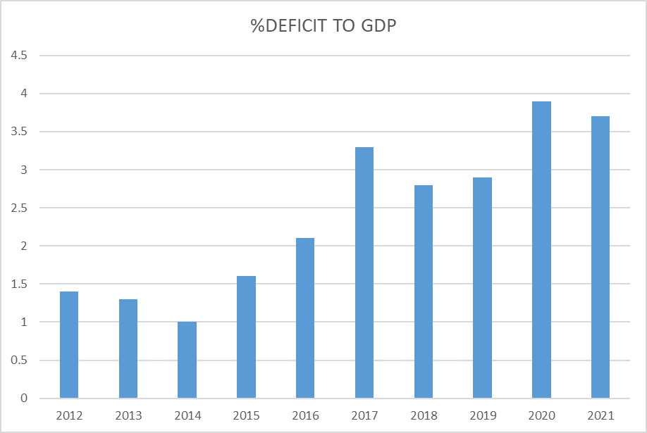

Fig. 6

Figure 3. 6

Table 3.7 above shows the actual fiscal/budget deficit to GDP ratio from 2012 - 2021. In 2012, the total actual budget deficit stood at ₦1.00trillion, while the GDP was ₦72.60 trillion. This represents 1.14% fiscal deficit to GDP ratio. Budget deficit in 2013 was ₦1.1 trillion, representing 1.3% of the GDP. In 2014, 2015, 2016, 2018 and 2019, fiscal deficits stood at 1.0%, 1.6%, 2.1%, 2.8% and 2.9% of the GDP respectively. This is conservatively below the 3% ceiling stipulated by S. 12 (1) of the FRA, 2007.
However, in 2017, 2020 and 2021, budget deficits breached the statutory 3% ceiling to 3.3%, 3.9% and 3.7% respectively. These clearly violate the provisions of the Section of the FRA, 2007. Although S. 61 of the Finance Act, 2020 amended S. 12(2) of the FRA and provided for certain exceptions or conditions under which the 3% may be exceeded, there was no indication that any of the conditions set out therein were responsible for exceeding the threshold in 2017, 2020 and 2021.

3.7 PERFORMANCE OF FISCAL DEFICIT FINANCING ITEMS

Budget deficit is the difference between all the receipts and all the expenses in both terms. In a balanced budget, the revenue and expenditure must be equal. During the period under review (2012 – 2021), there was consistent deficit in the FGN’s annual budget. Deficit financing is part of the expected receipts to fund the budget. It is, therefore, imperative to measure its performance/contributions in funding the annual budget against the projected values. Underperformance of the deficit-financing items will affect the funding of the budget, resulting in poor budget performance. Table 3.8 below shows the projected fiscal deficits and actual financing from 2012 – 2021.

Table 3.8 FGN’S PROJECTED FISCAL DEFICIT AND ACTUAL FINANCING
YEAR | DEFICIT FINANCING ITEM(DFI) | PROJECTED (DFI) ₦Bn | ACTUAL (DFI) ₦Bn | %PERFOMANCE OF DFI
2012 | Privatization Proceeds | 10 | 7.5 | 75.00
 | Signature Bonus | 75 | 0 | 0.00
 | FGN Share from Stabilization Funds | 306.76 | 163.59 | 53.33
 | Domestic Borrowing | 744.44 | 744.44 | 100.00
 | Borrowing From Dev. Of Natural resources Account | 0.00 | 74 | #DIV/0!
 | TOTAL | 1,136.20 | 989.53 | 87.09
YEAR | DEFICIT FINANCING ITEM(DFI) | PROJECTED (DFI) ₦Bn | ACTUAL (DFI) ₦Bn | %PERFOMANCE OF DFI
2013 | Privatization Proceeds | 10 | 0 | 0.00
 | Signature Bonus | 75 | 6.03 | 8.04
 | FGN Share from Stabilisation Fund Account | 225.00 | 195.86 | 87.05
 | Borrowing From Special Accounts |  | 223.93 | #DIV/0!
 | Borrowing to service Excess Domestic Debt |  | 75.08 | #DIV/0!
 | Domestic Borrowing FGN Bond) | 577.07 | 706.74 | 122.47
 | TOTAL | 887.07 | 1,207.64 | 136.14
YEAR | DEFICIT FINANCING ITEM(DFI) | PROJECTED (DFI) ₦Bn | ACTUAL (DFI) ₦Bn | %PERFOMANCE OF DFI
2014 | Privatization Proceeds | 15 | 0 | 0.00
 | FGN Share from Stabilisation Fund Account | 324.97 |  | 0.00
 | Domestic Borrowing FGN Bond) | 624.22 | 624.22 | 100.00
 | TOTAL | 964.19 | 624.22 | 64.74
YEAR | DEFICIT FINANCING ITEM(DFI) | PROJECTED (DFI) ₦Bn | ACTUAL (DFI) ₦Bn | %PERFOMANCE OF DFI
2015 | Privatization Proceeds | 10 | 0 | 0.00
 | Signature Bonus | 58.89 |  | 0.00
 | FGN Share from Stabilisation Fund Account | 80 | 6.6 | 8.25
 | Borrowing From Special Accounts |  | 17.41 | #DIV/0!
 | Credit Advance by CBN |  | 615.96 | #DIV/0!
 | Foreign Borrowing | 380.00 |  | 0.00
 | Domestic Borrowing FGN Bond) | 802.12 | 330 | 41.14
 | Transfer of Funds from Special Account (Monetization) |  | 73.51 | #DIV/0!
 | Proceed of sale of Government Property | 10.00 |  | 0.00
 | TOTAL | 1,341.01 | 1,043.48 | 77.81
YEAR | DEFICIT FINANCING ITEM(DFI) | PROJECTED (DFI) ₦Bn | ACTUAL (DFI) ₦Bn | %PERFOMANCE OF DFI
2016 | Privatization Proceeds | 10 | 5.92 | 59.20
 | Signature Bunos | 0.74 |  | 0.00
 | Borrowing From Special Accounts |  | 376.51 | #DIV/0!
 | Securitization of balance of 2015 borrowing |  | 224.6 | #DIV/0!
 | Foreign Borrowing | 635.88 |  | 0.00
 | Domestic Borrowing FGN Bond) | 1,182.80 | 300 | 25.36
 | Act |  | 300 | #DIV/0!
 | Refund to Excess Crude Account |  | -40 | #DIV/0!
 | Refunds/Recoveries From Strategic Alliance Contracts | 137.90 |  | 0.00
 | FGN Share of JV Assets transferred to NDPC (NNPC/CBN) | 162.43 |  | 0.00
 | Recoveries of other Misappropriated Funds | 50.00 |  | 0.00
 | Proceed of sale of Government Property | 25.00 |  | 0.00
 | TOTAL | 2,204.75 | 1,167.03 | 52.93
YEAR | DEFICIT FINANCING ITEM(DFI) | PROJECTED (DFI) ₦Bn | ACTUAL (DFI) ₦Bn | %PERFOMANCE OF DFI
 | Privatization Proceeds | 10 | 0 | 0.00
 | Signature Bonus | 114.3 | 0 | 0.00
 | Foreign Borrowing | 1,067.50 | 1,165.67 | 109.20
 | Domestic Borrowing | 1,254.27 | 1,337.55 | 106.64
 | Other FGN Recoveries/Financing | 205.56 | 0.00 | 0.00
 | Proceed of sale of Govt Properties | 25.00 | 0.00 | 0.00
 | TOTAL | 2,676.63 | 2,503.22 | 93.52
YEAR | DEFICIT FINANCING ITEM(DFI) | PROJECTED (DFI) ₦Bn | ACTUAL (DFI)₦Bn | %PERFOMANCE OF DFI
2018 | Privatization Proceeds | 306 | 0 | 0.00
 | Non-Oil Asset Sales | 5 | 0 | 0.00
 | Foreign Borrowing | 849.67 | 1,073.30 | 126.32
 | Domestic Borrowing | 793.79 | 668.79 | 84.25
 | TOTAL | 1,954.46 | 1,742.09 | 89.13
YEAR | DEFICIT FINANCING ITEM(DFI) | PROJECTED (DFI) ₦Bn | ACTUAL (DFI)₦Bn | %PERFOMANCE OF DFI
2019 | Privatization Proceeds | 210 | 0 | 0.00
 | Multi-lateral/Bi-lateral Project-tied Loans | 92.84 | 0 | 0.00
 | Foreign Borrowing | 802.82 | 0.00 | 0.00
 | Domestic Borrowing | 802.82 | 912.82 | 113.70
 | TOTAL | 1,908.48 | 912.82 | 47.83
YEAR | DEFICIT FINANCING ITEM(DFI) | PROJECTED (DFI) ₦Bn | ACTUAL (DFI)₦Bn | %PERFOMANCE OF DFI
2020 | Privatization Proceeds | 126.04 | 0 | 0.00
 | Borrowing from special Accounts | 263.63 | 0 | 0.00
 | Foreign Borrowing | 2,213.89 | 0 | 0.00
 | Domestic Borrowing | 1,984.68 | 2,057.54 | 103.67
 | TOTAL | 4,588.24 | 2,057.54 | 44.84
YEAR | DEFICIT FINANCING ITEM(DFI) | PROJECTED (DFI) ₦Bn | ACTUAL (DFI)₦Bn | %PERFOMANCE OF DFI
2021 | Privatization Proceeds | 205.15 | 0 | 0.00
 | Multi-lateral/Bi-lateral Project-tied Loans | 709.69 | 0 | 0.00
 | Restructured Loan | 45.63 | 0 | 0.00
 | Foreign Borrowing | 2,744.44 | 1,623.60 | 59.16
 | Domestic Borrowing | 2,744.44 | 2,895.49 | 105.50
 | TOTAL | 6,449.35 | 4,519.09 | 70.07

Source: BudgetImplementation Reports and FRC

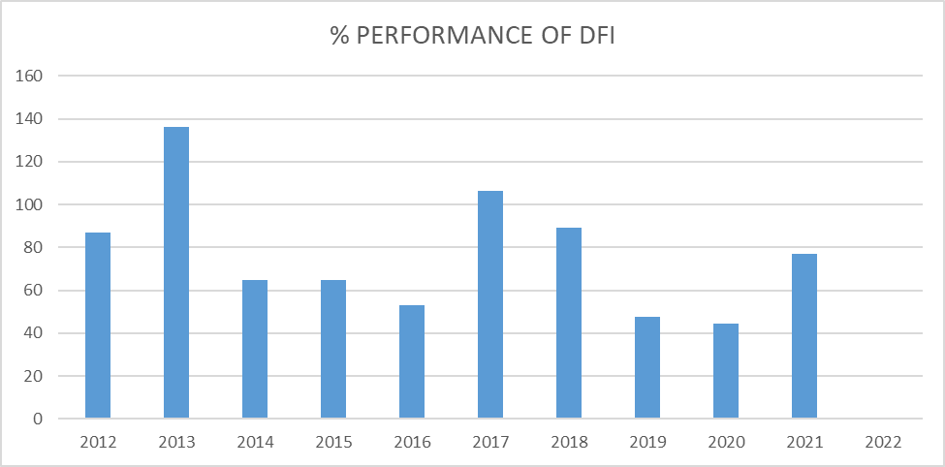
Figure 3.7

Table 3.8 and Figure 3.7 reveal that, the deficit financing items performance were below 80% from the projected sum for most of the years under review with the exception of year, 2012,2013,2017 and 2018 which had 87.09%, 136.14%, 93.52% and 89.13% respectively.
On the other hand, the deficit financing items performance of the following years: 2019 and 2020 were below 50% as highlighted on same table 3.8 above.

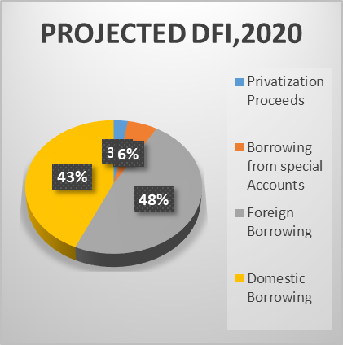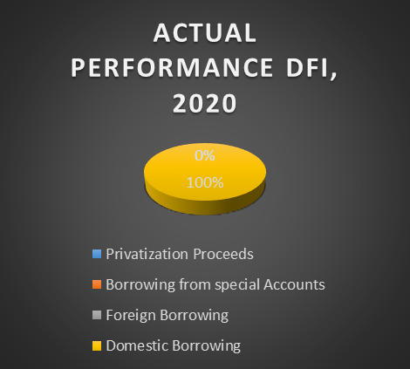
Figure 3.8 Figure 3.9
Observations
- The deficit financing items performance for all the years under review underperformed based on the projected sum, except for year 2013 where the sum of ₦887.07 billion was projected and ₦1,207.64 billion (136.14%) was realised at the end of the fiscal year.
- The deficit financing items performance for year 2019 and 2020 were 47.83% and 44.84% respectively. These poor performances were attributed to using only one source (Domestic borrowing) out of many items to finance the deficit while other sources of financing items did not materialise.
- With the recent reclassification of Nigeria as a Lower-Middle-Income country which caused limited funding access from concessional borrowing (Multi-lateral and Bi-lateral loans), there was more reliance on market-based financing (Domestic borrowing) with high interest rates and short amortisation period.
- The rate of yearly increment of fiscal deficit is alarming;the evolving structure of debt will drive up interest burdens and expose the country to greater solvency risks amid diminishing fiscal space and increasing debt vulnerabilities.

3.8 FORECAST ERROR
A forecast error is the difference between the actual or real and the predicted, projected, or forecast value of a time series data.
One way to check the quality of your forecast value is to calculate its forecast accuracy, also called forecast error. The forecast accuracy calculation shows the deviation of the actual value from the forecast value.

3.8.1 Borrowing Forecast Error
Borrowing Forecast Error is the difference between the actual borrowing and the projected borrowing within a specific period. The deviation of the actual from the projected shows the level of the forecast accuracy/forecast error. The greater the difference between the actual and the projected the greater the impact.

Table 3.9: BORROWING FORECAST ERROR
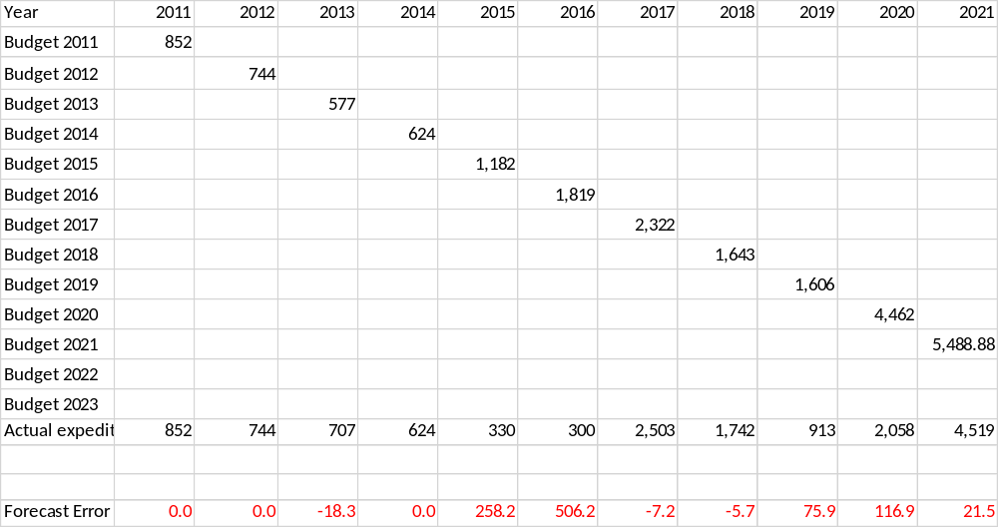
Source: Budget Implementation Reports and FRC

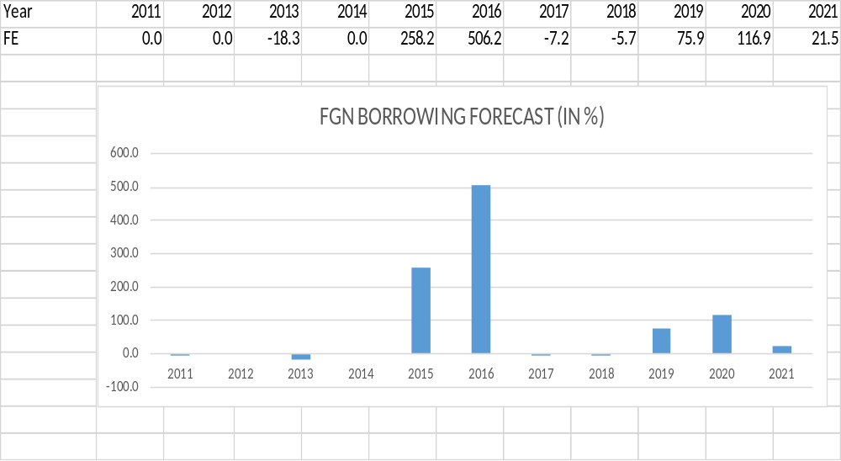
Figure 3.8

Table 3.10 ANNUAL BORROWING FORECAST AND OUTTURN
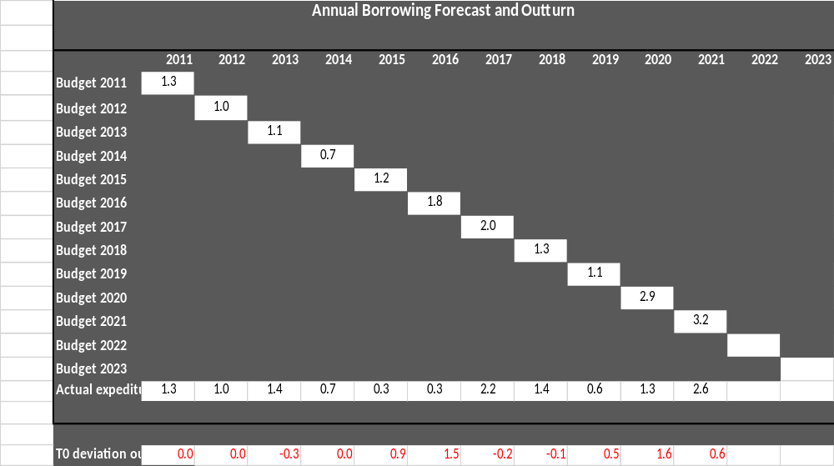
Source: BudgetImplementation Reports and FRC

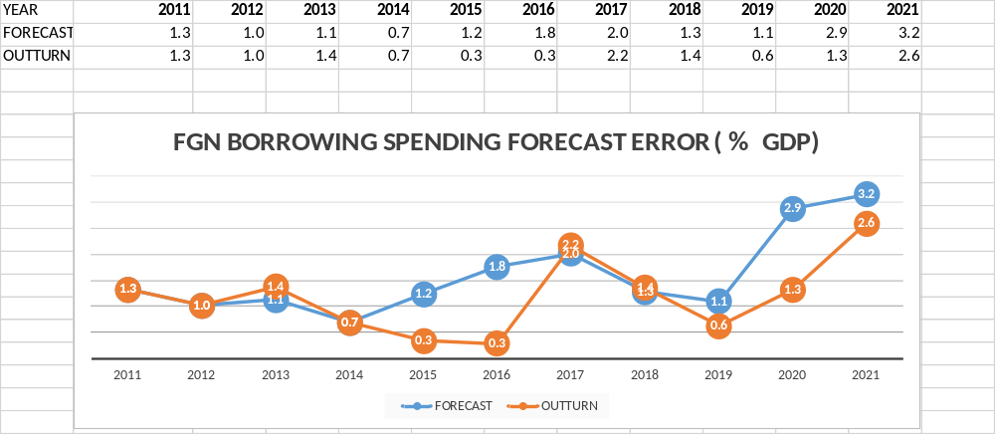
Figure 3.9

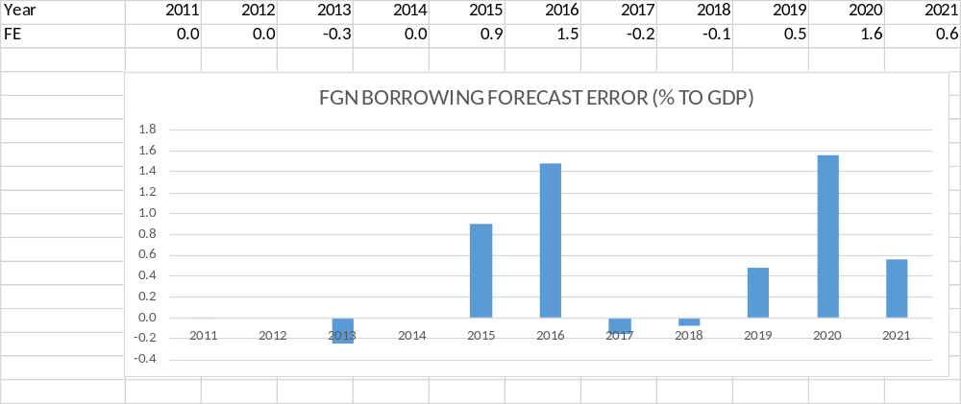
Figure3.10

3.8.2 Budget Deficit Forecast Error
Budget Deficit Forecast Error is the difference between the actual deficit financing and the projected deficit financing within a specific period. The deviation of the actual from the projected shows the level of the forecast accuracy/forecast error. The greater the difference between the actual and the projected the greater the impact.
Table 3.11 BUDGET DEFICIT FORECAST 2011 - 2021
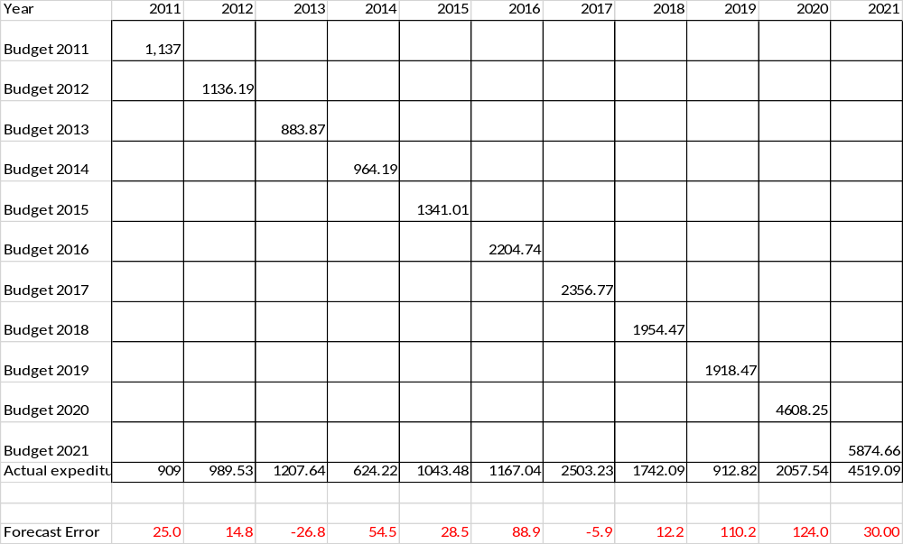
Source: Budget Implementation Reports and FRC

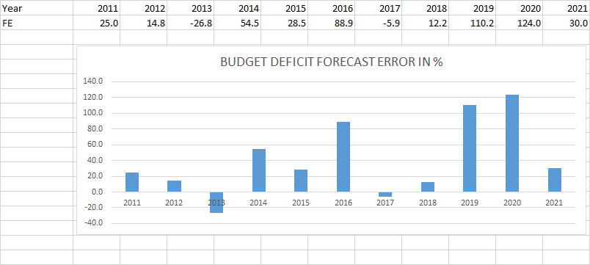
Figure 3.11

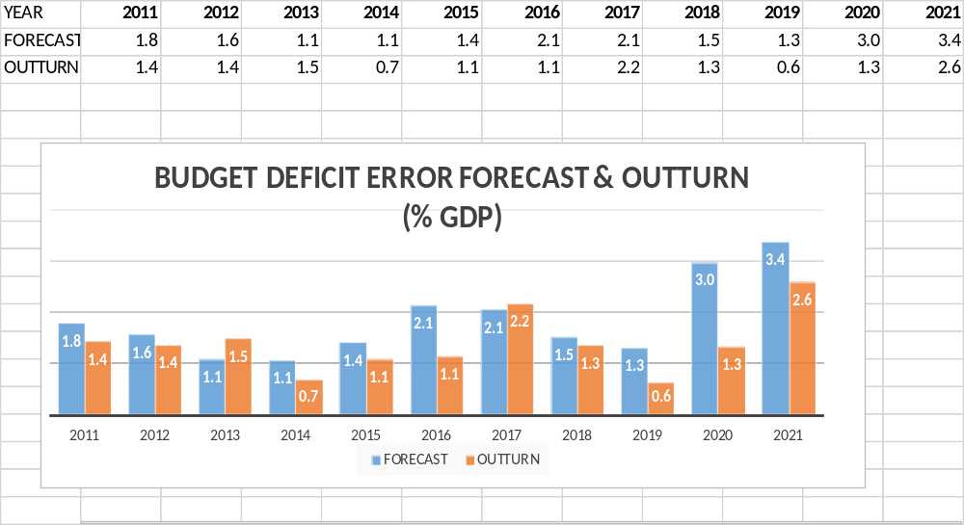
Figure 3.12

3.9 RECOMMENDATIONS
- Proper debt management is a critical ingredient for a stable economy. When debt is properly managed for the purpose to which it was borrowed, it boosts the GDP and reduces the debt-to-GDP ratio. Thus, there is a need for quality debt management to obtain a reliable forecast of gross financing needs and better understanding of refinancing risks.
- The quality of underlying economic forecasts, especially for interest rate, exchange rate, and growth are critical to a reliable sustainable assessment.
- Government desire to borrow should not be based on over optimism on future revenue generation but on conscious effort to shore up primary balance. Therefore, liquidity should be an important consideration in comprehensive debt sustainability assessment.
- Public debt is an important instrument used by sovereign governments to manage their fiscal imbalance that arises out of mismatches between revenue generation and expenditure needs. Due to the large fiscal imbalance faced by most countries, the government resorts to an external source of revenue in the form of borrowing to augment its internal revenue. While this practice is not bad, an excess accumulation of debt creates serious fiscal problems for both current and future generations if not properly managed. This is because mismanagement of external borrowing has little or no significant impact on the GDP, thereby increasing the debt-to-GDP ratio and draining out government revenue via debt servicing and interest payment. The government should ensure that it maintain its fiscal deficit to GDP ratio at within 3% as stipulated by the law.(Section 12(1) of the FRA, 2007
- Detailed information about debt structure in terms of maturing (either long or short term) and currency compositions, and repayment schedules are very important in sustainability assessment.
- Strengthening and continued implementation of the Strategic Revenue Growth Initiatives to shore up Government revenues, to reduce financing pressures, and expand the fiscal space.
- Rationalizing expenditure by focusing on priority spending on growth-enhancing sectors of the economy.
- Effective implementation of the Petroleum Industry Act (PIA), 2021 which is expected to attract investment in the oil and gas sector.
- Enhancing growth in non-oil export through fiscal and trade incentives, which will maintain relative stability in the foreign exchange market.
- Encouraging private sector participation in funding infrastructure projects through Public-Private Partnership arrangements; and,
- Improving and sustaining political and macroeconomic stability, as well as addressing security and infrastructural challenges, to attract Foreign Direct Investments (FDIs).
3.10 Conclusion
The Public Debt Sustainability Analysis shows that Nigeria’s Total Public Debt is sustainable in the medium-term and the Total Public Debt-to-GDP ratio was below the MAC-DSA’s benchmark of 70%. Similarly, the Gross Financing Needs are high but lower than the MAC-DSA’s benchmark of 15%.

The financing needs are met mostly by domestic financing through the issuance of FGN securities in the domestic financing market. External financing would be from the concessional and semi-concessional sources, as well as market financing by the issuance of Eurobonds in line with Nigeria’s Medium-Term Debt Management Strategy.

The Debt Profile, however, shows moderate risk and susceptibility to some shocks such as Market Perception, Share of Debt held by Non-Resident and Foreign Currency Denominated Debt, which may undermine debt sustainability in the medium-term.

Also, the Debt Profile is exposed to risks associated with the volatility of oil prices, as well as enhanced short-term debt vulnerabilities and cost of debt servicing arising from CBN financing. However, the sustained implementation of economic initiatives and reforms by the Government aimed at stimulating growth and boosting revenue are expected to moderate these shocks and financing pressures in the medium-term. In addition, if the CBN financing through Ways and Means Advances is re-structured into long term debt.

CHAPTER 4
4.0 MACRO-FISCAL FORECASTS COMPUTATION AND ANALYSIS

4.1 INTRODUCTION
Budgeting is the process of estimating revenues and expenditures over a specified period of one year. A Budget is the main instrument for translating government economic policy objectives into a series of activities for annual implementation aimed at improving socio-economic development and welfare of the citizens. The process of assigning financial values, quantities or rational values to economic variables in the budget based on certain underlying assumptions is budget estimation (forecasting). This process transforms the economic variables into fiscal variables. The fiscal forecast is an integral part of budget preparation. It is based on some assumptions. Some of the assumptions used in the preparation of the Federal Government budget include gross domestic product growth, inflation rate, dollar exchange rate, crude oil benchmark, as well as quantity of production of crude oil. Forecasting is about predicting the future with probability of error. This means that fiscal forecast is not always accurate. A forecast error is the difference between predicted and actual value. Regarding budgeting, fiscal forecast errors are the deviations between the amount budgeted and the actual figures.

4.2EMPIRICAL FRAMEWORK
4.2.1 Database
The data were obtained from the presentation of budget breakdown by the Federal Ministry of Finance, Budget and National Planning (MoFBNP) that were published after approval by the National Assembly. We also extract data from the Budget Implementation Reports published by Budget Office of the Federation. Other fiscal data are obtained from the bulletins of the National Bureau of Statistics and Central Bank of Nigeria. The data covered the period from 2011 to 2021, the summary is given in the table below.

Table 4.1 MACROECONOMIC FISCAL PARAMETERS – BUDGET AND ACTUAL FROM 2011 TO 2021
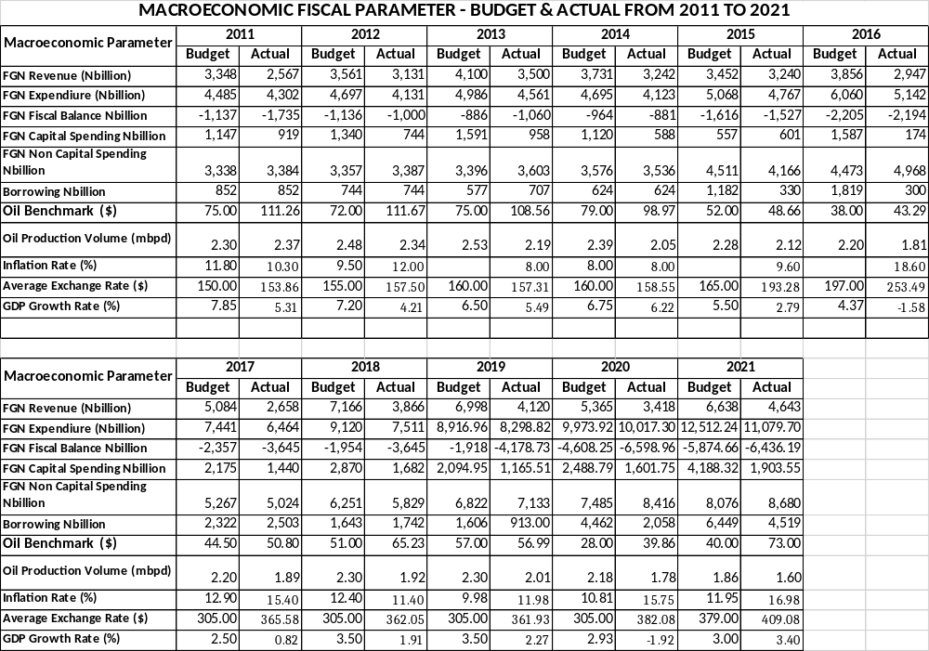
Source: BOF, CBN and NCS

Table 4.2 REVENUE FORECAST 2011 - 2021
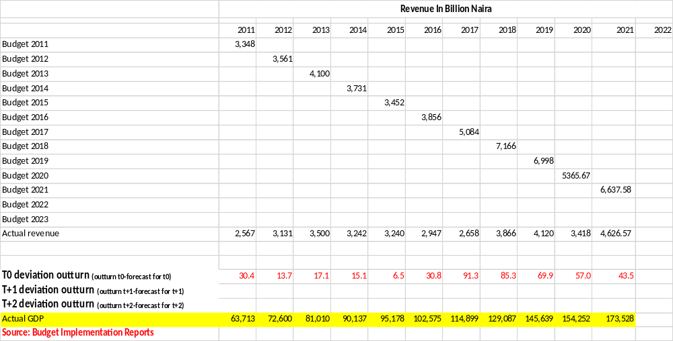

Table 4.3 REVENUE FORECAST IN % TO GDP 2011 -2021
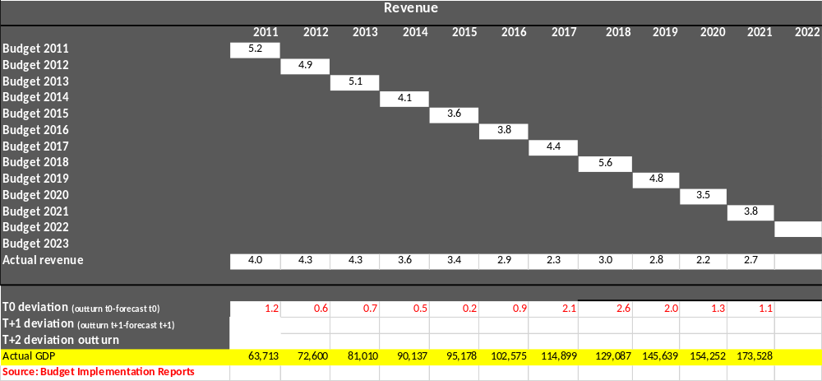
Note: The worksheets track Ministry of Finance projections of real GDP growth and fiscal indicators (revenue, expenditure, balance). A table/matrix for each macro-fiscal indicator is constructed. The rows show the forecasts published in each successive Budget Document or MTEF/FSP. The outturn is reported in the last row of the table. The analysts can use these tables to keep evidence of the past forecasts and produce respective forecast errors (deviations of forecasts from actuals). For example, a forecast error of the year t (forecast for the next budget year): (outturn t-forecast for t); for one year following the budget year, t+1: (outturn t+1-forecast for t+1); for year t+2: (outturn t+2-forecast for t+2). If a forecast error table is constructed for another macroeconomic indicator (in nominal terms, e.g. Naira Billions), a relative forecast error can be calculated as (forecast for t+i - outturn t+i)/(outturn t+1)*100), i=0,1,2. For each indicator, except GDP, the forecasts and actuals are presented in percentage of GDP and the nominal value. Current worksheets are built to allow to track forecast accuracy of MoFBNP published in the respective Q4 Budget Implementation Reports. However, this file could be built to track the projections published in each MTEF and calculate forecast errors for t0, t1, and t2.
The template was applied to some of the macroeconomic parameters in the table above and the results are populated in tables 4.4 and 4.5 below
Table 4.4FORECAST ERRORS MEASURED AS RELATIVE CHANGE FROM ACTUALS
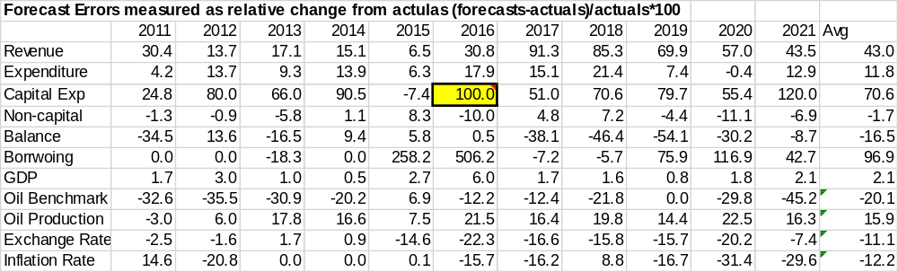

Table 4.5 FORECAST ERRORS MEASURED IN PERCENT OF GDP 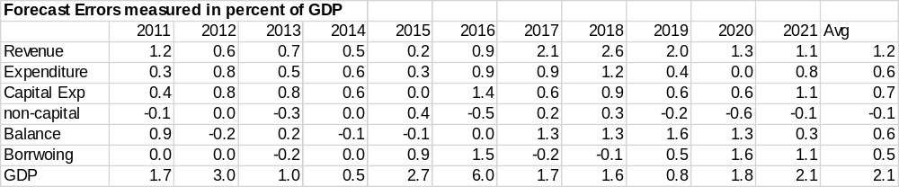

4.2.2Analysis of the Forecasts
Our analysis has shown that errors in severalyears of forecasts have significantly affected the final accuracy of the forecasts.
The formula used in calculating the fiscal forecast error in percentage is given as:
F.E_{actual} = (F_{b}-U_{a})/U_{a}*100 where F_{b} is budget forecast.
U_{a} is actual outturn.
And

F.E_{GDP} = (F_{b}/GDP – U_{a}/GDP) *100 where error is in percentage of the GDP.

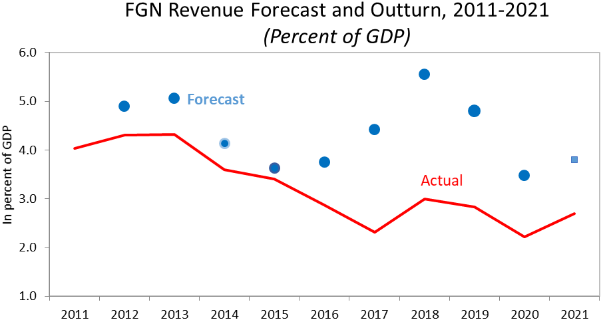
Figure 4.1

FGN Revenue Forecast Accuracy
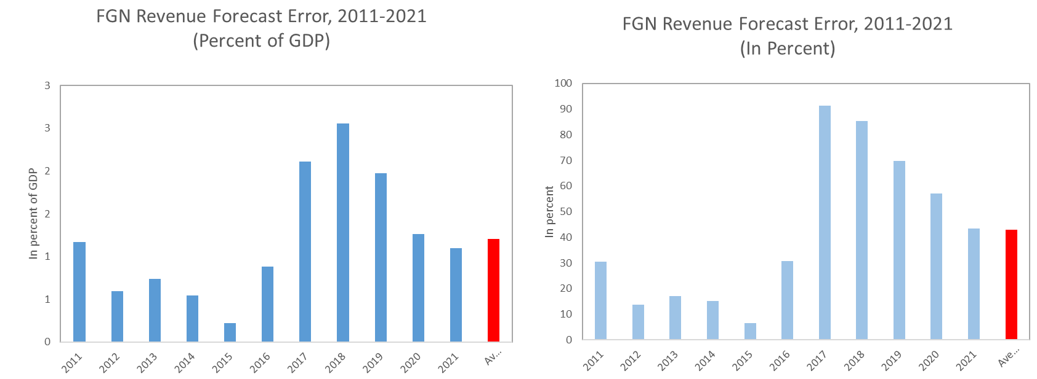
Figure 4.2

Note: The error was calculated as difference between forecast and actuals, in percentage of GDP. Positive means over projections.
It is expected that increased GDP should have corresponding impact on the performance of the related budget parameters such as revenue, expenditure, capital spending and others.Hence, the need to compute the fiscal forecast error based on the GDP to measure these impacts.
Table 4.6FGN EXPENDITURE PERFORMANCE FORECAST
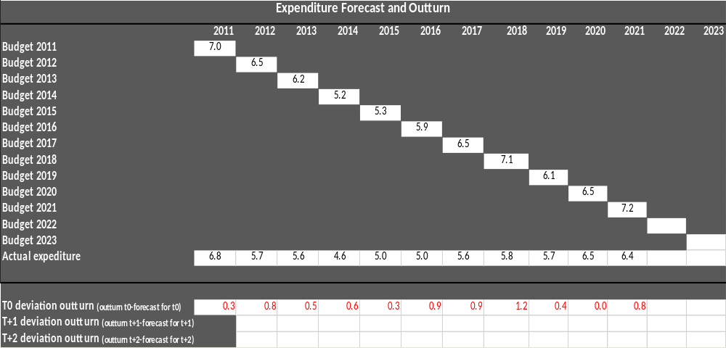
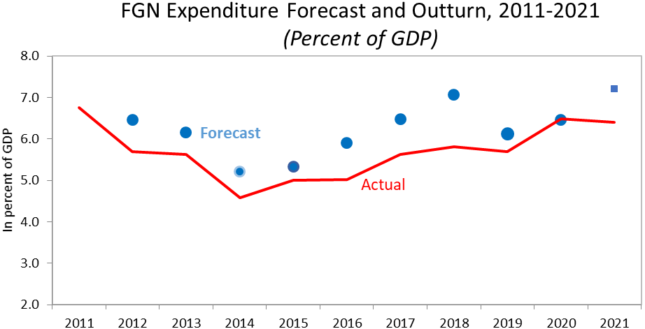
Figure 4.3
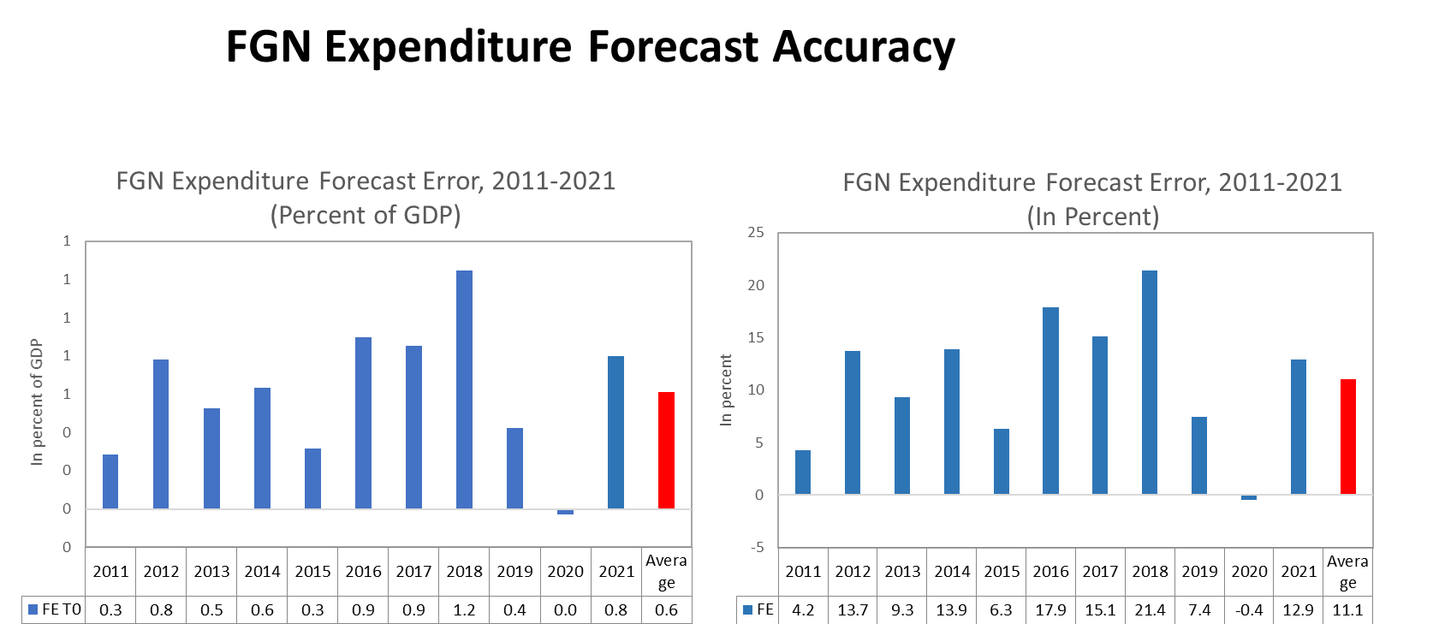
Figure 4.4 Figure 4.5
Note: The error was calculated as difference between forecasts and actuals, in percentage of GDP. Positive means over projections.

Table 4.7FISCAL BALANCE PERFORMANCE
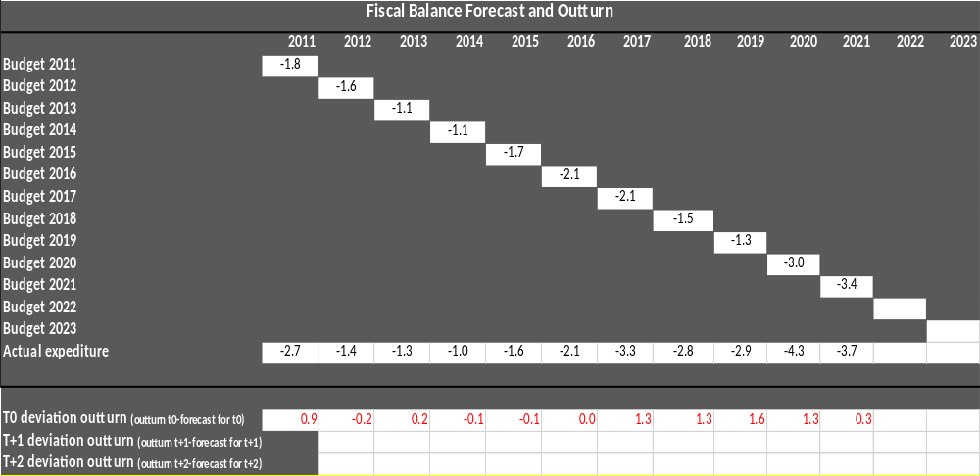

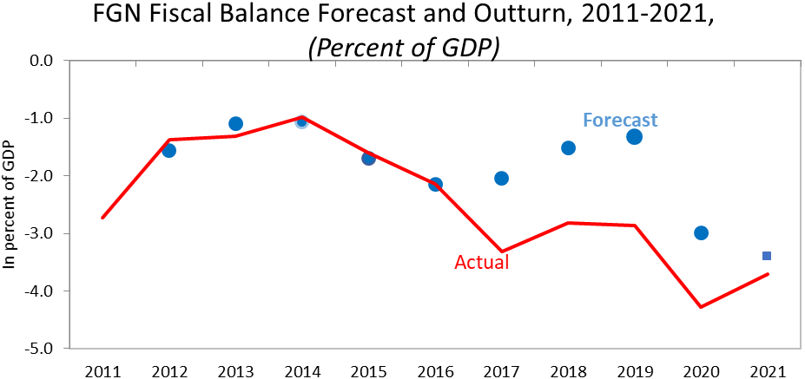
Figure 4.6

FGN Fiscal Balance Forecast Accuracy
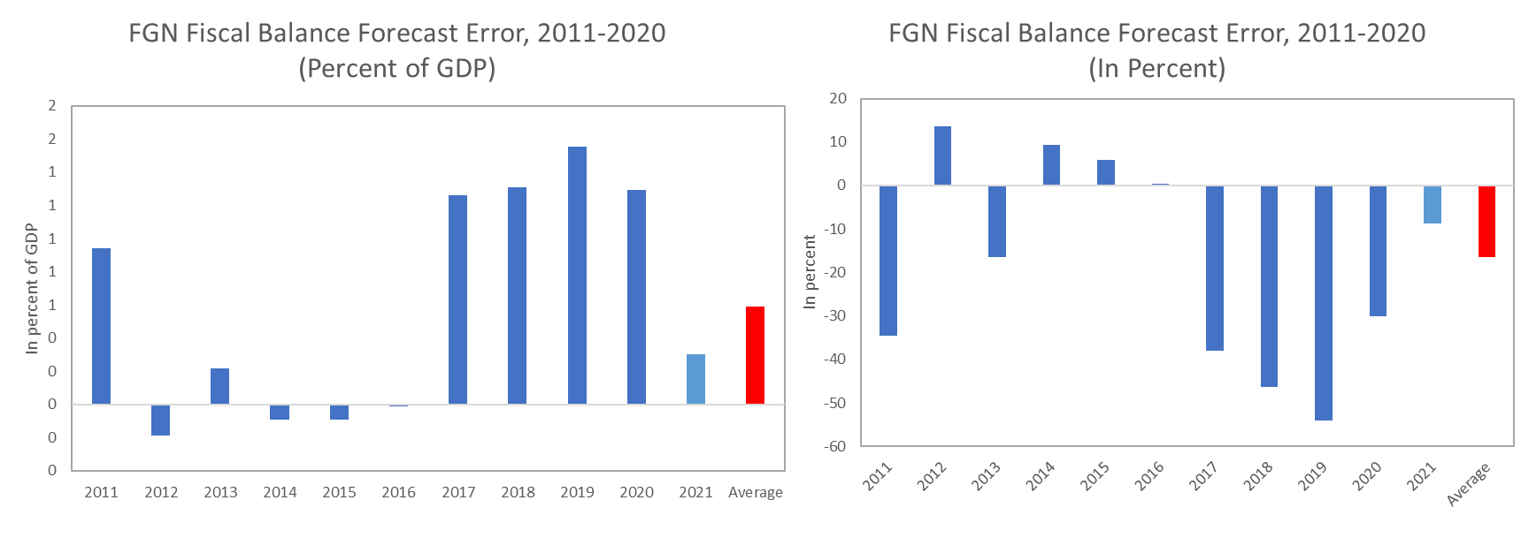
Figure 4.7 Figure 4.8
Note: The error was calculated as difference between forecast and actuals, in percentage of GDP. Positive means over projections.

Table 4.8FGN CAPITAL SPENDING PERFORMANCE
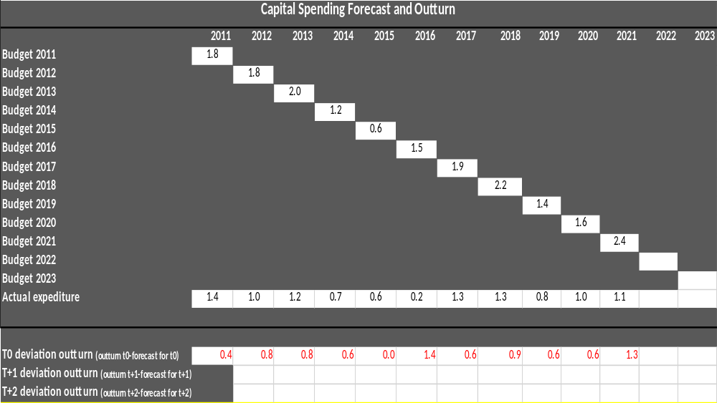
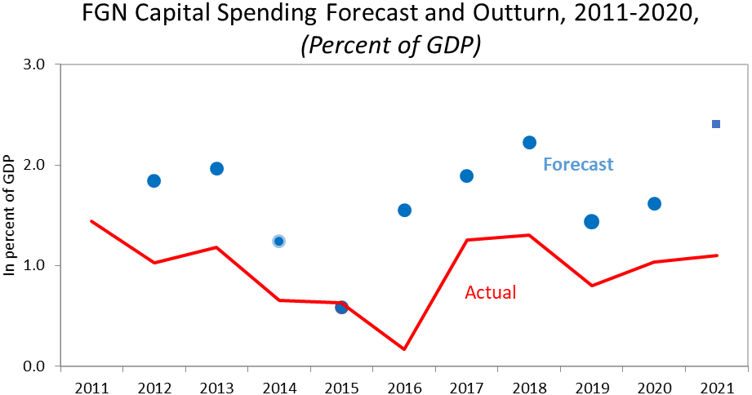
Figure 4.9

FGN Capital Spending Forecast Accuracy
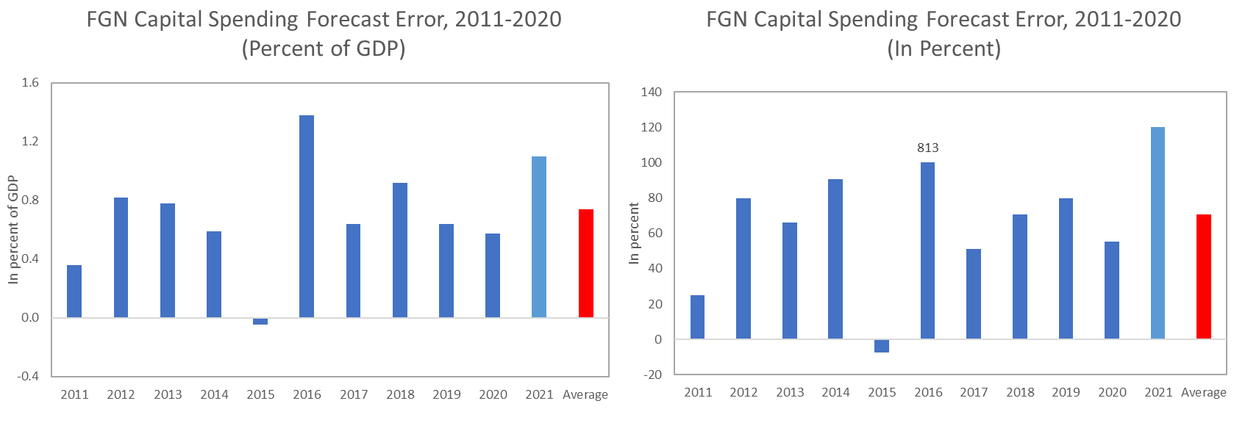
Figure 4.10 Figure 4.11
Note: The error was calculated as difference between forecast and actuals, in percentage of GDP. Positive means over projections.

Table 4.9FGN NON-CAPITAL SPENDING PERFORMANCE
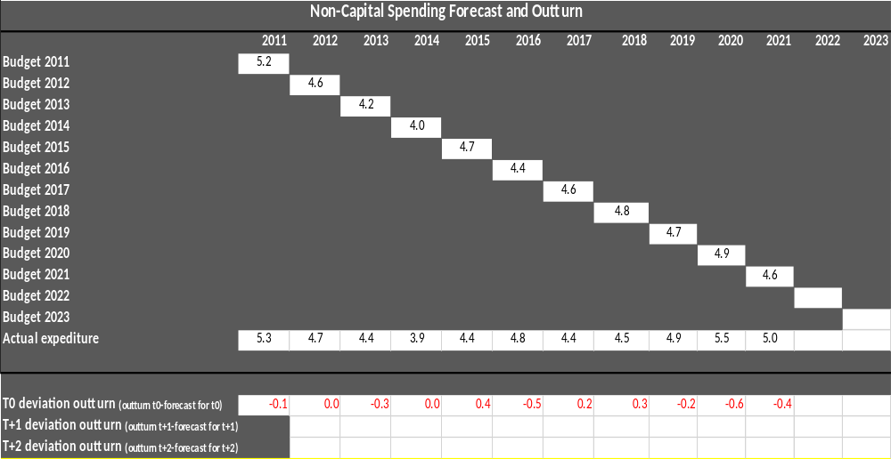
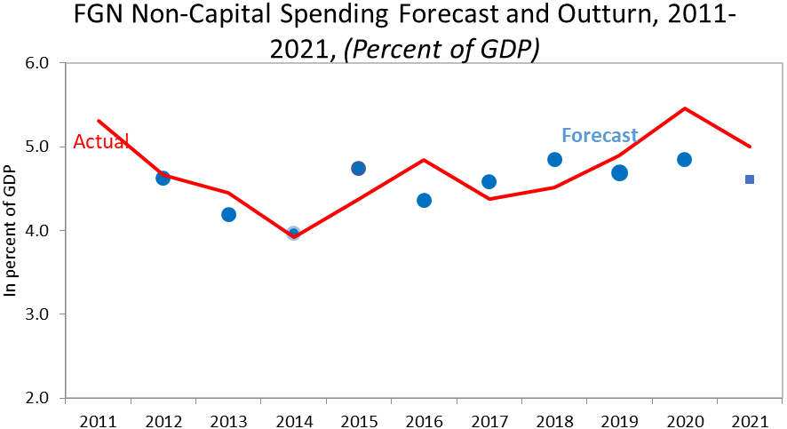
Figure 4.12
FGN Non-Capital Spending Forecast Accuracy
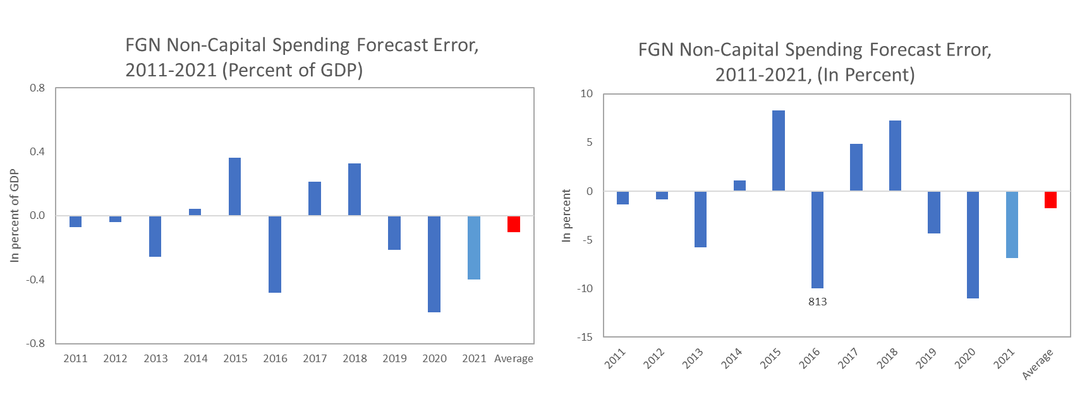
Figure 4.13 Figure 4.14

Note: The error was calculated as difference between forecast and actuals, in percentage of GDP. Positive means over projections.

4.4 Observations
Table 4.9 revealed that in years 2011, 2012, 2013 and 2016, the government spent more than its budget projections.
Meanwhile, FGN could not meet up with expected projections in the following years: 2014, 2015, 2017 and 2018 which might be because of poor revenue generation or unrealistic projections.
4.4.1 Implications
This could probably be responsible for the extra borrowing and low capital investment, resulting in low revenue during the years.

Table 4.10 FGN BORROWING PERFORMANCE
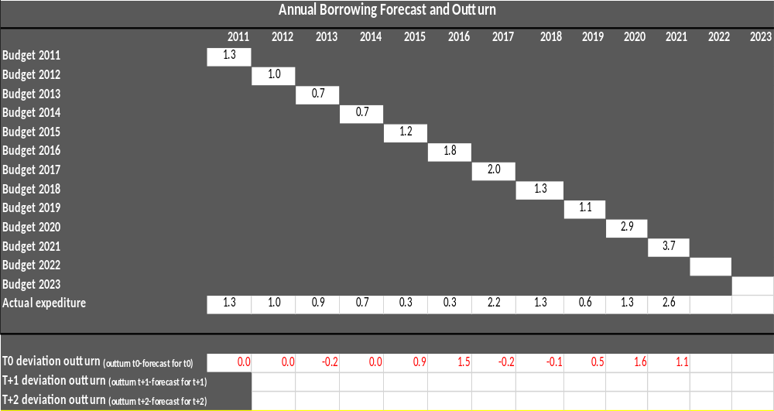
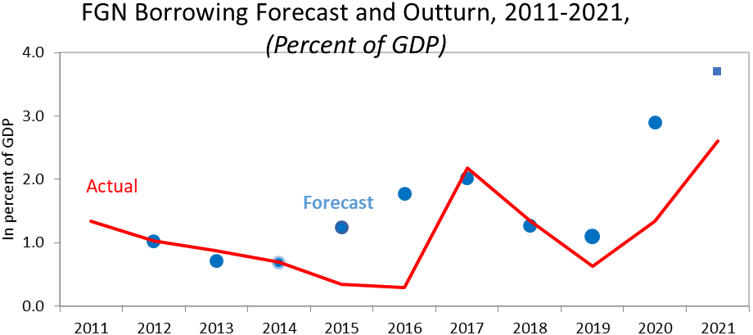
Figure 4.15

FGN Borrowing Forecast Accuracy
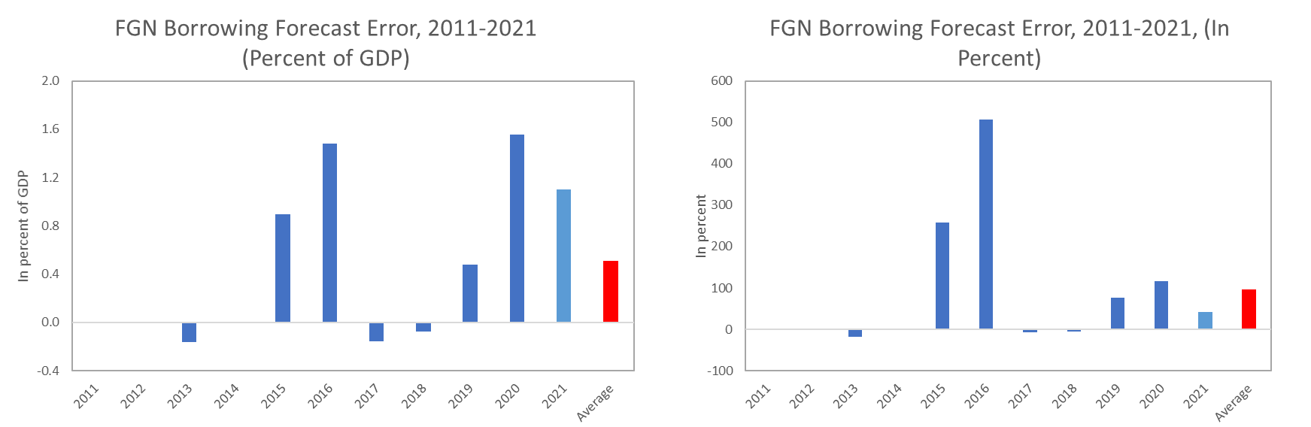
Figure 4.16 Figure 4.17

Note: The error was calculated as difference between forecast and actuals, in percentage of GDP. Positive means over projections.

Table 4.11FGN OIL BENCHMARK FORECAST AND OUTTURN
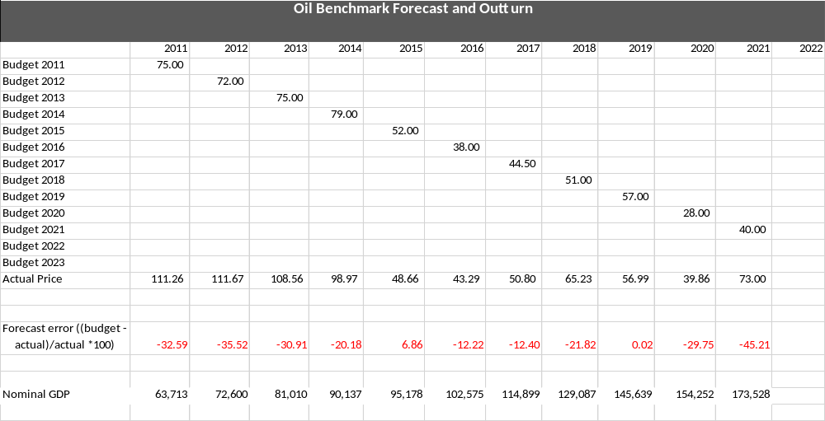

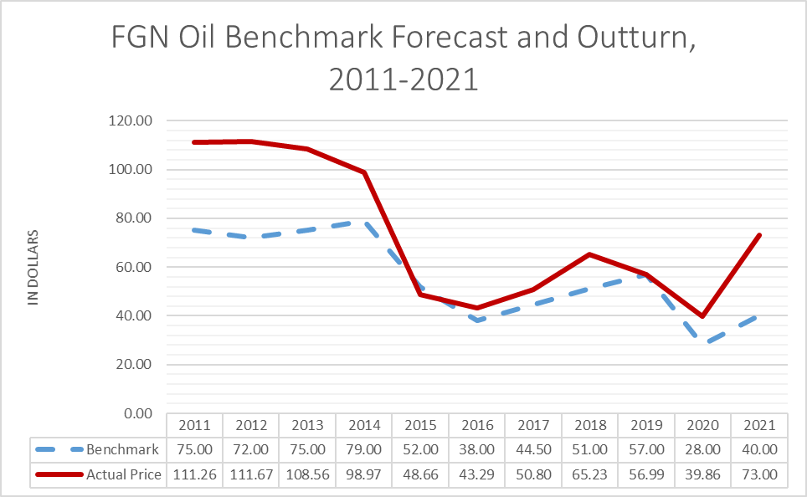
Figure 4.18

FGN Oil Benchmark Forecast Accuracy
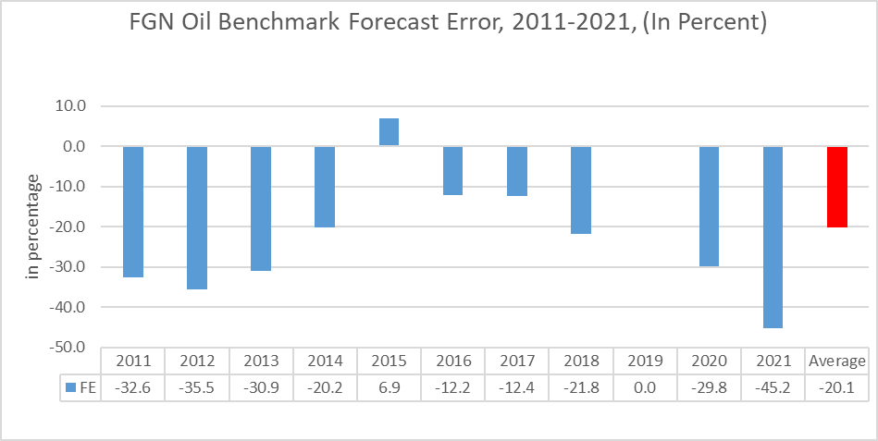
Figure 4.19

Note: The error was calculated as relative difference between forecast and actuals, in percentage of actual. Positive means over projections, while negative means under projections.

4.5 OBSERVATIONS
For the years under review, the oil benchmark has been under-projected except in the year 2015 that was over projected.This under-projection means crude oil was sold above the benchmark price for the years under review.
The under-projection of the extant benchmark over the years under review could have increasedsavings into the Excess Crude Account for the period.
However, lack of accountability of the Excess Crude Account and fall in volume of production, price or recession affected our economy and erroded the possible increase in Excess Crude Account.

Table 4.12 FGNOIL PRODUCTION FORECAST AND OUTTURN
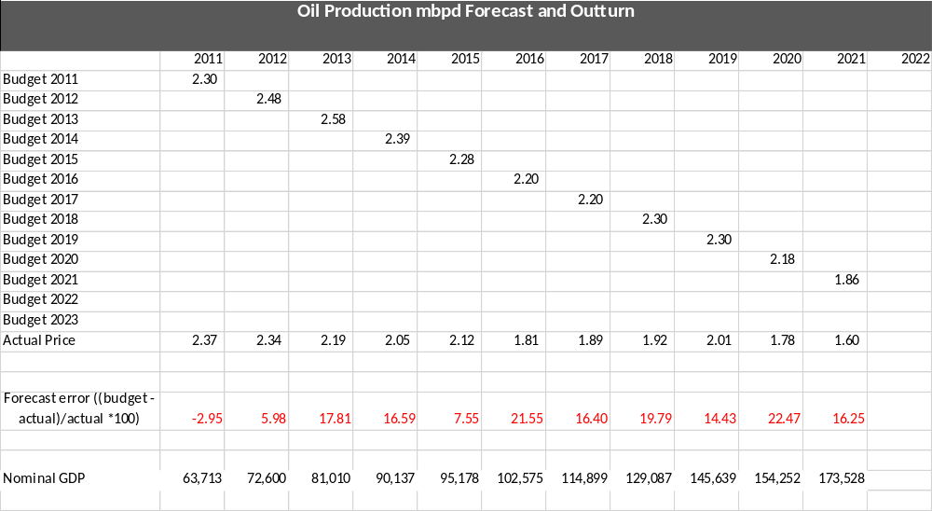

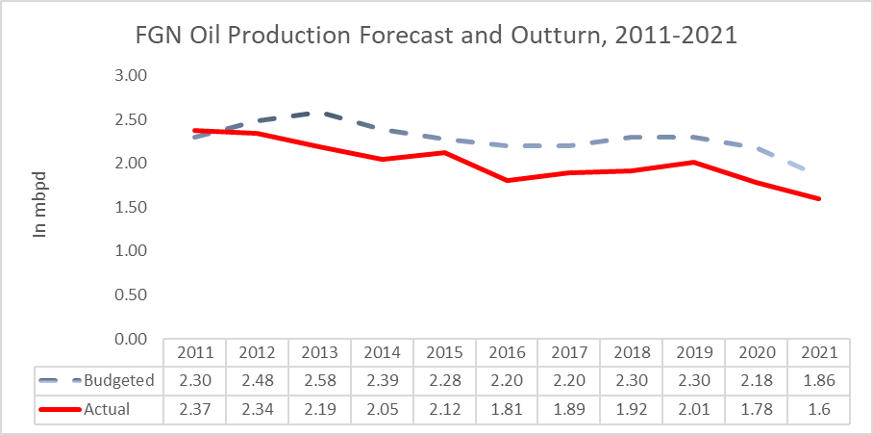
Figure 4.20

FGN Oil Production Forecast Accuracy
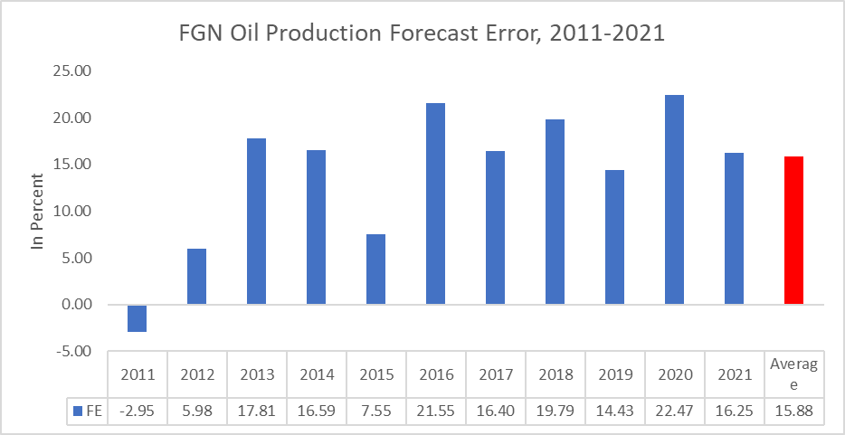
Figure 4.21

Note: The error was calculated as relative difference between forecast and actuals, in percentage of actual. Positive means over projections, while negative means under projections.

4.6 OBSERVATION
It is evident from table 4.12, that in 2011, oil production was under-projected. This clearly indicates that budget forecast is less than the actual outturn, a lot of factors could be responsible for this. While in the year 2012-2021, oil production was over-projected. This also indicates that, budget forecast is more than the actual outturn. Some factors could be attributable to this, such as: inability to meet production quota, oil theft, oil spillage, pipeline vandalism, etc.
4.6.1 Implications
The implications of under-projection could be that the production quota was exceeded, inflation was controlled, oil theft, pipeline vandalism and oil spillage were in check.
By implication, the over-projection could lead to budget deficit which will affect the overall performance of the budget, low revenue outturn and loss of foreign exchange.

Table 4.13FGN DOLLAR EXCHANGE RATE FORECAST AND OUTTURN
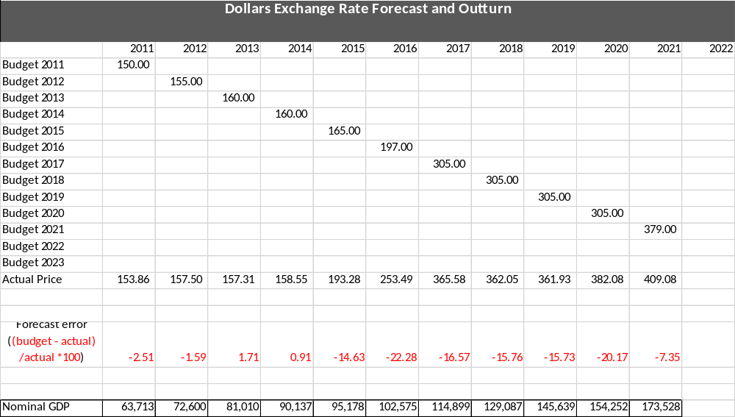

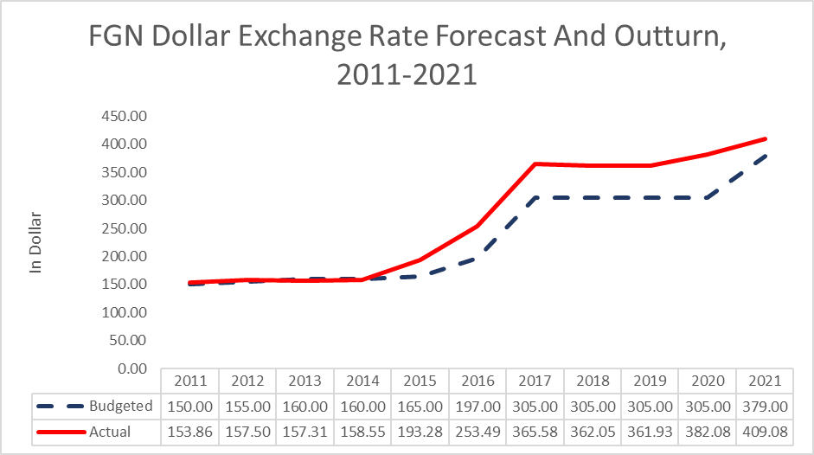
Figure 4.22

FGN Dollar Exchange Rate Forecast Accuracy
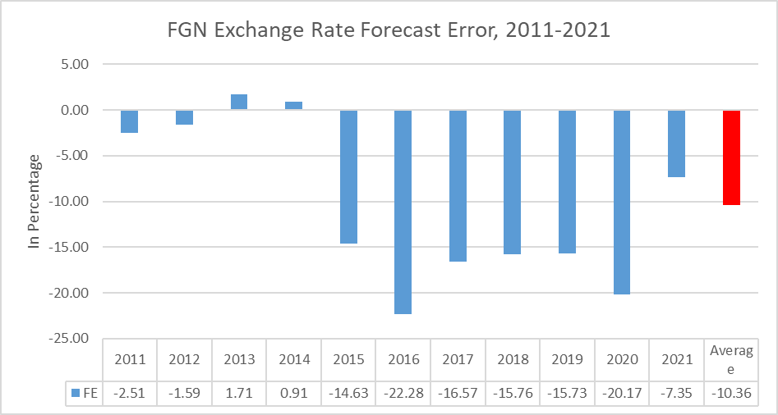
Figure 4.23

Note: The error was calculated as relative difference between forecast and actuals, in percentage of actual. Positive means over projections, while negative means under projections.

4.7 OBSERVATIONS
For the years under review, the actual dollar exchange rate exceeded the budgeted rate in 2011, 2012, 2015, 2016, 2017, 2019, 2020 and 2021. The highest outturn occurred in 2016 with forecast error of 22.28%. The forecast errors of actual and budgeted exchange rate were positively biased in 2013 and 2014, and slightly higher by1.71% and 0.91% in 2013 and 2014 respectively.
The dollar exchange rates were mostly under-projected in most of the years, hence resulting in high negative forecast error average of -10.36%.
4.7.1 Implication
The under-projection of exchange rates for most of the years under review have dire and overbearing effects on the economy as most of the transactions are done in dollars. Foreign investments, oil revenues, debt stock and external debt servicing are computed in dollars.

Table 4.14FGN INFLATION RATE FORECAST AND OUTTURN
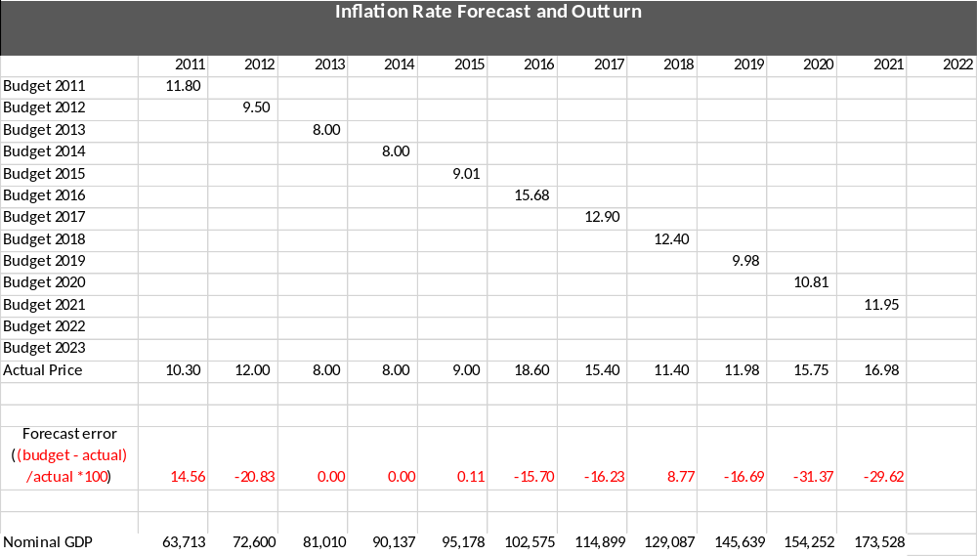

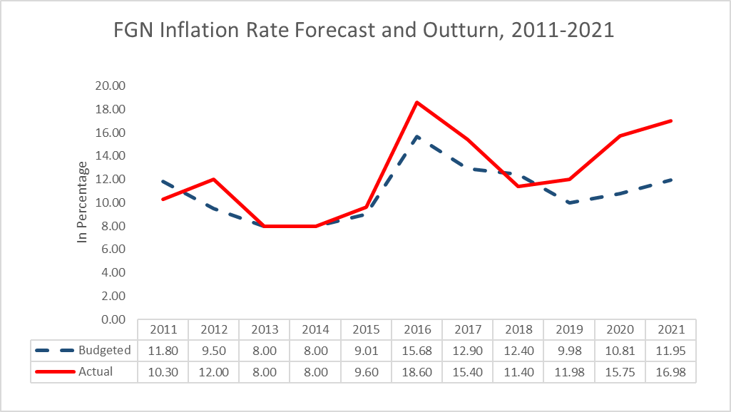
Figure 4.24

FGN Inflation Rate Forecast Accuracy
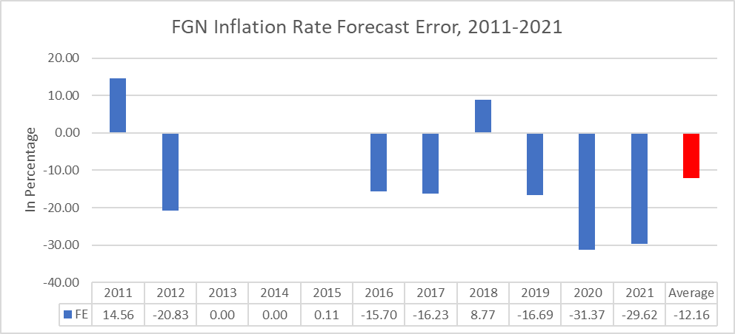
Figure 4.25

4.8 OBSERVATION
The actual inflation rate exceeded the budgeted inflation rate in 2012, 2016, 2017, 2019, 2020 and 2021 respectively. The highest outturn occurred in 2020 with forecast error of 31.37%.
For the years under review, the economy was able to achieve single digit inflation rate in 2013, 2014 and 2015 respectively. The actual inflation and budgeted inflation rates were accurately the same in 2013 and 2014, and slightly higher by 0.01% in 2015.
The inflation rates were mostly under-projected in most of the years, hence resulting in high negative forecast error average of -12.16%.
4.8.1 Implications
The under-projected inflation rates for most of the years under review have significant and pervasive effects on the economy. High inflation rate erodes the purchasing power of consumers, with its worst effect on capital products. This in turn affected the GDP and interest rate. It is worthy to note that the prevalent and persistent under-projected inflation rate if not checked will worsen.

4.9CONCLUSION AND RECOMMENDATIONS

4.9.1 Conclusion
Based on the data gathered from the sources, our analysis shows that forecast errors in the years under review have significantly affected the fiscal balance and the overall budget performance. This suggests that estimated budget parameters were not often taken as set targets once they were appropriated, as the implementers made marginal adjustments over the budget period with no recourse to overall effects. Revenue forecasts were overly optimistic resulting in huge deficits leading to accumulation of debt.
4.9.2 Recommendations
- Based on trend analysis over time, FGN should be more scientific and realistic in its revenue projections to minimize forecast errors.
- Agencies of government should be mandated to limit their expenditure within the approved budgets to ensure control of capital and non-capital spending.
- FGN should put more effort in minimizing forecast errors in oil production projection by addressing some factors attributable to the shortfall, such as: inflated production costs, inflation, oil theft, pipeline vandalism, oil spillage and unaccountable volume of production.
- Policy makers should watch closely, the trend in the exchange rate from at least the last two quarters preceding the end of every year to forecast exchange rate that will be feasible and more realistic for a robust economy.
- The forecasting government institutions and authorities should do more in achieving single digit inflation as well as ensuring reasonable forecast such that actual and budgeted inflation rates are always the same, or at worst, with little deviation.
- All relevant stakeholders should be carried along in forecasting future inflation rates.

CHAPTER 5
5.0 FISCAL RISK ANALYSIS
5.1 INTRODUCTION
Macroeconomic risks have been the subject of increasing attention over the last two decades. The financial crisis of the 1990s, the extensive use of guarantees by transition economies, the global insecurity and sovereign debt crisis have all shown that even apparently sound budget and debt positions can be subject to large hidden risks from off budget or off-balance sheet fiscal activities and implicit liabilities (Petrie, 2013). Pressure to reduce budget deficit and debt continue to induce some governments to shift activities of off-budget or off-balance sheet in ways that often increase cost or risk.
During the past two years, Nigeria economy and public finances have felt the consequences of a global health crisis caused by Covid-19, a global security crisis sparked by Russia’s invasion of Ukraine, and a global energy crisis brought about by both (Price, 2022). Furthermore, the world faced perhaps the still greater economic and fiscal challenges of addressing climate change and managing all these pressures and risks against a backdrop of potentially weak productivity growth, higher level of public debt, and rising interest rate.
Fiscal risks are deviations from fiscal outcomes expected at the time of budget formulation (World Bank, 2023). These deviations create significant impact on government finances and impair the capacity of governments to thrive. Fiscal risks cause fiscal outcomes to differ from expectations and it is needed to ensure sound public finances and macroeconomic stability as well as fiscal transparency in the economy of a country.
Examining the last two decades, fiscal risk outcomes have been costly, occurred frequently and emanated from different sources. Macroeconomic shocks, financial crises, commodity price shocks, natural disasters and bailouts of public enterprises have all pressurized public finances across high and low- income countries. In the most recent times is the COVID-19 pandemic that triggered the largest fiscal risk situations which has led to policy responses and in many cases caused additional fiscal risk exposures for economies around the world, sparing none.
Nigeria as a country was not exempted from the effects of the COVID-19 pandemic which is still lingering till date. Some of the factors that are identified with Fiscal Risks have been vividly present since the pandemic started. These include:
- Unemployment or underemployment, which is the greatest risk factor world-wide
- Insecurity
- Energy price shocks
- Failure of national governance
- Fiscal crises etc.
Pressures to reduce budget deficits and debt continue to induce some governments to shift activities off-budget in ways that often increase cost and risk, hence the need for Fiscal Risk Management.

5.2 FISCAL RISKS
According to IMF, 2008, fiscal risk is defined as “the possibility of short-to medium-term deviation in fiscal variables compared with what was anticipated in the government budget or other fiscal forecast”. On this basis, fiscal risk is the exposure of the central government to events or circumstances that could cause short to medium term variability in overall revenue, spending, fiscal balance, and assets and liabilities.
“Fiscal risk can arise from macroeconomic shocks or the realization of contingent liabilities, meaning an obligation triggered by an uncertain event” (IMF 2016). These can be either explicit liabilities that are legally grounded like government loan guarantees or implicit liabilities, where there is a public expectation of government responsibility not established in law like bailing out troubled sub-national governments.
5.2.3Classification of Fiscal Risks
Fiscal risks can be classified into four different groups:
- Macroeconomic risks: these are variations in macroeconomic variables used in the government budget or other forecasts, for example, fluctuations in growth rate, inflation rate, interest rate and exchange rate. The causes of these fluctuations may not be predictable and ascertained, e.g., variations in the rate of inflation from the estimate can be attributed to the pressures from the demand-side and the high cost of production or a wrong foreign exchange policy of government.
- Specific risks: these are government explicit or implicit objectives that materialize due to the occurrence of a particular event. For example, State guarantees being called, State-Owned Enterprises going bankrupt, bailouts to sub-national Governments, legal claims, and Public Private Partnerships (PPP).
- Institutional risks. These are general weaknesses in institutions and processes. For example, lack of expenditure control, poor revenue collection, ineffective fiscal coordination arrangement, pressure to reduce fiscal deficit and debt to meet fiscal rules or targets, lack of capacity to monitor and manage risks. These kinds of risks can be mitigated and managed by effective and efficient expenditure control measures, prudent and transparent revenue collection mechanisms and effective fiscal and monetary coordination and control measures.
- Contingent liabilities. The International Public Sector Accounting Standards (IPSAS) Board defines a contingent liability as: “a possible obligation that arises from past events and whose existence will be confirmed only by the occurrence or non-occurrence of one or more uncertain future events not wholly within the control of the entity; or a present obligation that arises from past events but is not recognized because: (i) It is not probable that an outflow of resources embodying economic benefits or service potential will be required to settle the obligation; or (ii) The amount of the obligation cannot be measured with sufficient reliability”. (IPSAS Board 2011: pp. 584-585).
IMF (2007) further states that “Contingent liabilities usually arise from explicit or implicit guarantees, including legal entitlements that commit the government to levels of support. Likely contingent liabilities include the following:

  - Explicit liabilities e.g.
• Commercial bank deposit and other balance sheet guarantees
• State insurance programs (crops, flood)
• Loan guarantees (for other levels of government, public corporations)
• Exchange rate guarantees
• Demand/revenue guarantees in public-private partnership contracts
• Underfunded entitlement programs
• Uncalled capital and other potential legal obligations
• Guarantees issued against possible environmental liabilities
  - Implicit liabilitiese.g.
• Banking system bailouts
• Coverage of liabilities of privatized entities
• Investment failure of nonguaranteed pension, employment, and social protection funds
• Environmental and disaster relief
• Debt obligations of sub-national governments”.

5.3 FISCAL RISK MANAGEMENT
Since the early 1990s, the management of fiscal risk has become an increasingly prominent topic in public finance. New sources of risks and unexpected shocks to Government finances have highlighted the importance of managing fiscal risks.
The 2008–2009 global economic and financial crisis, floods and its devastating effects, climate change, Covid-19 pandemic and Russia Ukraine war experience provides dramatic illustration of the magnitude of the risks to which public finances can be exposed, while at the same time underscoring the role of fiscal policy in managing the economic impact of those risks.

Fiscal risks from contingent and other opaque liabilities can cause serious fiscal instability if left unchecked (Budina & Petrie, 2013). But under conventional cash-basis government budgeting and accounting, the treatment of contingent liabilities is often inadequate, and their fiscal consequences frequently overlooked in the standard fiscal analysis. In recognition of these shortcomings, several international initiatives have been taken in the past two decades to improve information on fiscal risks and the effectiveness of fiscal risk management.

Generally, the objective of fiscal risk management for any government is to
improve the entity’s financial position and performance while protecting the entity from unacceptable variance in return. In government, however, the overall objective is national welfare maximization rather than a narrower focus on government’s financial position. Government’s fiscal position is both a bearer of risks emanating from other parts of the economy and a source of risk to the rest of the economy. Sound risk management by governments is essential for effective risk management by the rest of the world.

5.4 FISCAL RISK MANAGEMENT PROCESS
Although management of fiscal risks is an ongoing process, breaking it down into discrete stages that constitute a generic risk management process can be useful.
One outcome of a well-functioning fiscal risk management process can be summarized as “the right information being made available to the right people at the right time.” The information required to manage fiscal risks needs to be lumped with the responsibility for risk management, and those responsible should have the necessary authority to enable them to manage fiscal risks and to be accountable for doing so. The risk management process is a framework for the actions that need to be taken.
There are five basic steps that are taken to manage risk as follows:
- Identify the Risk
- Analyse the Risk
- Evaluate or Rank the Risk
- Treat the Risk
- Monitor and Review the Risk

5.4.1 Identify the Risk
It is critical to identify the risks that a country is exposed to and as many risk factors as possible. These can be noted manually or inserted into a system and made visible to every stakeholder. Instead of this vital information being locked away in a report which must be requested for anyone who wants to see which risks have been identified can access the information in the risk management system. This is the most essential step in any risk management process.

S. 12 (1) of Fiscal Responsibility FRA, 2007 clearly states that, “the estimates of aggregate expenditure and the aggregate amount appropriated by the National Assembly for each financial year shall not be more than the estimated aggregate revenue plus a deficit, not exceeding three percent of the estimated Gross Domestic Product (GDP) or any sustainable percentage as may be determined by the National Assembly for each financial year”. Based on this provision, any estimate of revenue or expenditure that exceeds three percent of GDP exposes government to macroeconomic or fiscal risks.

Responsibilities for identification of fiscal risks —a prerequisite for risk management—needs to be allocated clearly and are often centralized in one institution. Information on existing risk exposures needs to be centralized within the government to account for potential interactions and portfolio effects. For instance, some risks offset each other (e.g., in Nigeria, oil price changes have caused partially offsetting effects on government revenues and expenditures) whereas others can have magnifying effects (e.g., when government guarantees issued by diverse entities result in a bunching of exposure). These possibilities suggest a clear role for the ministry of Finance, Budget and National Planning or similar central agency as the Central Fiscal Institution, (CFI) to aggregate information on fiscal risks to which individual government agencies and the government are exposed.
However, institutional arrangements vary across countries. In some, a single
Ministry of Finance is responsible for most or nearly all the core functions relevant to the management of fiscal risks—macro fiscal policy, macroeconomic forecasting, revenue and expenditure forecasting, revenue and expenditure policy, budget management, asset and liability management, aid management, revenue administration, oversight of GOEs and sub-national governments, and financial sector regulation.
This centralization facilitates the aggregation of information on risks, although clear assignment of roles and operating procedures within a unified ministry is still needed, as is intra-ministry coordination and information sharing. In other countries, budget management is the responsibility of a separate agency, or functions such as macroeconomic forecasting, revenue forecasting, aid management, oversight of GOEs and sub-national governments, and financial sector regulation are led by separate agencies or shared between separate agencies and the finance ministry. The more fragmented the assignment of functions across agencies, and the more autonomy granted to individual agencies, the more challenging the task of coordination and centralization of information on fiscal risks.
Some countries may find it desirable to establish a high-level interagency committee on fiscal risk, chaired by the CFI, to oversee and coordinate activities and to ensure their proper integration with processes such as the annual budget, public investment planning, and financial market regulation. Many countries do not appear to clearly task a unit (or units) in the CFI with responsibility for risk identification and overall monitoring and analysis of fiscal risk (Budina & Petrie, 2013). According to them, specialized units for managing certain types of fiscal risk have recently been established in several countries—the chief example being public-private partnership (PPP) units—but only a few have established units for fiscal risk management more generally e.g., Indonesia and New Zealand provide examples of a comprehensive framework and clear accountabilities for fiscal risk management. The duo further opined that centralization of information on fiscal risks requires a clear definition of fiscal risks and the obligation of ministries and agencies to submit information on risks to the CFI regularly and routinely. Ministries could be required to submit information on fiscal risks to the CFI in their annual budget returns. Fiscal risks could also be incorporated in the government’s accounting standards—for example, all individual ministries and agencies could be required to record and report their contingent liabilities.

5.4.2 Analyse the Risk
Once a risk has been identified it needs to be analysed, the scope determined and the link between the risk and different factors within the entity understood. To determine the severity and seriousness of the risk, it is necessary to see how many functions the risk affects. There are risks that can bring the whole country to a standstill if actualized, while there are those that will only be minor inconveniences in the analysis.
It is necessary to have a mapped risk management framework that will evaluate risks and expose the far-reaching effects of each risk.

5.4.3 Evaluate or Rank the Risk
Ranking and prioritizing risks is essential. A risk that may cause some inconvenience is rated lowly while risks that can result in catastrophic losses are rated the highest. Ranking risks allows countries to gain a holistic view of the risk exposure. These risk assessments can either be qualitative or quantitative.

5.4.4 Treat the Risk
Risks can either be eliminated or contained as much as possible. This is done by connecting with the experts of the field to which the risk belongs.

5.4.5 Monitor and Review the Risk
Not all risks can be eliminated – some risks are always present. In the case of market risks and environmental risks, constant monitoring is essential. Those responsible must ensure a close watch on all risk factors in case any factor or risk changes.

5.6 DISCLOSURE OF FISCAL RISKS
Budina & Petrie (2013) further suggested that although nondisclosure of fiscal risks has traditionally been the norm, the trend to greater disclosure among countries at all levels of development is increasing. In general, more developed economies have higher levels of disclosure. Disclosure is often, however, more a political economy issue than a technical challenge. In many countries, information on some fiscal risks is available within government and with political will; it could be published with relatively little effort. Some countries have mandated disclosure of fiscal risks in law (e.g., Australia, Brazil, Chile, the Czech Republic, New Zealand, and Pakistan). An emerging view holds that a presumption should be made in favour of disclosure of information on all material fiscal risks, with exceptions narrowly and clearly defined. The case for publishing information on fiscal risks is that disclosure can create stronger incentives to ensure that all risks are identified, quantified, and carefully managed.
Disclosure can help promote earlier and smoother policy responses to changing circumstances and can also increase confidence among stakeholders in the quality of fiscal management.

Disclosure also reduces uncertainty for investors and taxpayers and can help improve a country’s access to international capital markets. Some empirical evidence indicates a positive impact of risk disclosure on capital market access. Research by IMF staff suggests that fiscal transparency, particularly fiscal risk disclosure, is associated with better sovereign bond ratings and greater access to international capital markets (IMF, 2008). The estimated coefficients on fiscal risk disclosure suggest that countries moving from non-disclosure of macro fiscal risks, contingent liabilities and quasi-fiscal activities to providing even partial information on all these areas would improve their credit ratings on average.

Disclosure of fiscal risks from macroeconomic shocks has become increasingly common. For example, an annual fiscal risk statement includes a sensitivity analysis of the state budget to variations in key macroeconomic assumptions. Uncertainty surrounding baseline projections is sometimes illustrated using a fan chart (e.g., in the United States). With respect to economic risks, half the member countries of the OECD publish a fiscal sensitivity analysis. Periodic assessments are published assessing the reliability of budget macroeconomic and fiscal forecasts compared with the outturn. In addition to disclosing the sensitivity of the annual budget to small changes in key macroeconomic variables, the publication of alternative medium-term macro fiscal scenarios is also desirable.

A government might go a step further and discuss its fiscal strategy if the economic and fiscal outlook turns out to be less favourable than that contained in the budget forecasts. Providing markets with a broad indication of the sorts of fiscal adjustments that will be made in response to possible negative developments—for example, spending cuts, tax increases, a bigger deficit, or some combination—may reduce the risk of abrupt market reactions to adverse market developments. This advance notice would be particularly important if the deficit and debt are already high or if the structure of public finances or features of the national economy create additional vulnerability.

With respect to contingent liabilities, comprehensive information should be published with the annual budget, within-year fiscal reports, and with end-of-year financial statements. This should include a list of all individual guarantees and other contingent liabilities where feasible, the gross exposure of each contingent liability, its duration, and public policy purpose where possible, an indication of likely expenditure and details of past calls on guarantees. In addition, comprehensive estimated fiscal impacts of tax expenditures should be disclosed, both on the introduction of the tax expenditures and each year they remain in force.
The IMF’s Manual on Fiscal Transparency suggests that disclosure of fiscal risks can be gathered into a single statement presented with the budget. These statements present macroeconomic risks and details of specific risks such as public debt, contingent liabilities, and risks arising from PPPs, SOEs, and sub-national governments, as relevant. Whether this practice will become institutionalized in these countries and become more widespread remains to be seen. However, this initiative appears likely to promote the more centralized, systematic, and transparent approach to managing fiscal risks that is now widely regarded as desirable, presenting information on general economic risks in the context of the macroeconomic outlook.

5.7 MITIGATING FISCAL RISKS
Risk mitigation can be used to reduce potential fiscal risks before they are taken on or materialize, or to minimize the cost once a risk has materialized. Risks include both those that can be influenced by an entity and those beyond the entity’s influence. In any case, the risk management objective is to minimize losses should the risk materialize.

The following risk mitigating measures can be considered:
- Cost-effective risk mitigation starts with sound macroeconomic policies and appropriate debt management strategies, which reduce countries’ vulnerability to crisis and lessen the demand for guarantees.
- Budina N, (2013) suggests that equally well-regulated capital markets permit investors to spread risks and to allocate them to those most willing to bear them, so that private investors may be more willing to forgo government guarantees on new investments, and less likely to suffer catastrophic losses that might result in calls for government support.
- Mitigation of fiscal risks should be guided by an assessment and identification of which economic agent has the best ability and incentive to manage risk and who is best placed to bear risks. These further measures include modifying activities that reduce risks, transferring risks to or sharing them with other parties.
- There should be sound macroeconomic policies such as fiscal deficit/debt reduction and structural reforms including privatization and public financial management reforms that play a key role in reducing fiscal risks.
- There should be a clear legal and administrative framework on ground to guide fiscal management and the government’s exposure to fiscal risks. Particularly, effective risk management is facilitated by a clear allocation of roles and responsibilities notably between the Central government and the rest of the public sector with respect to the allocation, investment, and the use of public funds. Fiscal risk management may be facilitated by a single house unit with the necessary authority and accountability for monitoring and coordinating the management of the overall level of fiscal risks. This helps consider possible interactions among different sources of risks to ensure effective fiscal risk management.
- Mitigation is an integral part of overall management. Such unit could be within the Ministry of Finance, Budget and National Planning depending on their capacity. It may be desirable for line Ministries, Departments and Agencies to have some responsibility for managing those fiscal risks to which they are exposed.
- Decisions on whether to limit or mitigate risks or bear them outright should be based on an assessment of the likely cost and benefit from a macroeconomic stability, fiscal stability, and efficiency perspective.
- Establishment of intra-governmental coordination mechanisms to assess and monitor risks and policy responses particularly between fiscal and monetary authorities to monitor and manage financial sector exposures.
- There should be coordinated and regulated fiscal-monetary policy to balance the macro-economic framework for smoother operation.
- There should be risk reduction by strengthening financial sector regulations making membership in a deposit insurance scheme compulsory for all eligible members to avoid adverse selection; subjecting fiscal estimates to independent review; acting to reduce tax base erosion; reducing balance sheet leverage by using government financial assets to repay foreign current debt; clarifying institutional responsibilities for fiscal risk management; introducing a comprehensive medium-term budget and reducing operational risks through strengthening internal control.

5.8 MACROECONOMIC RISK ANALYSIS AND INTERPRETATIONOF KEY PARAMETERS/VARIABLES, 2011 - 2021
Macroeconomic risks can be better understood with the use of tables and charts in analyses of fiscal items or variables. The study considered the following key parameters to determine the extent of risk occurrence and materialization, management, and possible mitigation in Nigeria: oil price, oil production, exchange rate, inflation, GDP growth, aggregate revenue, and aggregate expenditure.

Table 5.1 OIL PRICE (2011-2021)
Years | 2011 | 2012 | 2013 | 2014 | 2015 | 2016 | 2017 | 2018 | 2019 | 2020 | 2021
Oil Price Projection (Dollar/barrel) | 75 | 72 | 79 | 77.5 | 53 | 38 | 44.5 | 51 | 60 | 28 | 40
Oil Price Actual (Dollar/barrel) | 111.28 | 110.03 | 109.3 | 93.17 | 46.69 | 49.47 | 54 | 71.05 | 63.63 | 41.68 | 79.73
Source: Budget Implementation Report

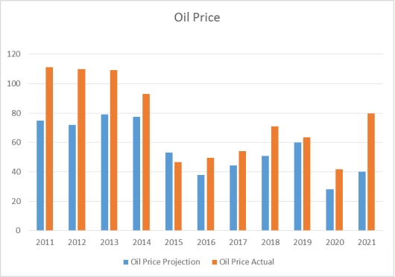
Figure 5.1

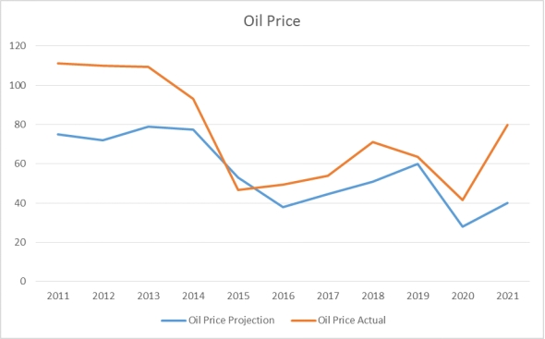
Figure 5.2
Table 5.1 indicated that, there are deviations or variations between the oil price projections and the actual price, and this can be attributed to the intervention scheme to halt downward trend in economic activities by the European Central Bank and the US Federal Reserve which aided investments in commodities and stocks. It can also be traced to the challenges of a slowing world economic growth and the rising supply of oil from both conventional and non-conventional sources as well as the entry of some new regional oil producers to the international market.
Furthermore, it can be seen from figures 5.1 and 5.2, that from 2015-2017 there was a downward trend in the oil prices. This is because of the transition process of handover from one government to another, global economic melt-down or recession, and global insecurity situations such as insurgency and kidnapping. Flooding activities that almost turned the whole country into a riverine area subjecting people to untold hardships is also responsible.
Also, there is a sharp increase in prices both projected and actual between 2018 and 2019 because of economic recovery from recession and the global economic melt-down which has positively affected both prices. Meanwhile, there was a downward slope from 2019 to early 2021 because of the Covid-19 pandemic and climate change that negatively affected economic activities globally.

Table 5.2 OIL PRODUCTION (2011-2021)
Years | 2011 | 2012 | 2013 | 2014 | 2015 | 2016 | 2017 | 2018 | 2019 | 2020 | 2021
Oil Production Projection (mbpd) | 2.3 | 2.48 | 2.52 | 2.39 | 2.28 | 2.22 | 2.2 | 2.3 | 2.3 | 1.8 | 1.86
Oil Prod. Actual (mbpd) | 2.53 | 2.2 | 2.15 | 2.23 | 2.19 | 1.76 | 1.89 | 1.93 | 1.86 | 1.78 | 1.56
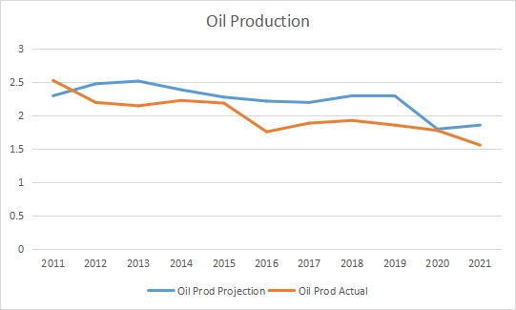
Figure 5.3

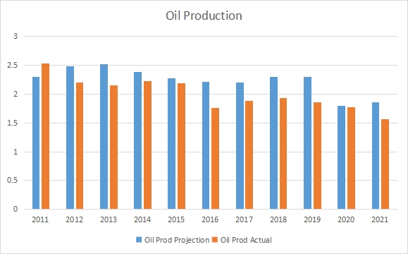
Figure 5.4
Source: Budget Implementation Report

A careful evaluation of table 5.2 as well as figures 5.3 and 5.4 show that, there was a drop in the volume of oil lifted during the period under review compared to what was projected. Reasons for the drop or deviations can be traced to persisting and unrelenting crude oil theft, illegal bunkering and pipeline vandalism experienced in the Niger Delta region. Also, production shut-ins and leakages decrease in demand for oil due to discovery of shale oil in the U.S. and non-commissioning of some oil wells are responsible. Furthermore, the impact of the deteriorating security situation in the country generally, the effects of Covid-19 pandemic which led to passage and approval of additional expenditure known as supplementary budget, the maturity of the fields and the moving away from onshore to deep water are accountable.
There is also a declining capacity to produce from a technical production point of view and a market production point of view because of the Covid-19 pandemic. Technical production is coming out of the wells and fields. This is obviously affected by the number of wells that are put into production and the less producing wells in a field at its peak, less the aggregate field output. Market production on the other hand is what Nigeria can put into the international market and domestic market. Furthermore, war in Ukraine has continued to affect global production, supply and prices of food and energy commodities (Akintunde, 2023).

Table 5.3 EXCHANGE RATE (2011-2021)
YEARS | 2011 | 2012 | 2013 | 2014 | 2015 | 2016 | 2017 | 2018 | 2019 | 2020 | 2021
Projection (Naira to USD1) | 150 | 155 | 160 | 160 | 165 | 197 | 305 | 305 | 305 | 305 | 379
Actual (Naira to USD1) | 153.86 | 157.5 | 157.31 | 158.55 | 193.28 | 253.49 | 365.58 | 362.05 | 361.93 | 382.08 | 409.08

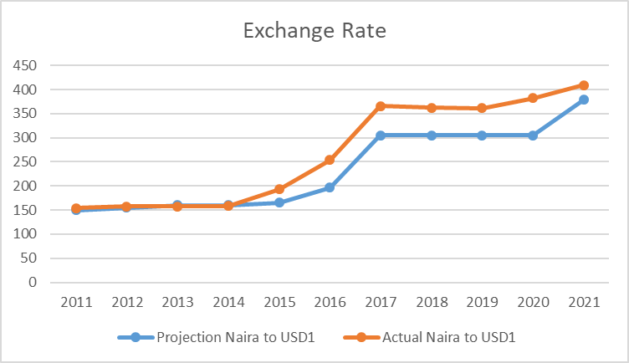
Figure 5.5
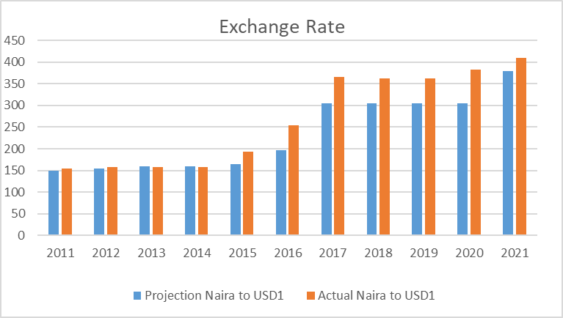
Figure 5.6
Source: Budget Implementation Report

This variable clearly indicated as can be seen in table 5.3 and figures 5.5 and 5.6 that, from the beginning of the period under review, there were uniform rates between the projected and actual till 2015, before it began to experience shocks. This can be attributed to the notable satisfactory growth of patronage at the investors and exporters (I&E) window of foreign exchange. It can as well be traced to increase due to the support of the CBN proactive exchange rate management policies, stability in the market by the implementation of the Bilateral Currency Swap Agreement (BCSA) with China and inflow of Eurobonds in millions of dollars.
The appreciations recorded in the foreign exchange market at the beginning of the period under review could also be attributed to the combined effects of improved supply of foreign exchange by oil companies and enhanced capital inflows from portfolio investors.
The premium between the Wholesale Dutch Auction System (WDAS) and interbank rate narrowed and widened between WDAS and BDCs after 2015 suggesting the need to sustain and further complement existing measures to discourage speculative activities in the foreign exchange market. There was also a slowdown in portfolio and foreign direct investment, thereby resulting in an increased funding of the foreign exchange market by CBN to stabilize the Naira.

Table 5.4 INFLATION RATE (2011-2021)
YEARS | 2011 | 2012 | 2013 | 2014 | 2015 | 2016 | 2017 | 2018 | 2019 | 2020 | 2021
Projection % | 11.80 | 9.50 | 8.00 | 8.00 | 9.10 | 15.68 | 12.90 | 12.40 | 9.98 | 10.81 | 11.95
Actual % | 10.30 | 12.00 | 8.00 | 8.00 | 9.00 | 18.60 | 12.40 | 11.40 | 11.98 | 11.98 | 16.98
Source: Budget Implementation Report

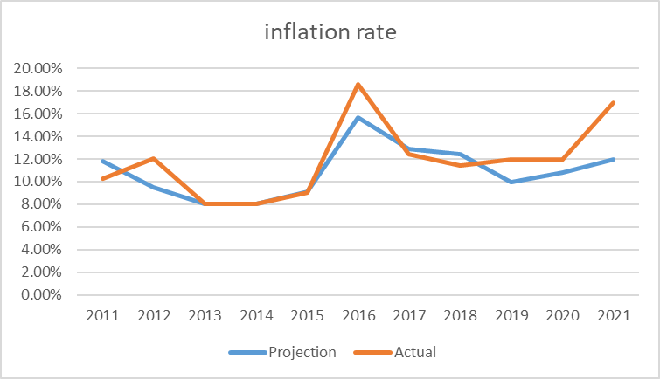
Figure 5.7
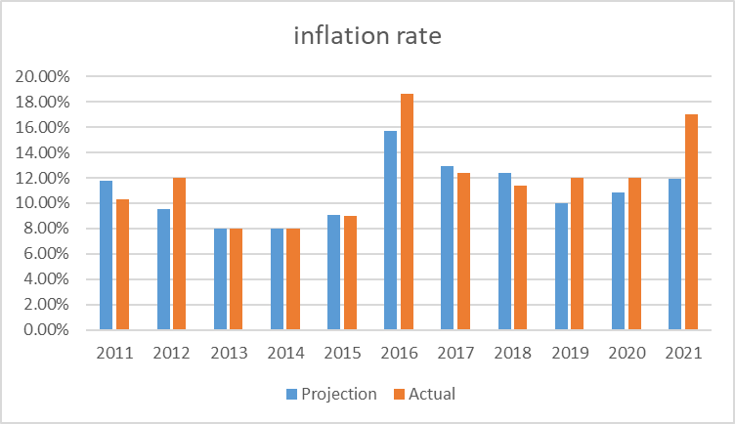
Figure 5.8

High inflation has been the major global macroeconomic risk since the reopening of economies after Covid-19 pandemic lockdown. Russia’s invasion of Ukraine has further stoked inflationary pressure through high energy prices and shortfalls in the supply of grain from the war region. From table 5.4, figures 5.7 and 5.8 above, it shows that the projected inflation figures were consistently lower than the actual in 2012, 2016, 2019, 2020 and 2021and this may be traced to so many factors some of which are effective demands for goods and services without the corresponding supply of those goods and services putting more pressure on the price of the commodities. Another factor to be considered within the period under review is the historic level of climate change around the world. For instance, in Nigeria, flood devastated many farmlands and businesses making the cost of production and the price of finished products very high beyond the reach of the common man.
Additionally, crude oil theft, pipelines vandalism and illegal oil bunkering has contributed heavily to the high rate of inflation in Nigeria. The supply does not match the demands ultimately resulting in uncontrollable high prices. Global insecurity has also caused inflation. For example, agricultural products which are major sources of raw materials for industries are not available because farmers’ security is no longer guaranteed to produce the needed goods. Market failure and scarcity of products and services because of the supply chain disruption during the pandemic also caused inflation.
Nigeria is a long-term net-importer of energy products despite being a major producer of crude oil, combined with high external dependence for food and other basic products and the country is highly susceptible to imported inflation that caused the deviations in macroeconomic variables. Also, wrong macroeconomic policies triggered inflationary pressure in the economy, e g expansionary fiscal and monetary policy that aimed at reasonable economic growth and development triggered inflation.

Table 5.5 GDP GROWTH RATE (2011-2021)
YEARS | 2011 | 2012 | 2013 | 2014 | 2015 | 2016 | 2017 | 2018 | 2019 | 2020 | 2021
Projection % | 7.000 | 7.200 | 0.065 | 6.800 | 5.500 | 4.400 | 2.500 | 3.500 | 3.000 | 3.600 | 0.039
Actual % | 5.300 | 4.200 | 0.055 | 6.200 | 2.800 | -1.600 | 8.000 | 1.900 | 2.200 | -1.800 | 0.036
Source: Budget Implementation Report
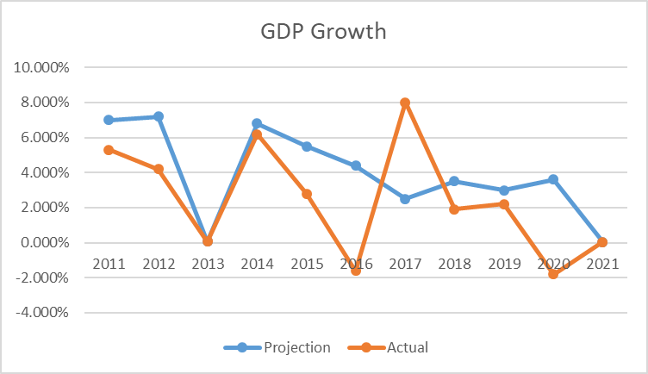
Figure 5.9
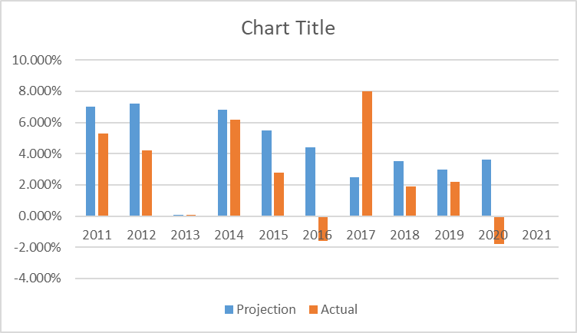
Figure 5.10
According to a World Bank report released in Washington on Tuesday October 4, 2022, Nigeria’s economic growth will slow down in 2023.
The report tagged “Africa’s Pulse” says the growth rate will be down from 3.3% to 3.2%.It blamed the development on inflationary pressures. Based on this World Bank prediction, other than inflationary pressures, there are many other factors militating against the GDP growth in the continent which exposed Nigeria, in particular, to terrible fiscal risks, one of which is insecurity in the North- East. According to Jihad Analytic, Nigeria became the second most terrorized country in the world in 2022, after Iraq and ahead of Syria. In the first half of the year, Nigeria recorded 305 terrorist attacks, compared to 337 in Iraq and 142 in Syria. Terror attacks in Nigeria affect economic production, house-hold income, and social development, therefore causing high level of poverty and low economic growth in the country (Akintunde, 2023).
Akintunde (2023) further noted that the scale of the devastation of flood on farmlands, business premises, properties, infrastructure etc, had necessitated the President Buhari government to send a supplementary appropriation bill of ₦819 billion to the National Assembly for approval in December 2022 to fix the affected areas and forestall food shortage in the country. An IMF publication in September 2022 identified the lack of resilience to climate change as the critical factor underlining food insecurity in sub-Saharan Africa, causing lasting adverse macroeconomic effects, especially on economic growth and poverty and which National Bureau of Statistics (NBS) in 2022 Multidimensional Poverty Index showed that 63% of the Nigerian population (i.e., 133 million Nigerians) are multi-dimensionally poor.
Another factor militating against the GDP growth in Nigeria is unrelenting crude oil theft, illegal bunkering, pipeline vandalism, decrease in demand for oil due to shale oil in U.S. and other alternative sources of energy in the world, shortage in production and leakages, corruption, lack of political will to maintain the existing refineries and the establishment of new ones for optimal productions and distributions. It can also be attributed to trade tension between the United States of America and China causing a decline in business confidence, tightening financial conditions and policies and uncertainty across countries. Also, the GDP growth rate was inhibited by herdsmen attack on farmers, cattle rustling and Covid-19 pandemic.

Table 5.6 AGGREGATE REVENUE (2011-2021)
YEARS | 2011 | 2012 | 2013 | 2014 | 2015 | 2016 | 2017 | 2018 | 2019 | 2020 | 2021
Projected Aggregate Revenue(₦'tn) | 3.3 | 3.6 | 4.1 | 3.7 | 3.5 | 3.9 | 5.08 | 7.2 | 6.1 | 5.4 | 6.6
Actual Aggregate Revenue(₦'tn) | 2.6 | 3.3 | 3.5 | 3.2 | 3.2 | 2.9 | 2.7 | 3.9 | 4.12 | 3.1 | 4.6
Source: Budget Implementation Report

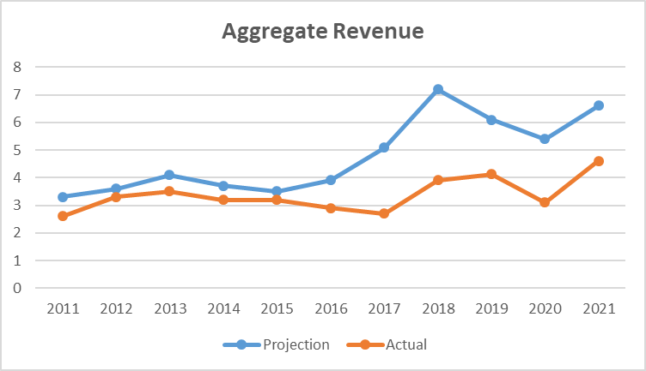
Figure 5.11
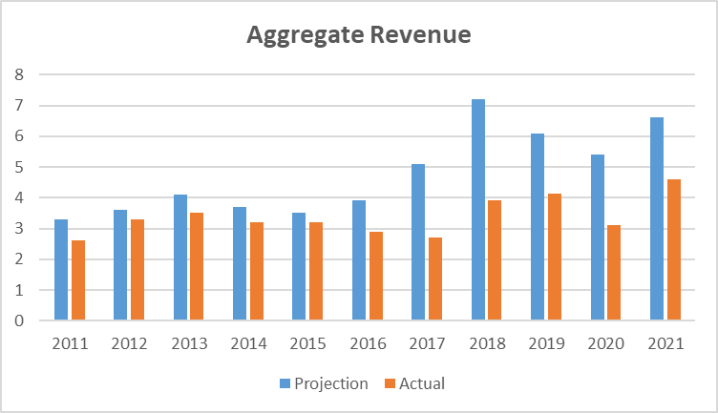
Figure 5.12

From table 5.6 and figures 5.11 and 5.12, the projected revenue estimate is always higher than the actual and the reasons can be seen from both oil and non-oil revenue sources. From the oil source, crude oil theft, pipeline vandalism and illegal oil bunkering, decrease in demand for oil at the international market because of shale oil in U.S., shortage in production and leakages, oil spillage, corruption, have contributed heavily to shortfalls of the oil revenue generation in the country. Insecurity in the oil producing regions and oil facilities being vandalized affected the supply as well as revenue generation. The emergence of Covid-19 that shut down the global economy had negative effects in revenue generation.
Meanwhile, from non-oil sources, there was growth in economic activities, expansion of the country’s tax base, and improvement in the performance of the revenue generating agencies. Most of the revenues were largely driven by agriculture, trade, and transportation even though attacks from herdsmen to farmers and climate change like flooding which devastated farmlands and many businesses had exposed the country to fiscal risks which slowed down revenue generation against projections.

Table 5.7 AGGREGATE EXPENDITURE (2011-2021)
YEARS | 2011 | 2012 | 2013 | 2014 | 2015 | 2016 | 2017 | 2018 | 2019 | 2020 | 2021
Projected Aggregate Expenditure(₦tn) | 7 | 7.2 | 6.5 | 6.8 | 5.5 | 4.4 | 2.5 | 3.5 | 3 | 3.6 | 3.9
Actual Aggregate Expenditure(₦tn) | 5.3 | 4.2 | 5.5 | 6.2 | 2.8 | -1.6 | 0.8 | 1.9 | 2.2 | -1.8 | 3.6
Source: Budget Implementation Report

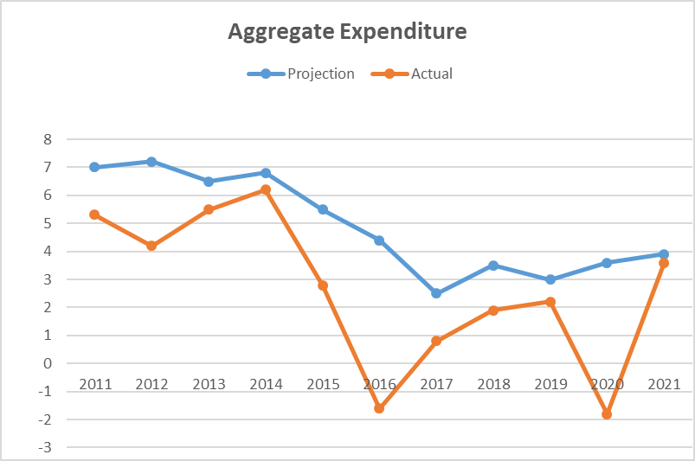
Figure 5.13
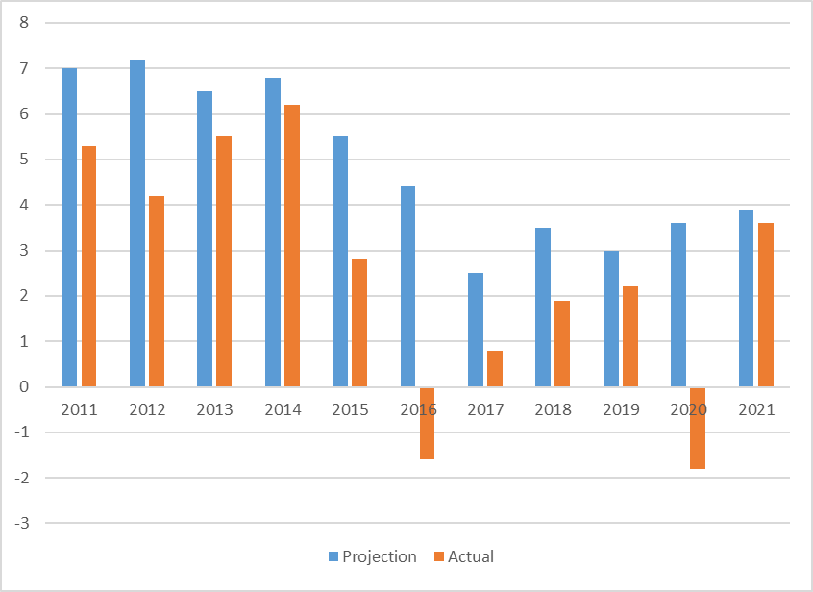
Figure 5.14
Source: Budget Implementation Report

From Table 5.7, there is a consistent deviation from the projected aggregate expenditure which shows that there was poor forecast. That means, there is always a false fiscal space created at the time of budgeting.

  - FISCAL RISK REGISTRY
According to the IMF, a Fiscal Risk Registry (FRR) is a comprehensive summary inventory of fiscal risks that support internal discussions, analysis, and management of fiscal risks. This registry provides a reference for reporting and preparation of the Fiscal Risk Statement where individual risks are identified for each of the risk categories. This document when populated comprehensively, identifies gaps in data and analysis.
Several countries around the world have started preparing Fiscal Risk Registries including Brazil, the United Kingdom, the ASEAN -4 (Indonesia, the Philippines, Malaysia and Thailand) and the State of Odisha in India among others. These countries generally agree on the assessment of certain items as suggested by the IMF including:
- A short description of the risk.
- The likelihood of materialization. Ideally, this would be a probability drawing on historical analysis, but a qualitative assessment is sufficient.
- The severity of the risk materialization. This can be qualitative and used to easily identify the largest and most concerning risks. Color-coding of these cells could also help to quickly assess risks.
- A summary of the current and potential future mitigation measures that are currently in place.
- The sources of information, such as ministry databases.
- More detailed information contained in sub-sheets. For some risks, more detailed information can be included in the registry, though this should not replicate the estimates and calculations undertaken in core tools (like the Financial Oversight Tool).
Based on the above, a Fiscal Risk Registry has been proposed. The document has been customized for Nigeria’s circumstances and is expected to be a dynamic document as seen in the table below.

PROPOSED FISCAL RISK REGISTER FOR NIGERIA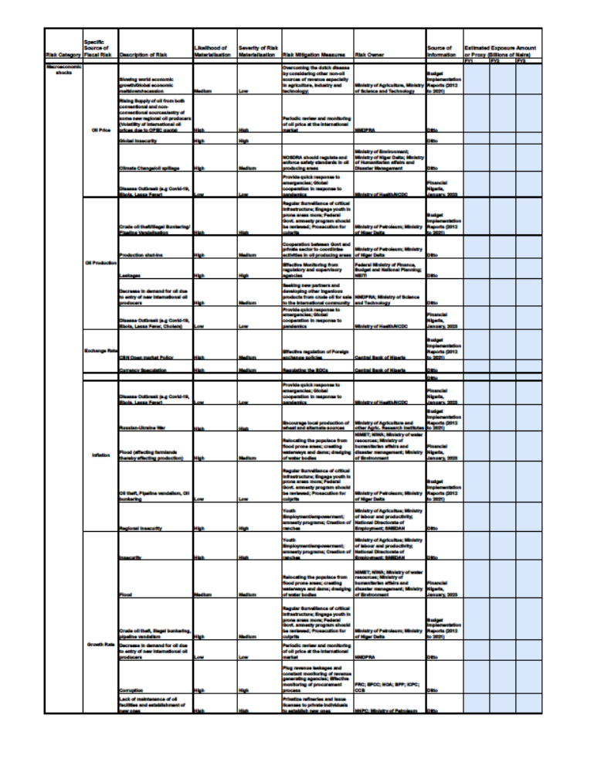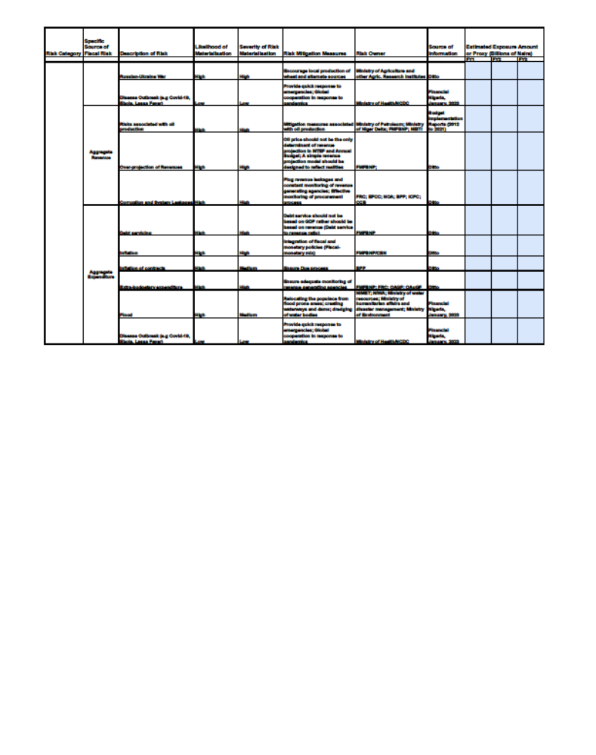5.10RECOMMENDATIONS, LIMITATIONS AND CONCLUSION
5.10.1 Recommendations on possible ways of mitigating Macro-Economic risks in Nigeria.
Oil Price
- Overcome the Dutch disease by considering other non-oil sources of revenue especially in agriculture, industry, and technology.
- Engage in periodic monitoring of oil price at the international market.
- Collaborate with NOSDRA to regulate and enforce safety standards in oil producing areas.
- Ensure that Ministry of Health and NCDC Provide quick response to health emergencies and global cooperation in response to pandemics.
- Resuscitate the Excess Crude Account for the rainy day.

Oil Production
- Ensure regular surveillance (use of drone technology) and adequate security to secure critical infrastructure; engage more youth in prone areas.
- Federal Government amnesty programs should be reviewed and culprits of crude oil theft, illegal bunkering, and pipeline vandalization prosecuted. If Government continues to reward criminality, crime will continue to expand, and the oil and gas industry may soon collapse.
- Collaborate with oil stakeholders to coordinate activities in oil producing areas to address production shut-ins.
- Encourage regulatory and supervisory agencies to engage more in effective monitoring to curb leakages.
- Seek new partners and develop other ingenious products from crude oil for sale to the international community.
- Provide quick response to health emergencies and global cooperation in response to pandemics.

Exchange Rate
- Engage in effective regulation of foreign exchange policies.
- Better regulate the activities of Bureaus de change (BDCs).

Inflation
- Provide quick response to emergencies and global cooperation in response to pandemics.
- Encourage local production of wheat (which is majorly obtained from Ukraine) and discover alternate sources.
- Recommend the relocation of the populace from flood prone areas, creating waterways, dams and dredging of water bodies.
- Engage in regular surveillance of critical infrastructure; engage more youth in prone areas to secure infrastructure.
- Federal Government amnesty program should be reviewed and culprits of crude-oil theft, prosecuted.
- Create youth employment/empowerment opportunities, amnesty programs and creation of ranches.
- Government should make adequate provisions for forest guides and preservation to prevent incessant move in and out of miscreants such as Boko Haram, kidnapping and bandits that turn forests into a habitat for illegal business.

GDP Growth rate
- Create youth employment/empowerment opportunities; amnesty programs; creation of ranches.
- Recommend the relocation of the populace from flood prone areas, creating waterways and dams and dredging of water bodies.
- Engage in regular surveillance of critical infrastructure; engage more youth in prone areas to secure infrastructure; Federal Government amnesty program should be reviewed, and culprits of crude-oil theft prosecuted.
- Engage in constant monitoring of oil price at the international market.
- Plug revenue leakages and constantly monitor revenue generating agencies, effective monitoring of procurement processes.
- Privatize refineries and issue licenses to private individuals to establish new ones.
- Encourage local production of wheat (majorly sourced from Ukraine) and find alternate sources.
- Provide quick response to health emergencies and global cooperation in response to pandemics.

Aggregate Revenue
- Engage mitigation measures associated with oil production.
- Ensure that oil price is not the only determinant of revenue projections in MTEF and Annual Budget preparation; A simple revenue projection model should be designed to reflect current realities.
- Plug revenue leakages, constantly monitor revenue generating agencies, and effectively monitor the procurement process.

Aggregate Expenditure
- Ensure that debt service is not based on GDP. Debt-GDP ratio should rather be Debt-Revenue ratio in order to properly reflect or define the position of public debt in the country.
- Integrate fiscal and monetary policies (Fiscal-monetary mix)
- Ensure Due process.
- Ensure adequate monitoring of revenue generating agencies.
- Relocate the populace from flood prone areas; create waterways, dams and dredging of water bodies.
- Provide quick response to health emergencies and global cooperation in response to pandemics.

5.10.2 Recommendations on preparation of Macro-Fiscal Forecast Scenarios as well as Revenue and Expenditure Projections
Pursuant to the study conducted, it is proposed that:
- The Federal Ministry of Finance, Budget and National Planning, hereafter referred to as the Ministry should ensure the use of accurate and reliable data (information) in preparing the Annual Budget to avoid over-projection.
- The Ministry should employ economic and financial experts in planning the budgetary process and forecasting budget/economic parameters with minimal errors.
- All relevant bodies, agencies and Civil Society Organizations should be involved in budget preparation and implementation process to ensure effective and efficient monitoring of projects and to avoid budget padding and inflation of contract values.
- The Ministry should collaborate with Projects’ Stakeholders for speedy and timely execution of projects without protracted delay so that budgetary allocations and provisions can translate into concrete development in all sectors of the economy.
- The Ministry should assess whether sufficient fiscal headroom exists to accommodate those risks that cannot be insured or mitigated. Some risks may be too large to make provision for, too costly to mitigate or simply not known to a sufficient degree of precision.
- The Ministry should consider risks in setting long-term targets for government debt or net worth or at least ensure there is sufficient safe margin relative to debt ceiling defined in fiscal rules.
- The Ministry should employ a comprehensive analysis and management of Fiscal risks that can ensure sound and solid fiscal public finances and macroeconomic stability both in the short-run and to promote economic growth over the longer-term. It also allows policy makers to take fiscal risks into account when formulating fiscal targets.
- Oil price alone should not be used as a determinant for aggregate revenue; rather, a simple revenue model should be designed to include both oil revenue and non-oil revenue in determining the revenue projections in both the MTEF and National budget.
- The Ministry should collaborate with FIRS to expand the tax net to include those that are not currently paying taxes but are making taxable profits.
- As advised by the IMF, for the purpose of debt limit policy, in order not to expose the public to Fiscal risks, public sector debt coverage should be broad such that it should normally cover public and publicly guaranteed debt and also would typically refer to debt of the non-financial public sector.
- The GDP is a weak measure of debt burden, although it measures the size of the economy, but it does not translate into a capacity to pay debt. Unlike government revenue, which is available to service debt, it is also important to note that too much emphasis on GDP could lead to costly borrowing decisions given that it is one indicator that is susceptible to creative accounting. GDP does not translate to standard of living; therefore, it cannot be used as a determinant of economic growth and development, rather, per capita income.
- The Ministry should collaborate with Fiscal Responsibility Commission to compel those MDAs who are not remitting what is due to the government to begin doing same to boost Independent Revenue.
- The Ministry should ensure that computation of Operating Surplus/IGR is strictly based on FRC’s robust Operating Surplus Template in order to ensure that GOEs operate in a more fiscally responsible manner.
- The Ministry should support the amendment of relevant Fiscal laws such as the FRA, 2007 in order to strengthen the budgetary process.
- Government should consider investing in new industries including renewable energy and create resilient economies because of the opportunities that come with climate risks.
- Addressing climate vulnerabilities can provide a new outlook for fighting poverty through investments in adaptation programs.
- There is a need for inter-agency collaboration and synergy to fight and tackle corruption particularly in the oil and gas sector where most of Nigeria’s revenue is currently generated.

5.10.3 Limitations to Establishing and Maintaining an Effective Fiscal Risk Registry
The Fiscal Risk Register in Nigeria will be a useful tool by the government to identify and manage fiscal risks that may impact the country's economy. However, there are a range of factors that may affect its effectiveness. These include data availability, transparency, capacity, political interference, implementation, and coverage.
1. Limited data availability: The fiscal risk register relies on the availability of accurate and reliable data to identify and assess fiscal risks. However, in Nigeria, data availability is often limited, particularly in areas such as public debt, contingent liabilities, and fiscal risks arising from the oil sector.
2. Lack of transparency: The information contained in the fiscal risk register if not made available to the public, can limit transparency and accountability. This can undermine public trust and confidence in the government's management of fiscal risks.
3. Inadequate capacity: The effective management of fiscal risks requires technical expertise and a robust institutional framework. In Nigeria, there may be limited capacity in some areas, such as risk assessment and management, which can affect the effectiveness of the fiscal risk register.
4. Political interference: Political interference can undermine the effectiveness of the fiscal risk register by influencing the identification and management of fiscal risks.
5. Limited implementation: Even when fiscal risks are identified and assessed, there may be limited implementation of risk mitigation measures due to funding constraints, competing priorities, or other factors.
6. Inadequate coverage: The fiscal risk register may not cover all potential fiscal risks, particularly those that are difficult to quantify or assess, such as political risks or environmental risks.

5.10.4 Conclusion
The International Monetary Fund’s (IMF) Fiscal Risk Toolkit has helped policymakers around the world to identify, monitor, analyse, manage and disclose fiscal risks. The understanding of fiscal risks, transparent reporting and effective risk management is a premise for fiscal credibility and the sustainability of public finances. The IMF’s Fiscal Risk Toolkit comprises the tools meant to provide a practical basis to help countries and they are regularly updated as revisions are made.
Meanwhile, to mitigate these risks, a comprehensive analysis and management of risks can help to ensure sound fiscal public finances and macroeconomic stability. However, it is also critical to allow fiscal policy to assist in stabilizing economic activity in the short-run and to promote economic growth over the longer term. This will help policy makers to take fiscal risk into account when formulating fiscal targets and projections to maximize a sustainable level of national income, economic growth to raise standard of living of citizens in the system and relative price stability.

6.0 GENERAL OBSERVATIONS, RECOMMENDATIONS AND CONCLUSION
6.1GENERAL OBSERVATIONS
“Public revenues are government incomes that are recurring by nature and available to meet the day-to-day expenses of government. They includetaxes, privatization proceeds, sale proceeds of goods, interest received, commission received, rent received etc. Public revenue is an important tool of fiscal policy and is the opposite of government spending. It is in form of taxes and non-tax revenue or oil and non-oil revenue” (CBN 2017).
Accurate and efficient macroeconomic and fiscal forecasting is the panacea for rapid and sustainable economic growth. Consequently, the gap between the projected macroeconomic parameters and the underlying assumptions, and the outturns determines the state of the economy per time. Where, for example, the projected revenue is unrealistic, either because of lack of capacity or due to some risks, the objectives and targets of the budget cannot be achieved. Similarly, where during the implementation of the budget, strict adherence to the appropriations is not observed, the objectives of the budget may not be achieved.
During this exercise, the followings were observed:
- There was consistent shortfall and deviation from the projected revenues in most of the revenue items in the budgets within the period under review.
- There was general underperformance of revenue items in most of the fiscal years within the period.
- The Public Debt Profile shows moderate risk and is susceptible to some shocks such as Market Perception, Share of Debt held by Non-Resident and Foreign Currency Denominated Debt, which may undermine debt sustainability in the medium-term.
- Also, the Debt Profile is exposed to risks associated with the volatility of oil prices, as well as enhanced short-term debt vulnerabilities and cost of debt servicing arising from CBN financing. However, the sustained implementation of economic initiatives and reforms by the Government aimed at stimulating growth and boosting revenue are expected to moderate these shocks and financing pressures in the medium-term. In addition, the re-structuring of the CBN financing through Ways and Means Advances into long term debt should be maintained.
- The deficit financing items performance for all the years under review underperformed based on the projected sum, except for year 2013 where the sum of ₦887.07 billion was projected and ₦1,207.64 billion (136.14%) was realised at the end of the fiscal year.
- The deficit financing items performance for year 2019 and 2020 were 47.83% and 44.84% respectively. These poor performances were attributed to using only one source (Domestic borrowing) out of many items to finance the deficit while other sources of financing items did not materialise.
- With the recent reclassification of Nigeria as a Lower-Middle-Income country which caused limited funding access from concessional borrowing (Multi-lateral and Bi-lateral loans), there was more reliance on market-based financing (Domestic borrowing) with high interest rates and short amortisation period.
- The rate of yearly increment of fiscal deficit is alarming. The evolving structure of debt will drive up interest burdens and expose the country to greater solvency risks amid diminishing fiscal space and increasing debt vulnerabilities.

GENERAL RECOMMENDATIONS
Government should:
- Be more scientific and realistic in its revenue projections to minimize forecast errors with all key stakeholders involved to reduce the disparity between the budget and revenue outturns.
- Engage in effective regulation of foreign exchange policies.
- Plug revenue leakages and constantly monitor revenue generating agencies.
- Effectively monitor procurement processes.
- Diversify revenue sources to shore up revenue to fund the budget.
- Integrate fiscal and monetary policies for optimal outturns.
- Strengthen the implementation of the Strategic Revenue Growth Initiatives to enhance revenues, reduce financing pressures, and expand the fiscal space.
- Rationalize expenditure by focusing on priority spending on growth-enhancing sector of the economy.
- Effectively implement the Petroleum Industry Act (PIA), 2021 which is expected to attract investment in the oil and gas sector.
- Provide sensitivity analysis, alternative scenarios, and probabilistic forecasts of fiscal outcomes in both MTEF and the Annual Budget. This would reduce the probability of risks occurring and enhance the credibility of the forecasts to avoid optimistic bias which would invariably translate to achieving the set targets.
- Mandate Agencies to limit their expenditure within the approved budgets to ensure control of capital and non-capital spending.
- Put more effort in minimizing forecast errors in oil production projection by addressing some factors attributable to the shortfall.
- Monitor the trend in the exchange rate from at least the last two quarters preceding the end of every year to forecast exchange rate that will be feasible and more realistic for a robust economy.
- Do more in achieving single digit inflation.
- Mitigate fiscal risks through a comprehensive analysis and management of risks to ensure sound fiscal public finances and macroeconomic stability.

- Allow fiscal policy to assist in stabilizing economic activity in the short run to promote economic growth over the longer term.

- Take fiscal risk into account when formulating fiscal targets and projections to maximize a sustainable level of national income and economic growth.

CONCLUSION
The aggregate of government’s short-term policies is usually expressed and contained in the annual budget. The annual budget reflects the developmental priorities of government over a short period. Whether the policy priorities and targets set out in the budget may be achieved depends on several factors including but not limited to accurate macroeconomic and fiscal forecasts and their underlying assumptions contained in the budget.
To ensure consistency and continuity of public policies for economic stability, the Fiscal Responsibility Act, 2007 provides for a medium-term expenditure framework as the basis for the preparation and execution of the annual budget. And for purpose of smooth and effective implementation of the provisions of the Act, it established the Fiscal Responsibility Commission to monitor and enforce the provisions of the Act.
It is common knowledge that Budgeting and Financial Forecasting is very important to a nation, and this cannot be over emphasized. The key parameters driving the Medium-Term Revenue and Expenditure Framework reflect Nigeria’s multiple domestic challenges and the fragile recovery of the global economy due to the vintages of the Covid-19 pandemic compounded by the Russian-Ukraine war.
Generally, the period under review has witnessed intense global economic fluctuations owing to several factors resulting in global economic crunch of high impacts. Expectedly, all developing economies, Nigeria inclusive, had their fair share of missing policy targets within the period. However, the impacts differ from country to country due to several peculiar, intrinsic factors including accurate or inaccurate macro-fiscal forecasting. This underscores the importance of conducting a review of the macroeconomic and fiscal forecasts and their associated risks in relation to the achievement of policy targets in Nigeria from 2011 to 2021.
Macroeconomic risks have been the subject of increasing attention over the last two decades. The financial crisis of the 1990s, the extensive use of guarantees by transition economies, the global insecurity and sovereign debt crisis have all shown that even apparently sound budget and debt positions can be subject to large hidden risks from off-budget or off-balance sheet fiscal activities and implicit liabilities (Petrie, 2013). Pressure to reduce budget deficit and debt continue to induce some governments to shift activities of off-budget or off-balance sheet in ways that often increase cost or risk.
Accurate and efficient macroeconomic and fiscal forecasting is the panacea for rapid and sustainable economic growth. Consequently, the gap between the projected macroeconomic parameters and the underlying assumptions, and the outturns determines the state of the economy per time. Where, for example, the projected revenue is unrealistic, either because of lack of capacity or due to some risks, the objectives and targets of the budget cannot be achieved. Similarly, where during the implementation of the budget, strict adherence to the appropriations is not observed, the objectives of the budget may not be achieved.

