FISCAL POLICY MONITORING

(MEDIUM TERM EXPENDITURE FRAMEWORK/FISCAL STRATEGY PAPER, BUDGET REVIEW AND ANALYSIS -2011-2021)

WITH FOCUS ON
REVENUE AND EXPENDITURE

1.0 ANALYSIS OF REVENUE FORECAST
1.1 FGN REVENUE INFLOWS
A review of Federal Government Revenue inflows to fund the National Budget was undertaken. The objective of this review was to gain insight into the pattern created by the deviations from budgeted revenue. Actual revenues against budgeted revenues contained in the Budget Implementation Report were analysed. The analysis revealed a pattern of actual revenue forecasts having a minimal negative deviation from budgeted revenue from year 2011 to 2015. The gap between Actual revenue and Budgeted revenue increased between 2016 and 2021 as highlighted in the table 1.1 below.
Table1.1 COMPARATIVE ANALYSIS OF BUDGET AND ACTUAL REVENUE, 2011 - 2021
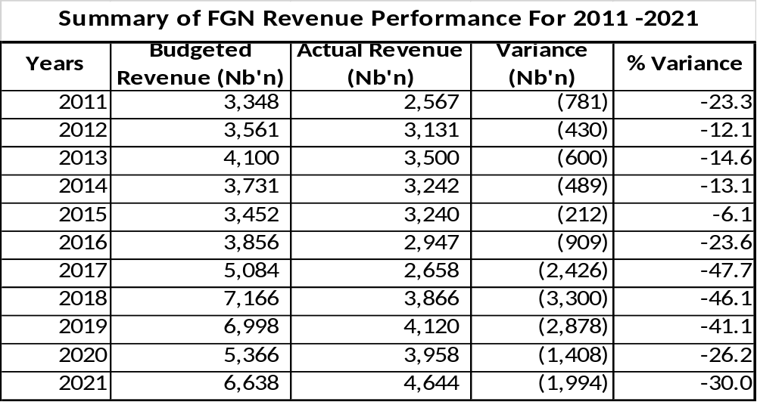
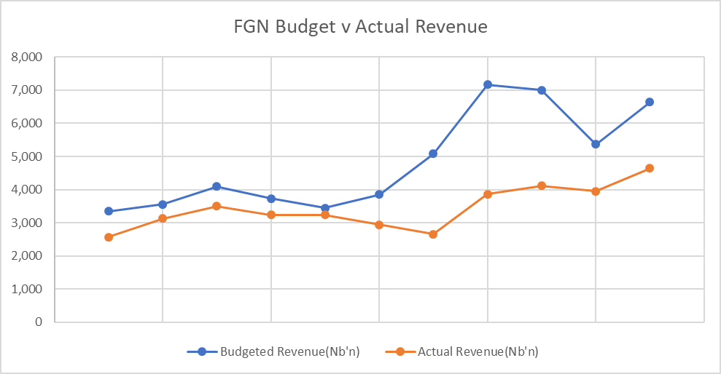
Figure 1.1
Source: FGN Budget Inflows, BIR (2011-2021)

The table 1.1 above shows the FGN Budgeted inflows varied by 23% in 2011 with 12%, 15% and 13% in years 2012, 2013 and 2014 respectively. The variance had its minimum value in 2015 at 6%. Variance increased in 2016 to 24%, and to an all-time high of 48% in 2017, before easing off to 26% in 2020. It later rose slightly to 30% in year 2021.

1.2 ANALYSIS OF ACTUAL REVENUE OUTTURNS AGAINST BUDGETS
Revenue budget outturns measures deviations of budgeted revenue against actual as a percentage of GDP. From the general review of the budget performance, an analysis of the reason for the budget outturns was conducted using the figures contained in the BIR for the period. Table 1.2 and figure 1.2 show the revenue Outturns for 2011 to 2021 Budget.

Table1.2 REVENUE OUTTURNS 2011 – 2021 BUDGET
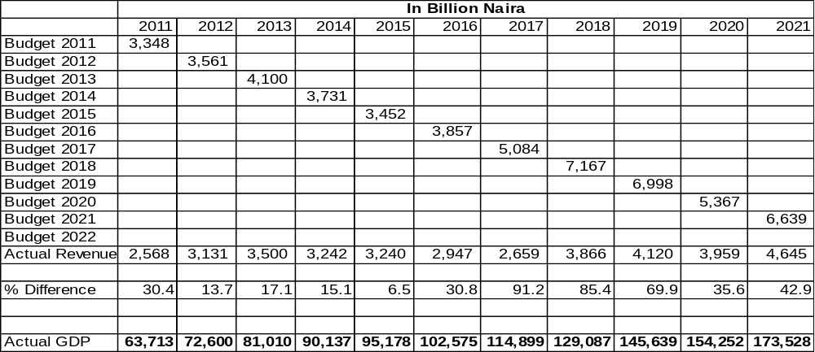
Source: Budget Implementation Report

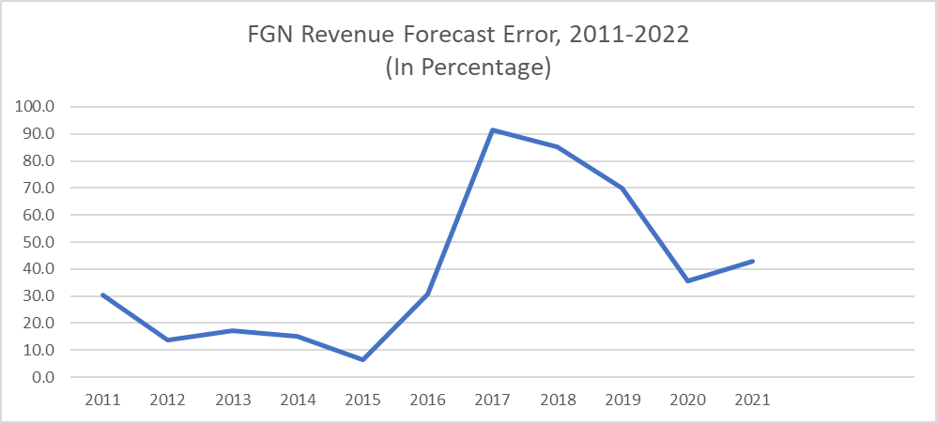
Figure 1.2

Table1.3 REVENUE FORECAST AND OUTTURN, BUDGET 2011-2021
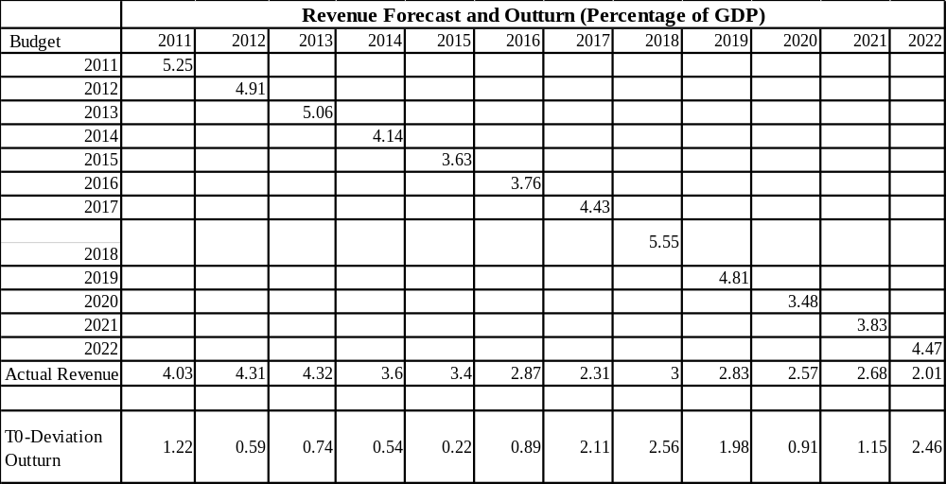

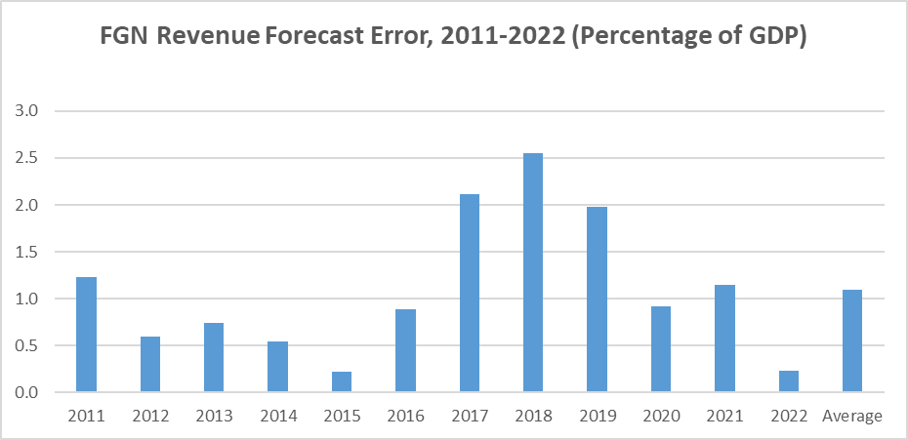
Figure 1.3

1.3 ANALYSIS OF FACTORS RESPONSIBLE FOR BUDGET DEVIATIONS (OIL REVENUE)
- Over-estimated Oil Production benchmark: Oil revenue accounts for a substantial portion of FGN revenue budget projections. Oil production, which is measured at million barrels per day (mbpd) is dependent on a quota system determined by OPEC and other market forces. Projected oil production from actual production has been largely attributed to supply disruptions by oil theft in the Niger Delta. Taking a closer look at oil production from 2011 to 2022 a pattern of production over-estimation can be seen.

Table1.4 OIL PRODUCTION (PROJECTION VS ACTUAL)
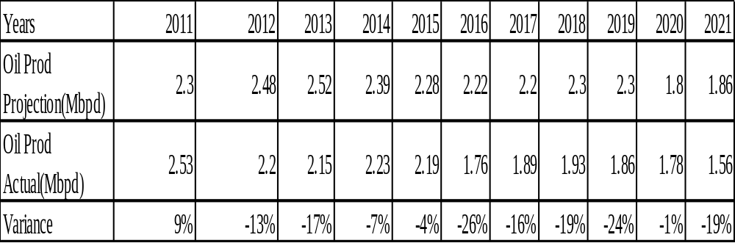
Source: FGN BIR 2011-2021

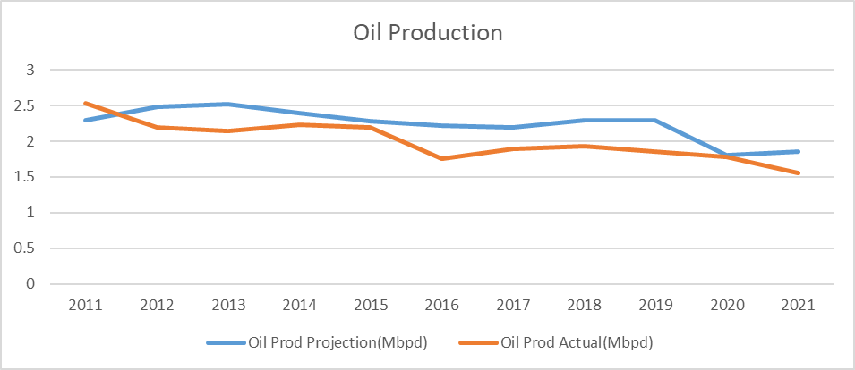
Figure 1.4
Actual Oil production has been below projection from 2012 at -13% with its lowest in 2016 at -26% and 2019 at -24%. In 2020 the gap eased to -1% largely due to global economic slowdown occasioned by the Covid-19 pandemic. This factor contributed to the widening budget outturns from 2016 to 2020.
- Volatile Oil Price: Like oil production, oil price is a determining factor in FGN budget. Since oil price is determined by the global oil market and world events, it is subject to volatility which in turn affects FGN revenue projections. From the standpoint of actual oil price to projected oil price, the figure below presents a positive outlook for oil prices. This is because of FGN budgeting policy of pegging oil price based on world market outlook below OPEC global prices when preparing the budget and saving any positive difference in Excess Crude Account. The table and figure below show a positive estimation of prices. However, in 2015, actual price fell below projected price by 14% and in 2019 it only increased by 6%. That was before the economic slowdown occasioned by Covid-19.

Table 1.4 PROJECTIONS AND ACTION OIL PRICE, 2011 - 2021
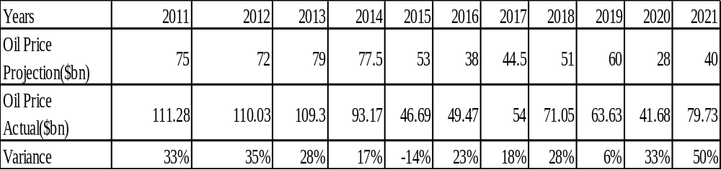
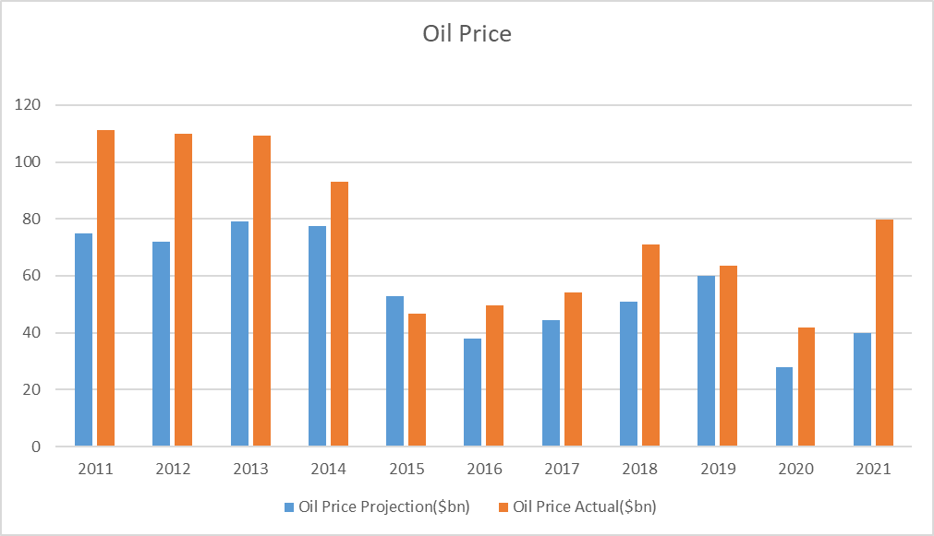
Figure 1.5 Oil Price 2011 - 2021

3 Global Exchange Rate: Any fluctuation in the value of US Dollar will invariably affect revenue derivable from crude oil of countries and Nigeria is not an exception.
4. Environmental issues: Oil exploration which comes with its attendant environmental issues such as oil spillage, waste disposal, air pollution, etc. this incurs expenditures that drain revenue available to government.
5. Security threats and Pipeline Vandalism: Security threats and pipeline vandalism lead to stoppage/reduction in oil production which in turn affects the ability of the government to meet its revenue target.

Table1.5 ANALYSIS OF FACTORS RESPONSIBLE FOR BUDGET DEVIATIONS (NON-OIL REVENUE)
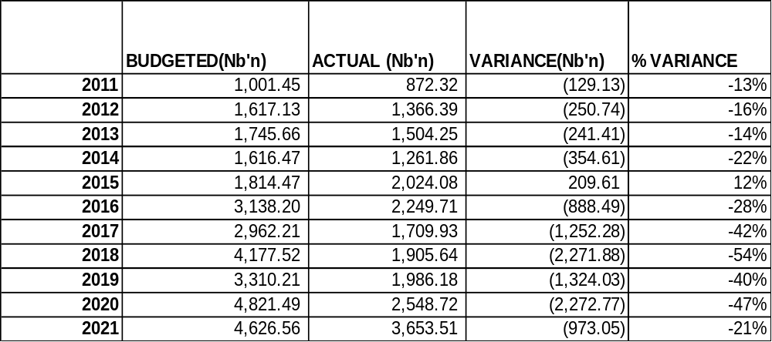

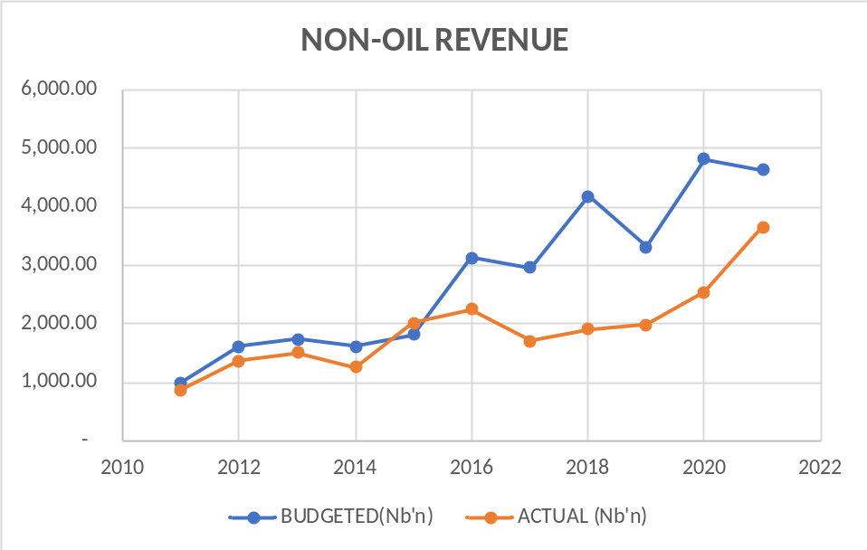
Figure 1.5 Non-Oil Revenue 2011 - 2021

Table 1.6 BUDGET AND ACTUAL REVENUE TARGET FOR GOEs
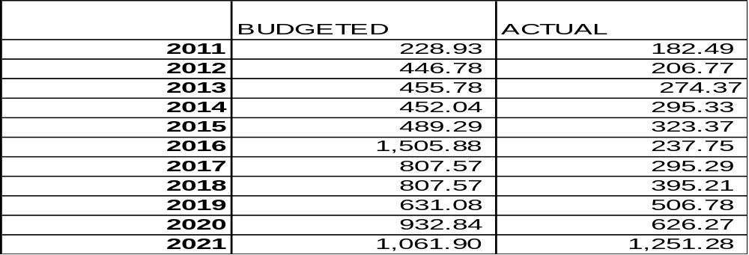
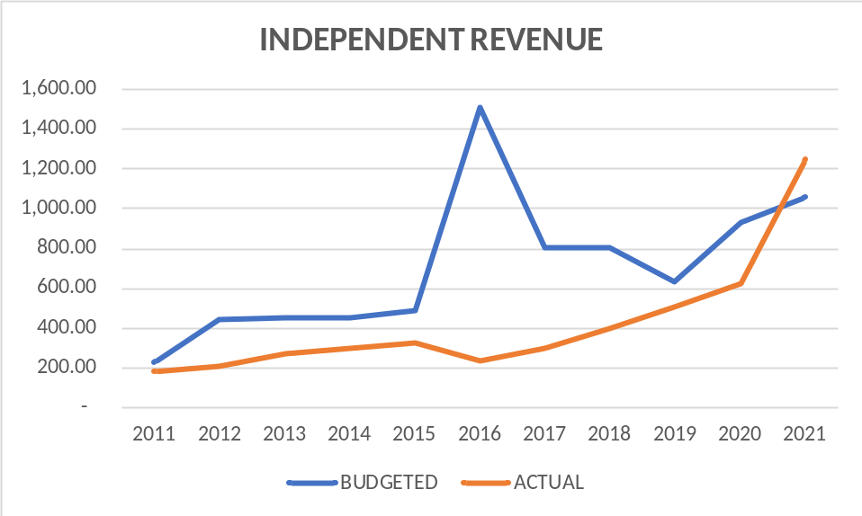
Figure 1.6 Budget and Actual Independent Revenue for GOE’s

- Unrealistic Internally Generated Revenue Target placed on government agencies including GOEs

- Revenue leakages- There are lack of proper internal control in the revenue generation/ collection processes of government revenue, which include revenues from taxes, excise duties, etc. It can be observed that, it’s only in year 2021 that revenue from Tax did relevantly better than the budgeted.

- Concessions/PPP: Despite several signed concession agreements with the private sector especially in the Transportation Sector and the appreciable revenue expected from these PPP agreements, regrettably the Government has not been able to determine the exact income accruing to it from such contracts. About 51 known concessions worth over N3.2 trillion generated estimated revenue of over N124.27 billion only. This is a far cry from what is being generated from PPP contracts.
Despite the creation of Special Concession Account (SCAs) - separate and distinct from the CRF- to warehouse all anticipated revenue accruing from PPP contracts, most MDAs failed to remit the Federal Government share to the account.
Table 1.7 SPECIAL ACCOUNTS/LEVIES
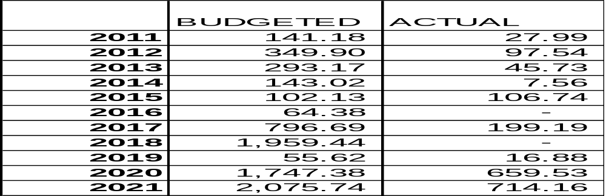
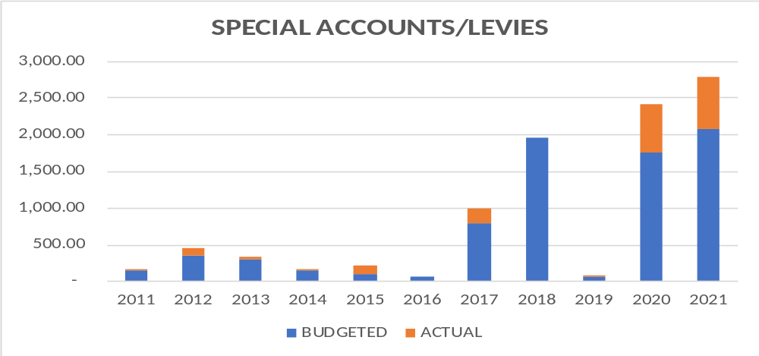
Figure 1.7 Budget and Actual, Special Levies 2011 – 2011

- Reliance on Contingent Revenue- For government to be budgeting with revenue from contingencies, such as revenue from whistle blower policy, privatization proceeds, etc. there is a big draw back on its ability to meet its target. Revenues from such sources should be brought into the budget only when it has been realised.

Table 1.8 OTHER FINANCING REVENUE
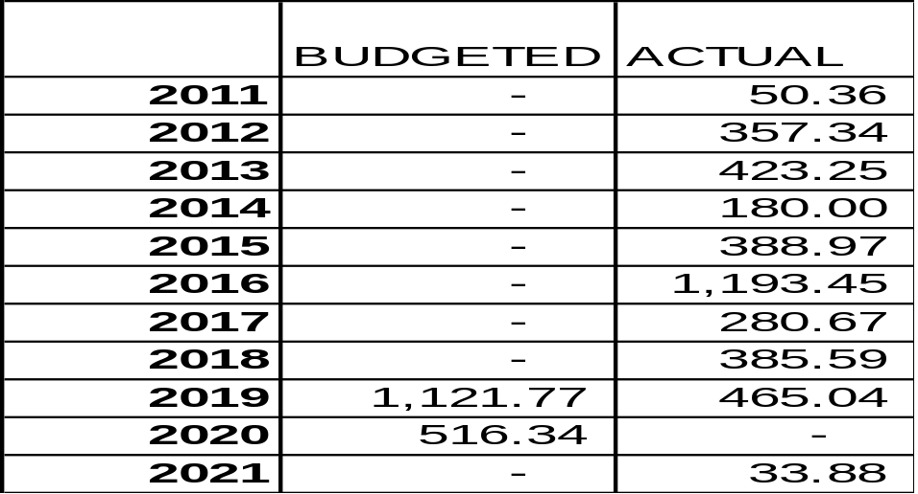

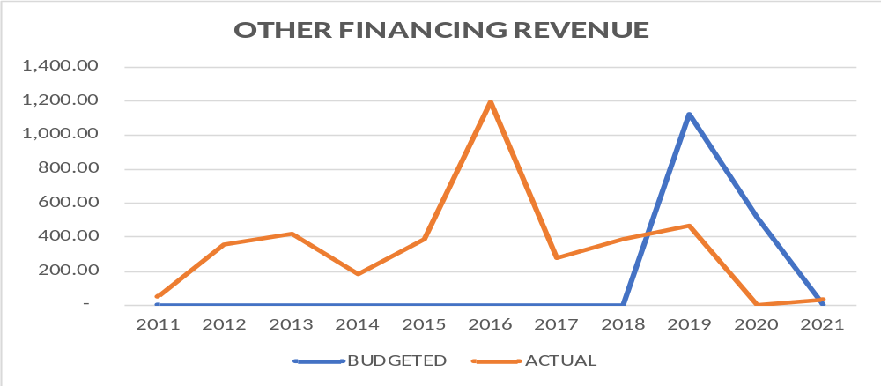
Figure 1.8

- Lack of proper exploitation of the solid minerals sector of the Economy. Solid mineral exploration has been left in the hands of unprofessional practitioners thereby making harnessing revenue from it difficult.

1.4 RECOMMENDATIONS
- FGN revenue budget should be based on realisable forecast. The FGN should develop a more reliable revenue forecast model with all key stakeholders involved to reduce revenue outturns.
- FMBNP should ensure that revenue forecast from special accounts, independent revenue and other financing sources are realistic. These budget financing options should be properly assessed before including them in the FGN budget.
- Expand Tax base: FGN should expand the tax base to bring in more revenue to fund the budget. The country’s tax to GDP ratio is still very low compared to countries in sub-Saharan region.
- FGN should invest in the security of the nation’s critical oil assets like pipelines to reduce cases of illegal oil theft which adversely affect the FGN revenue. Also there should be punishment for oil theft to serve as a deterrent to other potential oil thieves.
- The government should amend the Fiscal Responsibility Act 2007 to allow for sanctions where there are infractions to the law, especially for agencies of government that generate independent revenue.
- Expand the Tax Net- this will put government in a very good position towards meeting its revenue target. Taxes on unoccupied buildings, luxurious lifestyle, etc. should be seriously considered.
- The government should step up efforts in diversifying its revenue sources through the exploration of other sectors of the economy such as the solid minerals, agriculture, telecommunications, and digital economy, among others.

2.0` ANALYSIS OF EXPENDITURE FORECAST
2.1 INTRODUCTION
It is common knowledge that Budgeting and Financial Forecasting is very important to a nation, and this cannot be over emphasized.
“The term budget refers to an estimation of revenue and expense over a specified future period of time and is usually compiled and re-evaluated on a periodic basis” (Investopedia). It is the act/process of keeping track of how much you earn and spend, and you will have greater control over your finances. So, any entity or government that earns and spends money, and at the same time wants to have control over its finances, must engage in budgeting.
Every year, the Federal Government of Nigeria through the Honourable Minister of Finance, Budget, and National Planning makes a public presentation of its Approved Budget pursuant to the provisions of FRA, 2007; the Fiscal Responsibility Commission has a duty to compile and re-evaluate these budgets, most importantly, to test for accuracy of Macro-Fiscal Forecasts.
This segment of the exercise therefore focuses on the Expenditure aspect of the Budgets. That is, the Expenditure Forecasting Analysis of accuracy of expenditure forecasts within the period under review.

2.2 2023-2025 MEDIUM TERM EXPENDITURE FRAMEWORK AND FISCAL STRATEGY PAPER (MTEF/FSP)
2.2.1 Introduction
The FRA, 2007 established the FRC to among other things monitor and enforce the provisions of the FRA, 2007 and by so doing, promote the economic objectives contained in Section 16 of the constitution of the Federal Republic of Nigeria. Section 11(1a) of the FRA, 2007 provides that, not more than four months before the commencement of the next financial year, the Federal Government after consultation with the states shall, cause to be prepared a Medium Term Expenditure Framework and Strategy Paper (MTEF/FSP) for the 3 financial years in effect, the 2022-2024 MTEF/FSP is to precede the proposed 2023-2025 MTEF/FSP already approved by the National Assembly.
Successive MTEF/FSP in Nigeria serve as the Pre- budget statement. It is prepared as a multi-year planning tool to communicate the development aspirations of government. It is also a measurable framework for translating plan to public goods and services, and forms the basis of the annual budget, which sets out the resource requirements for implementing government’s programs and projects, while maintaining fiscal discipline in resource allocation, and ensuring macro-economic stability. This practice has been consistently followed since 2007, underscoring a strong nexus between development planning and budgeting.
The 2023-2025 MTEF/FSP is designed to accentuate the implementation of National Development Plan 2021-2025 (NDP 2021-2025). As envisioned in the NDP 2021-2025, the 2023-2025 MTEF/FSP is framed to implement policies and programs aimed at unlocking the potential in all sectors of the economy for a sustainable holistic and inclusive national development. The key objectives include achieving economic diversification, increased investment in infrastructure, improved security and good governance, investment in education and health and social investment to alleviate poverty.
The MTEF/FSP has improved efficiency in public financial management (PFM) in Nigeria. The 3-year rolling structure acts as an embedded mechanism to update the projections and reduce divergence between plan/forecasts and outturns.

2.2.2 Medium- Term Macroeconomic Framework: Parameters and Targets for 2023-2025
Macroeconomics projections
The key parameters driving the Medium-Term Revenue and Expenditure Framework reflect Nigeria’s multiple domestic challenges and the fragile recovery of the global economy due to the vintages of the Covid-19 pandemic compounded by the Russian-Ukraine war.

Table 2.1. MACROECONOMIC PROJECTIONS 2023-2025
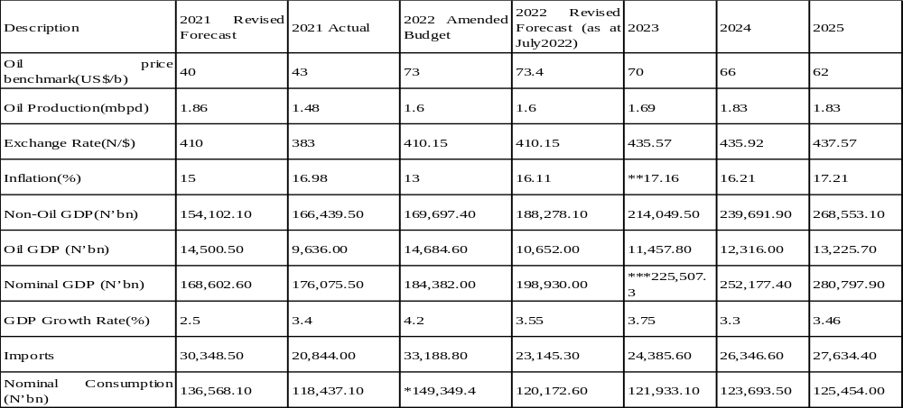Source: Ministry of Finance, Budget Planning; BOF, NBS.
Note: The initial projection is not likely to be achieved based on current trends.

2.2 THE 2023 FEDERAL GOVERNMENT BUDGET
The 2023 Budget termed ‘’Budget of Fiscal Consolidation and Transition’’ set out below the assumptions and highlights of the 2023 budget, as signed by the President.

Table 2.2 2023 FGN BUDGET PARAMETERS
Benchmark | $ 75
Oil production | 1.69mbpd
Inflation rate | 17.16%
Exchange rate | ₦ 435.57/$
GDP growth | 3.75%
Statutory Transfer | ₦ 967,486,010,536
Debt Service | ₦ 6,557,597,611,797
Recurrent Expenditure | ₦ 8,329,370,195,637
Capital Expenditure | ₦ 5,972,734,929,421
Total Revenue | ₦ 10.49 trillion
Total Expenditure | ₦ 21. 83 trillion
Fiscal Deficit | ₦ 11.34 trillion
Source: HMFBNP 2023 Approved Budget Presentation final
Note: Total Revenue; includes the gross revenues of 63 GOEs totalling ₦3.87 trillion

Table 2.3 COMPARATIVE ANALYSIS OF 2022 AND 2023 BUDGET ESTIMATES

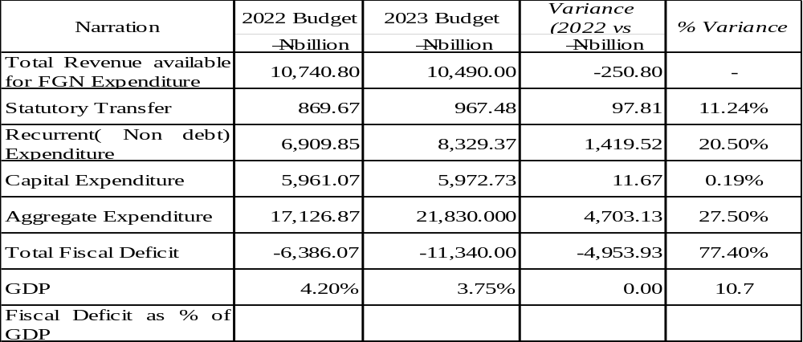
Source: HMFBNP 2023 Approved Budget Presentation final
2.3 COMPARATIVE ANALYSIS OF 2022 AND 2023 BUDGET ESTIMATES

- Oil Benchmark is USD 75.00 per barrel in the 2023 budget, as against USD 62.00 per barrel in the 2022 budget. This is an increase of USD 13.00.
- Crude oil production volume estimated at 1.69mpbd is achievable. This is because Nigeria’s total production capacity is 2.5mpbd and no major disruption to crude oil production (such as pipe vandalism) is envisaged in 2023.
- The Projected inflation rate of 17.16% for 2023 is possible, considering the current effort of the Government in tackling insecurity in the country. Improvement in the security situation will boost food production and lead to reduction in food prices.
- The estimated fiscal deficit for 2023 is ₦11.34 trillion as against ₦6.39 trillion in 2022, translating to increase of ₦4.95 trillion.
- The total revenue of ₦10.49 trillion is projected for 2023 fiscal year. Compared to the budgeted revenue of ₦10.74trillion in 2022 budget, resulting to decrease of ₦0.25 trillion.
- Recurrent (non- debt) expenditure in 2023 is projected at ₦8.33 trillion as against ₦6.91 trillion in the 2022 budget, resulting in an increase of ₦1.42 trillion or 20.5%
- The sum of ₦5.97 trillion is budgeted for capital expenditure in 2023. This amount is ₦11.67 billion or 0.19% higher than ₦5.96 trillion budgeted for the same purpose in 2022.
- Debt service is projected at ₦6.56 trillion in 2023. If weighed against the allocation of ₦3.61 trillion in the 2022 budget, it signposts an increase of ₦2.95 trillion.

The budget estimate as approved and the key assumptions in it show the serious intention of Government to overcome the challenges that led to two recessions the economy was engulfed in recent times. The 2023 Budget is expected to further accelerate the recovery of the country’s economy and facilitate the completion of critical projects as well as improve the general standard of living of the citizens.
Generally, the 2023 approved budget estimate is rather a pro poor one. This is because the allocation of government expenditures is considered a key instrument for government to promote economic growth and reduce poverty in the country.

2.4 FGN EXPENDITURE PERFORMANCE
- Immediate Past Year, 2022
It is worthy of note that the 2022 Aggregate FGN Expenditure dropped by a 5.4% (₦732.75billion) from its projected amount, that is a decrease in actual expenditure incurred.

Table 2.4 2022 EXPENDITURE PERFORMANCE 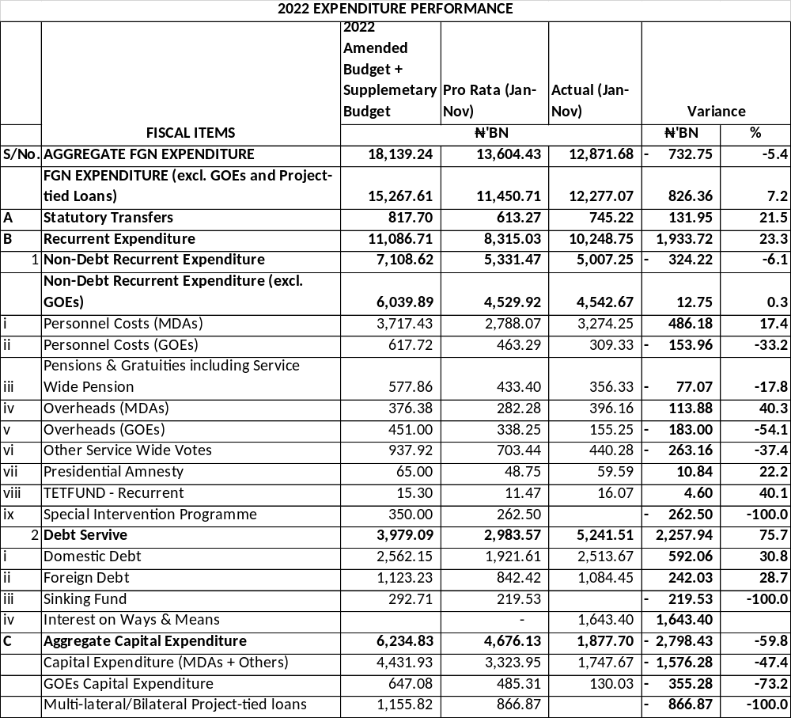
Source: HMFBNP 2023 Approved Budget Presentation final

The aggregate budgeted expenditure for 2022 (inclusive of the supplementary budget of ₦819.5billion) was ₦18.14 trillion, with a pro - rata spending target of ₦16.63 trillion at the end of November.
▪ the actual spending as of November 30 was ₦12.87 trillion. Of this amount,
▪ ₦5.24 trillion was for debt service.
▪ ₦3.94 trillion for Personnel costs, including Pensions.
▪ Statutory Transfers, Overhead and Service Wide Votes expenditures totalled₦1.81 trillion; and
▪ ₦1.88 billion was released for capital expenditure.

Table 2.5 COMPARATIVE ANALYSIS OF 2022 APPROVED EXPENDITURE BUDGET WITH THAT OF 2023
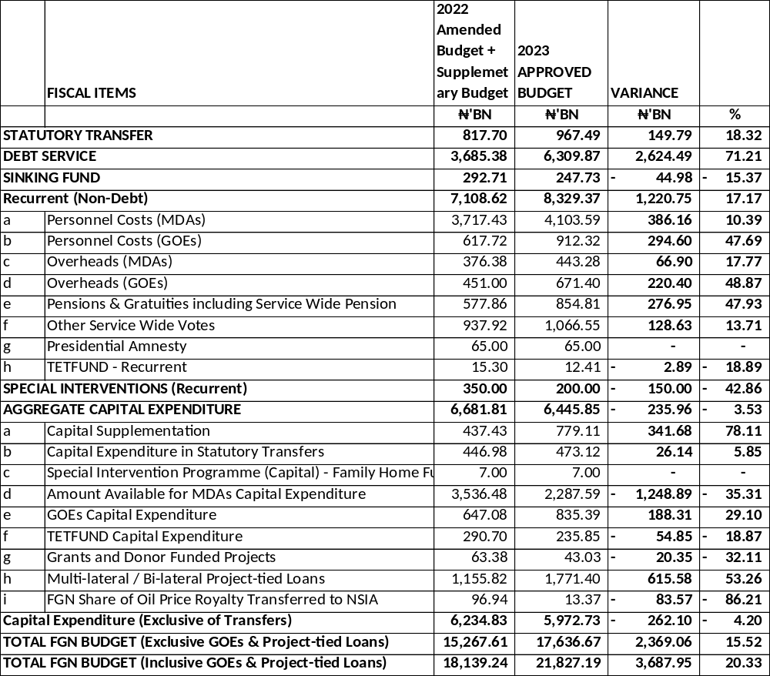
Source: HMFBNP 2023 Approved Budget Presentation final

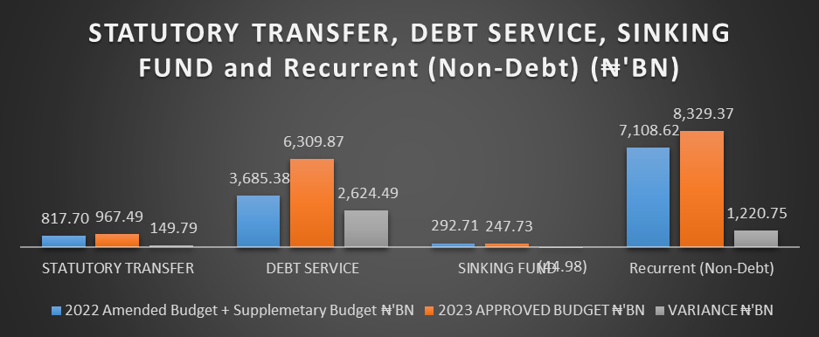

Figure 2.1
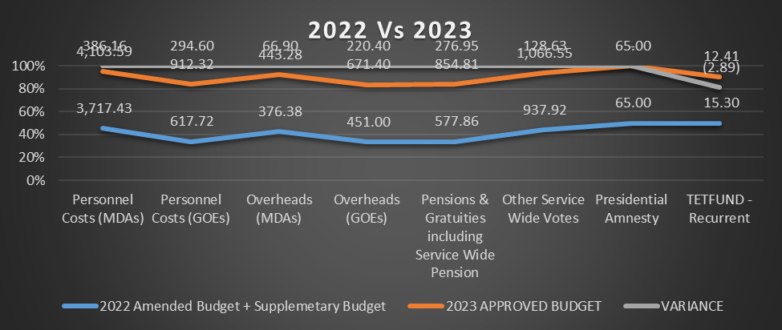
Figure 2.2
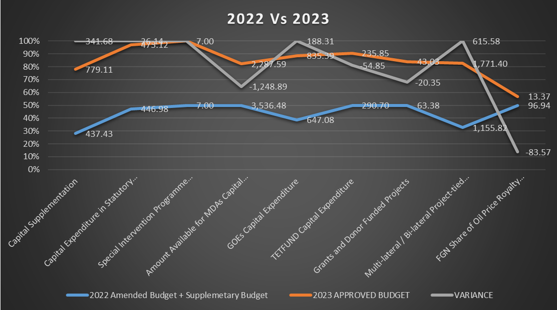
Figure 2.3

- FGN Budgeted Aggregate Expenditure for 2012-2022
In this section, we will be looking at the variance between a year’s budgeted aggregate expenditure with its immediate succeeding year’s. Using the average variance trend, ceteris paribus, to estimate or determine the forecast error for FY 2023.

Table 2.6 COMPARATIVE ANALYSIS OF FGN BUDGET EXPENDITURE 2012 -2022
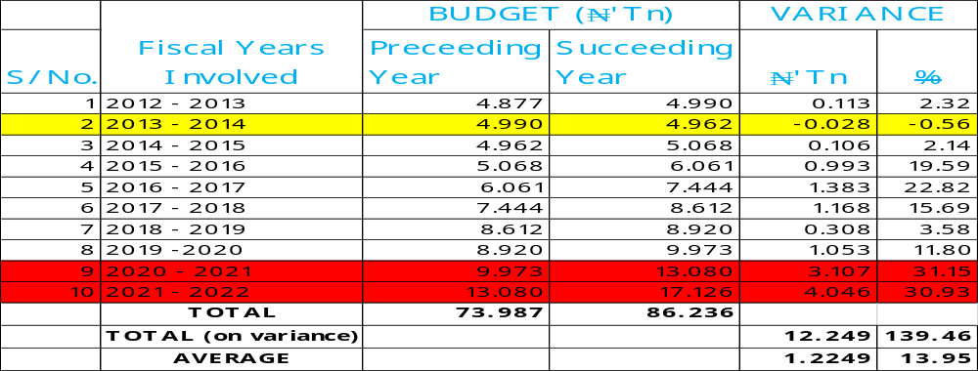
Source: BIR 2012 – 2022

2.5 Observations
From the tables (2.4, 2.5 and 2.6), the following can be deduced:
- In FY2022 as at November ending, the general actual performance on expenditure was 5.4% lesser than the budgeted. According to National Bureau of Statistics, the general price level was 0.32% higher in December 2022 relative to November 2022. Nigeria’s inflation rate eased to 21.34% in December from 21.47% in November 2022; first drop in about 11 months. Focus Economics Consensus Forecast Panellists expect inflation to average 18.5% in 2023, which is from last month’s forecast.
Therefore, it is expected based on the above that the budget for FY2023 should at least be at par with that of FY2022 if not less. Inflation is expected to be lesser and the actual performance for last year 2022 was lesser than budgeted.

- The FGN has budgeted to spend ₦6,445.85bn on aggregate capital expenditure in FY2023 which is 3.53% lesser than the budgeted amount in FY2022.
It is therefore expected that since less is budgeted for capital development, by and large, less should be budgeted on general expenditure. If not, borrowing will be on the high side without plans to invest in areas that will generate adequate return on investment. Just as we can see in table (2.1) where Debt Service performed 75.7% higher than budgeted in FY2022.

- Also, comparing FY 2023 budgeted figure (on Debt Service), it is 71.21% higher than the budgeted figure in FY2022 while Capital Expenditure is reducing.

- From table 2.3, only in FY 2014 was there a decrease in the Approved Budget as against its preceding FY, 2013. Every other year from 2015 had an increased Approved Budgeted figure when compared with its previous. The worst of those periods was 2020 - 2021with the percentage of 31.15% that is, over ₦3.1 trillion increase.
Despite this, considering the ten fiscal years ahead of 2023; there had been an average increase of 13.95% which is slightly above One Trillion Naira.
Following this trend and looking at the 2023 Approved Budget, its deviation is quite large. It has a 20.33% deviation from that of 2022 Approved Budget, which is over Three Trillion Naira variance.
It can therefore be said to be a poor forecast. More so, the increase in 2023 budget is totally away from capital expenditure.

Table 2.7 DEBT SERVICE AND STATUTORY TRANSFERS
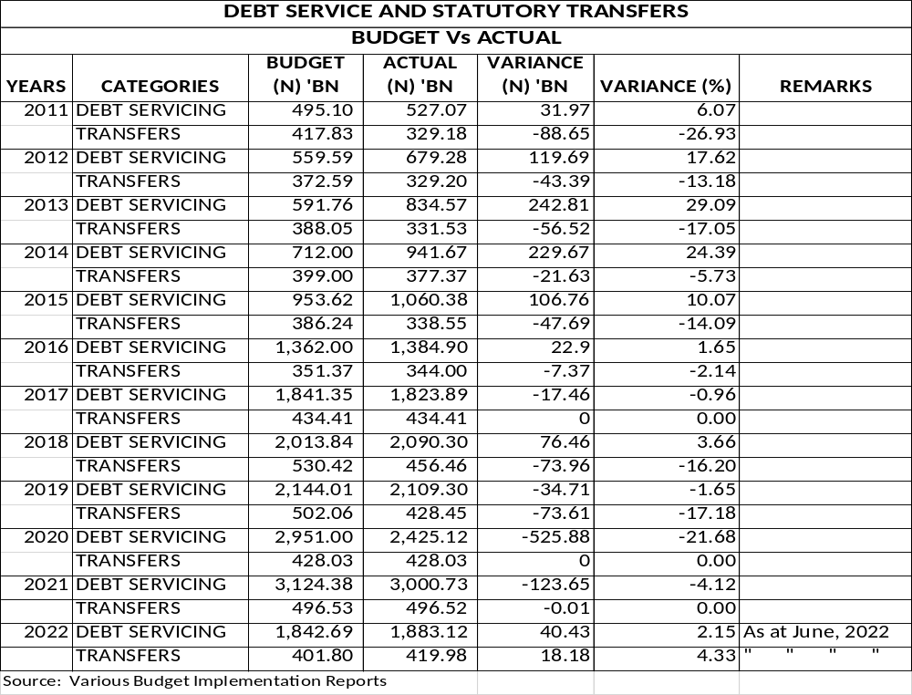

In assessing debt servicing and statutory transfers, a negative variance is such that actuals are less than the amount budgeted. A positive variance means the account is overspent (bad).
The actual performance by debt servicing varied positively from the budgeted with worst case scenario in 2013 (29.09%) which perhaps could be due to high risks and uncertainties resulting in higher servicing of debt than the planned, except for financial years 2017 & 2019 – 2021.
While otherwise could be said for the statutory transfers, that is, actual transfers are lesser than the budgeted, except in the following years; 2017, 2020 & 2021 - with zero (0) expenditure or no variance recorded and suddenly, it had a positive variance for the half year 2022 recorded (partly attributable to half-year results).
This also shows increased government commitment to debt servicing when compared to statutory transfers.

Table 2.8. FGN EXPENDITURE FORECAST ERROR
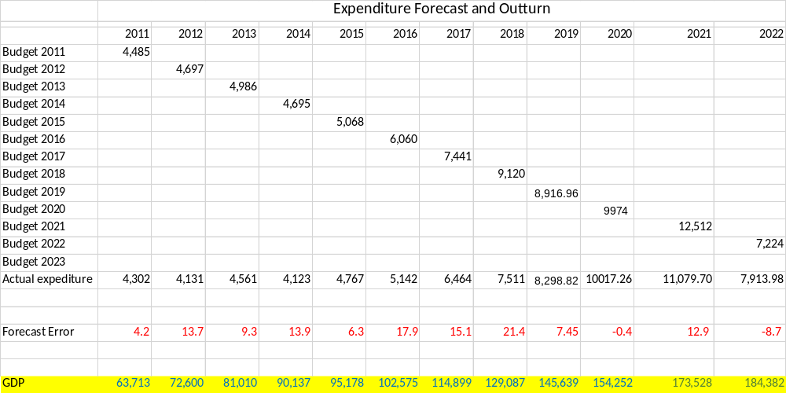

Table 2.9. FGN EXPENDITURE FORECAST ERROR
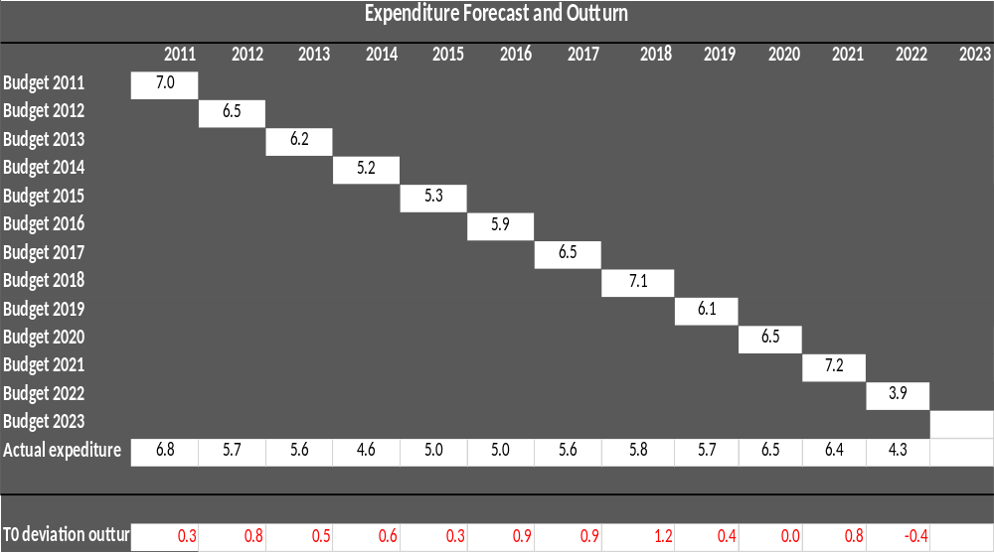
In this section, we will be expressing both the FGN Expenditure Forecast and Actual Expenditure in percentage of GDP. We want to know what percentage they covered in the GDP.
For instance, in year 2011 (figs in Billion):
Amount Budgeted for Expenditure = ₦4,485.
Actual Expenditure Incurred = ₦4,302.
GDP = ₦63,713.
Therefore, from the spreadsheet, expressing Budget as a percentage of GDP is 7.039% while Actual is 6.752%. That is, a deviation/forecast error of 0.287; approximately 0.3 and so it occurred in all the years considered (2011 – 2022), positive deviations, except in year 2022 where the reverse was the case. Though the figures used were half year figures.
Away from GDP, it can also be observed from the Spreadsheet that Actual Expenditure Performances for 2011 – 2022 were below the Budgeted Expenditure Amounts, except for years 2020 and 2022.
Reasons could be interpreted to be:
FY 2020 – COVID 19 and
FY 2022 – Information available is half year report.

Table 2.10. FGN CAPITAL SPENDING FORECAST ERROR
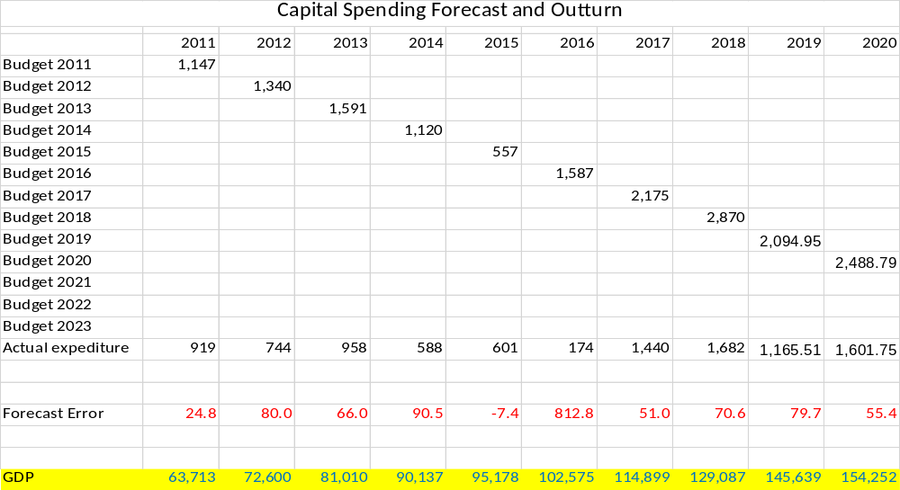

Table 2.11. FGN CAPITAL SPENDING FORECAST ERROR
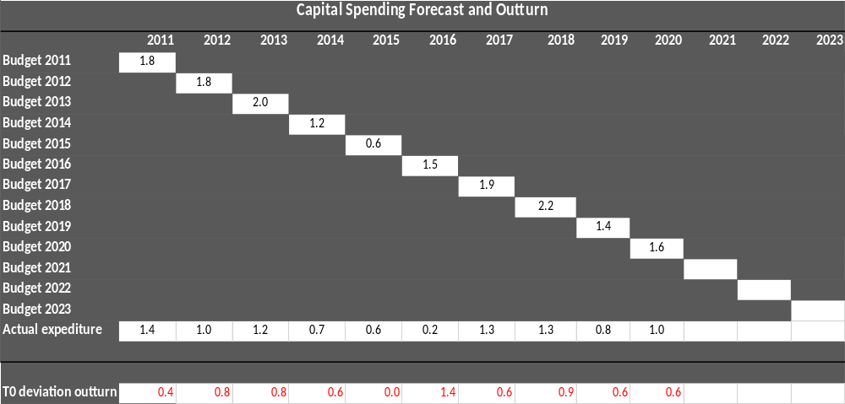

Now while taking a separate look at Capital Expenditure Performances (as a stand-alone), the general trend as captured in the Expenditure forecast above; also occurred here. Only in the year 2015 was the Actual Amount Expended greater than the Budgeted.
It is shown in the earlier analysis that the year 2023 performance may not be far from this trend of below-the-budget performances. This therefore supports our initial analysis/assumptions of a forecast error.

2.6 RECOMMENDATIONS
Based on the Expenditure Forecast Analysis Report for 2023 Financial Year, the following recommendations were made for improvement in the Federal Budget and the Nigerian economy at large.
- Government should investigate the wasteful components in the Expenditure Budget and undertake a rigorous rationalization of the expenditures, because the current rising recurrent expenditure is not sustainable.
- There is urgent need for an aggressive revenue drive to meet up with the ever-increasing expenditure aspect of the budget.
- Government should encourage more inclusion of the private sector in national economic development plan process to achieve inclusive growth of the economy. It is more sustainable to empower the private sector to create jobs while the government creates a thriving business environment (this is very key). The Public Private Partnership Initiative should be boosted to reduce infrastructure deficit.
- The government should consider low-interest-bearing loans and assets securitization as a new model of growing the debt stock as this will reduce our debt servicing burden.
- The government should identify and block existing revenue leakages to boost revenue mobilization, enhance tax compliance and reduce tax evasion. This is possible by leveraging technology and automation and reducing the human interface between government agencies and business operators.
- Government should integrate States and Federal Budgets to have a representative budget for Nigeria that is comparable among emerging economies in Africa.
- The Fiscal Responsibility Act 2007 should be reviewed to create a more robust budget policy framework and provide sanctions for defaulters.

