EXECUTIVE SUMMARY
The Fiscal Responsibility Commission (FRC), established by the Fiscal Responsibility Act (FRA) 2007, plays a crucial role in ensuring prudent and transparent management of Nigeria's public finances. One of its core functions is monitoring the borrowing activities of the three tiers of government (Federal, State, and Local) to promote sustainable debt levels.
Sections 41 and 44 of the FRA (2007) outline the rules and conditions governing government borrowing in Nigeria. These provisions aim to ensure responsible loan utilization and minimize long-term financial risks. Key requirements include:
- Purpose Limitation: Borrowing is restricted to financing capital expenditures and human development initiatives that yield long-term economic and social benefits, as demonstrated by a cost-benefit analysis.
- Favorable Loan Terms: Borrowed funds must be secured on concessional terms, typically featuring long repayment periods and low interest rates.
- Prior Authorization: All borrowing must be pre-approved by the relevant legislative body - the National Assembly for the Federal Government and the State House of Assembly for each State.
- Verification and Compliance: The FRC is empowered to conduct quarterly reviews to verify compliance with borrowing regulations by all government entities.
- Financial Institution Responsibility: Banks and financial institutions are obligated to request proof of compliance with FRC regulations before extending loans to any government body. Non-compliance constitutes a violation of the Act.

To assess compliance with borrowing regulations outlined in Parts IX and X of the FRA (2007), the Fiscal Responsibility Commission (FRC) conducted a verification exercise. This initiative focused on evaluating how loan proceeds were utilized by sub-national governments (states and local governments). The FRC employed a strategic approach to select a representative sample of states for the verification exercise. This involved prioritizing at least one state from each of Nigeria's six geopolitical zones (North-West, North-East, North-Central, South-West, South-South, and South-East). The final selection of the six states was based on timely responses to information requests.
This edition of the Debt Verification Report presents findings on the use of borrowed funds as of December 2024. Table 1.1 presents the states selected and a summary of the borrowing verified.

Table 1: Summary of Borrowing Verified, in 6 (Six) States in the Federation
S/N | Geo-political zone | State Selected | Year of Borrowing | Purpose of Borrowing | Amount Borrowed  N | Source of Borrowing
1 | North Central | Benue State | 2020 | Capital development | 10,200,000,000.00 | UBA plc
2 | South-West | Ondo State | 2019 | Infrastructure Development | 30,000,000,000,.00 | Capital Market
3 | South-West | Oyo State | 2023 | Infrastructural development | 26,000,000,0000.00 | Access Bank
4 | South-East | Bauchi State | 2023 | infrastructural development | 15,000,000,000.00 | Fidelity Bank
5 | North-East | Taraba State | 2023 | infrastructural development | 15,000,000,000.00 | Fidelitys Bank
6 | North-West | Kano State | 2021 | infrastructural development | 18.43,000,000,000.00 | Capital Market
Source: State Governments and Banks
Key Observations/Findings:
The Debt Verification Exercise identified widespread non-compliance with the FRA (2007) among the states reviewed. Specifically:
The Debt Verification Exercise identified widespread +
non-compliance with the FRA (2007) among the states reviewed. Specifically:
- Missing Compliance Documentation: None of the state obtained the mandatory “Proof of Compliance” from the Fiscal Responsibility Commission (FRC) before borrowing, breaching Section 45(1) of the FRA (2007).
- Absent Cost-Benefit Analysis: No state presented cost-benefit analysis before acquiring loans, a requirement under Section 44(1) of the FRA (2007).
- Unsustainable Debt Practices: All the States borrowed for infrastructure projects, which typically require long-term financing. However, only one state utilized the capital market, a suitable source for such loans. The remaining states relied on commercial banks.
Recommendations:
To address the identified non-compliance with the FRA (2007) and promote responsible borrowing practices, the following recommendations are made:
- Strengthen FRC Compliance: The FRC should collaborate with State Governments to ensure all states obtain "Proof of Compliance" and conduct cost-benefit analyses as mandated by the FRA (2007).
- Improve Project Management: State governments, particularly departments handling infrastructure projects and budgeting, should implement robust project management practices and enhance budgetary transparency.
- Strengthen Financial Management: State finance departments and relevant authorities should reinforce internal controls and explore debt management strategies.
- Explore Alternatives: State Governments should explore alternative funding mechanisms like Public-Private Partnerships (PPPs) for infrastructure development.
- Capacity Building: State governments should invest in staff training for effective loan project management.
- Domesticate FRA: State governments, in collaboration with FRC, should prioritize the adoption of the FRA (2007) in States where it does not currently exist.
- Public Disclosure of Borrowing Activities: State Houses of Assembly should strengthen open governance, mandating public disclose of information on borrowing activities, including loan purposes, funding sources, and repayment plans. This transparency strengthens public oversight and promotes responsible borrowing practices.

CHAPTER ONE

INTRODUCTION

1.1 Background
The Fiscal Responsibility Commission (FRC), in accordance with its mandate outlined in Parts IX and X of the Fiscal Responsibility Act (FRA) of 2007, conducted a debt verification exercise. This exercise, fourth of its kind, aimed to verify how four state governments utilized loan proceeds obtained from commercial banks and two state government's bond issuance in the capital market in the year 2019 and 2021.

1.2 Purpose of the Debt Verification Exercise
The primary purpose of this exercise was to assess the compliance of selected state governments with relevant provisions of the FRA (2007) concerning debt, borrowing, and indebtedness. This evaluation focused on their practices during the loan acquisition and utilization processes. Specific sections of the FRA examined included:
- Section 41(1a): Restricts borrowing by all government levels to capital expenditures and human development, with stipulations for concessionary terms, low-interest rates, and extended amortization periods. Also, loan approvals require legislative body endorsement.
- Section 42(3): Mandates the FRC to determine the consolidated debt of each tier of government at each quarter's end.
- Section 42(4): Requires the FRC to publish quarterly lists identifying governments exceeding their consolidated debt limits and the extent of the transgression.
- Section 44(1): Requires any government entity intending to borrow to specify the loan's purpose and present a cost-benefit analysis detailing the economic and social benefits associated with the intended use of the borrowed funds.
- Section 44 (2a): emphasizes the existence of prior authorization in the appropriation or other Act or law for the purpose for which the borrowing is to be utilized.
- Section 44 (2b): stipulates that the proceeds of such borrowing shall solely be applied towards long-term capital expenditure.

1.3 Methodology
The verification exercise employed a multi-pronged approach:
- Document Review: This involved examining loan authorization documents, scrutinizing disbursement records, and reviewing relevant contracts.
- Interviews: Interviews were conducted with senior officials from the targeted state governments.
- Verification Visits: Project sites were physically visited to assess work quality, interact with personnel involved (site workers, contractors, consultants, and supervising staff), and verify project existence through photographs.

1.4 Scope and Limitations
The exercise scope encompassed the public borrowing rules and conditions outlined in Parts IX and X of the FRA 2007. Additionally, any supplementary regulations established by the FRC regarding public borrowing under Section 3(d) and (e) of the FRA were considered. Due to funding constraints, the FRC was only able to conduct the verification exercise in six states.

CHAPTER TWO:

SOUTH-WEST GEO-POLITICAL ZONE: ONDO STATE
2.1 Verification of Bond Proceeds
In 2019, Ondo State issued bonds in the capital market to raise N30, billion for infrastructure development projects. This chapter details with the verification exercise conducted to assess the utilization of these funds for five selected projects.

Table 2.1: Selected Projects Funded by N30 Billion Bond Issuance (Ondo1 State)
S/N | Project Description | Loan amount in Naira | Contractor | Project location | Completion status
1 | Building of Hospital Facilities at the Akure and Ondo complex of University of Medical Science | 4,136,768,108.80 | Messr Sobak Nig Ltd | Akure and Ondo town | 81%
2 | Construction of Ondo state Governor,s and Deputy Governor,s lodge | 3,000,000,000.00 | Messrs. Craneburg construction. Ltd | Akure town | 32.4%
3 | Construction of 15km ijoka Idanre road | 3,699,820,512.65 | Messrs.Lee Fakino Nig Ltd | Akure town | 100%
4 | Construction of Treasury House Akure | 500,000,000.00 | Messrs Integrated Builders Ltd | Akure town | 83.34%
5 | Construction of selected roads in Owo Town | 1,884,742,440.54 |  | Owo Tpwn | 100%
 | Total Loan Amount | 13,221,331,061.99

2.2 Physical Verification of the Utilization of the Proceeds of N30 Billion Bond

2.2.1 Building of Hospital facilities at the Akure and Ondo Complex of University of Medical Science.
Project Description:
This project involved the reconstruction of a Hospital Complex in Akure and hospital facilities at Ondo complex of University of Science.
Project Funding:(Akure section of the project)
- Initial Contract Cost (2020): N2,322,111,029.82
- Revised Contract Cost (2022): N3,805,264,461.36, due to variations in the prices
- Loan Component (funded by bond proceeds): N4,136,768,108.80
Project Funding: (Ondo section of the project):
- Initial Contract Cost (2020): N2,233,607,779.93
- Revised contract cost (2022): N4,064,543,736.06
Verification Details:
The verification exercise involved a site visit to assess the quality of construction and the project's current condition. The project is (81%), with the building currently in good condition due to high-quality construction.

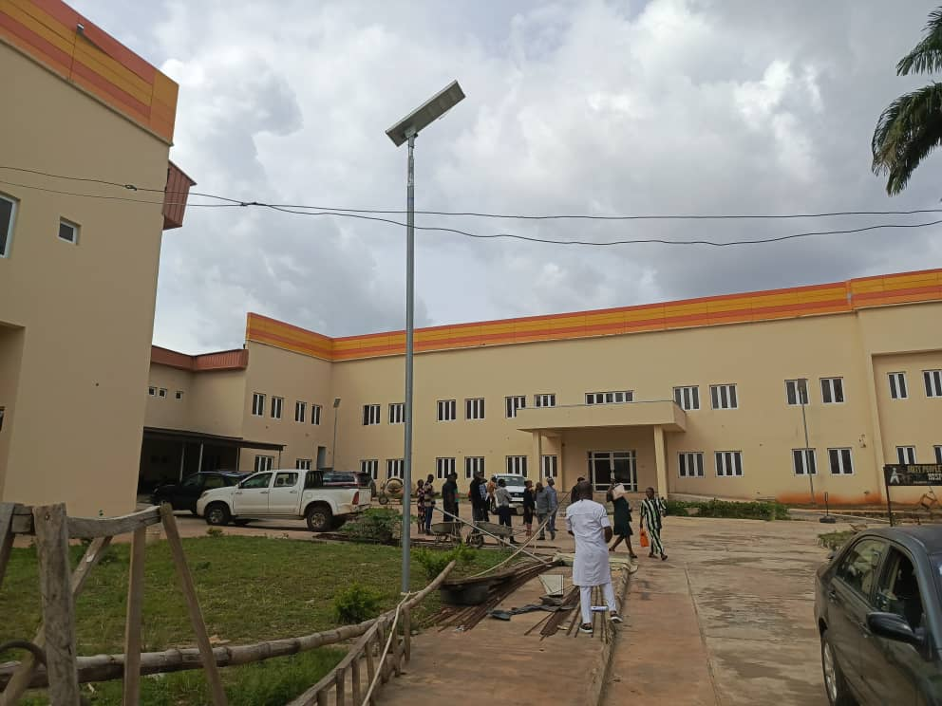

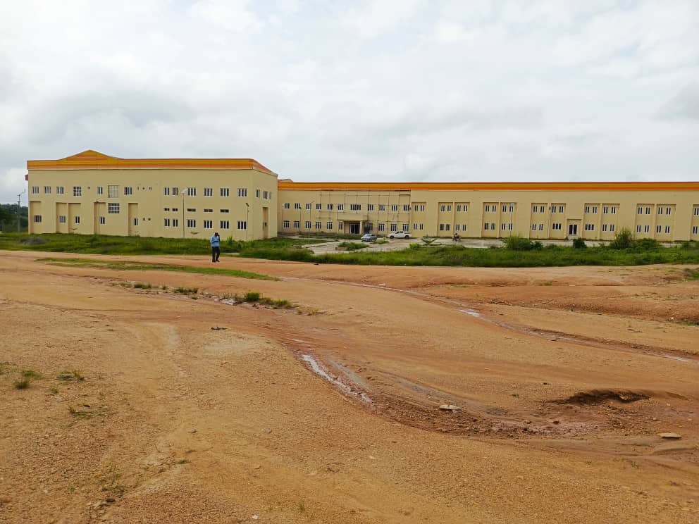

Figure 2.1: The pictures of both hospital facilities at the Akure and Ondo complex of University of Medical Science

2.2.2 Construction of Governor and Deputy Governor’s Lodge
Project Description:
This project involved the construction of Governor and Deputy Governor lodge at Alagbaka Akure town in Ondo State
Project Funding:
- The Governor,s lodge Contract Cost (2021): N6,495,623,271.25
- The Deputy Governor,s lodge Contract Cost: (2024): N217, 881, 304,35
- Loan Component (funded by bond proceeds): N3,000,000,000.00
Verification Details:
The verification exercise involved a site visit to assess the construction progress and quality of work done.The Governor’s lodge project was at 97.5% during the exercise and the Deputy Governor’s lodge was 32.4% respectively

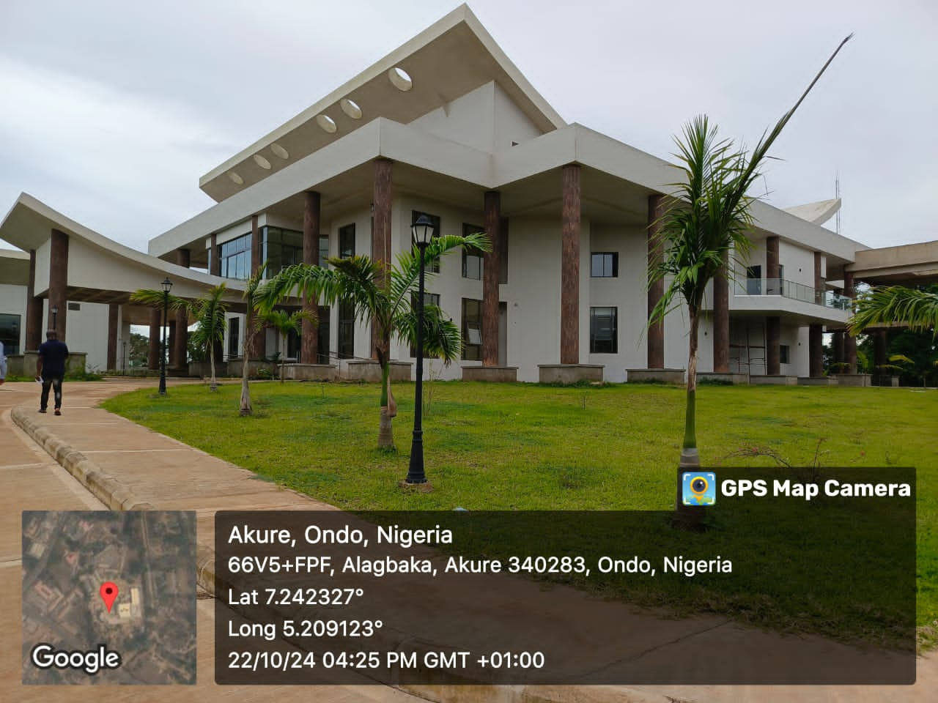
Figure 2:2: Building of Ondo state Governor,s lodge at Alagbaka Akure, Ondo state

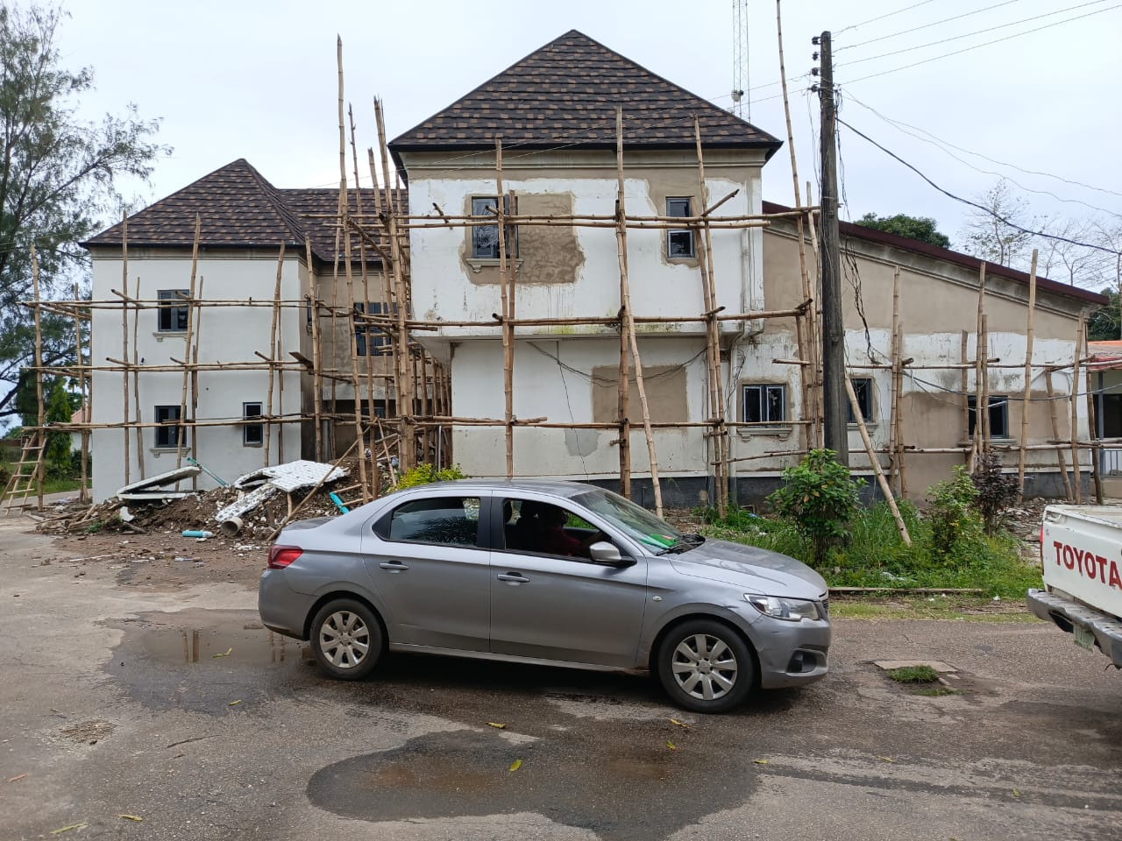

Figure 2:3: Construction building of Ondo state Deputy Governor,s lodge at Alagbaka Akure, Ondo stste

2.2.3 Construction of 15km Ijoka Idanre road at Akure, Ondo State
Project Description:
This project involved the construction of 15km single carriage way Ijoka-Idanre road at Akure, Ondo State.
Project Funding:
- Initial Contract Cost (December 2018): N3, 699, 820,512.65
- Loan Component (funded by bond proceeds): N3, 699, 820,512.65
Verification Details: The project is reported to be 100% completed and commissioned in 2021, still under defect liability period. However, 100% payment was made to the contractor without withholding 5% retention fee to fund the defect liabilities.

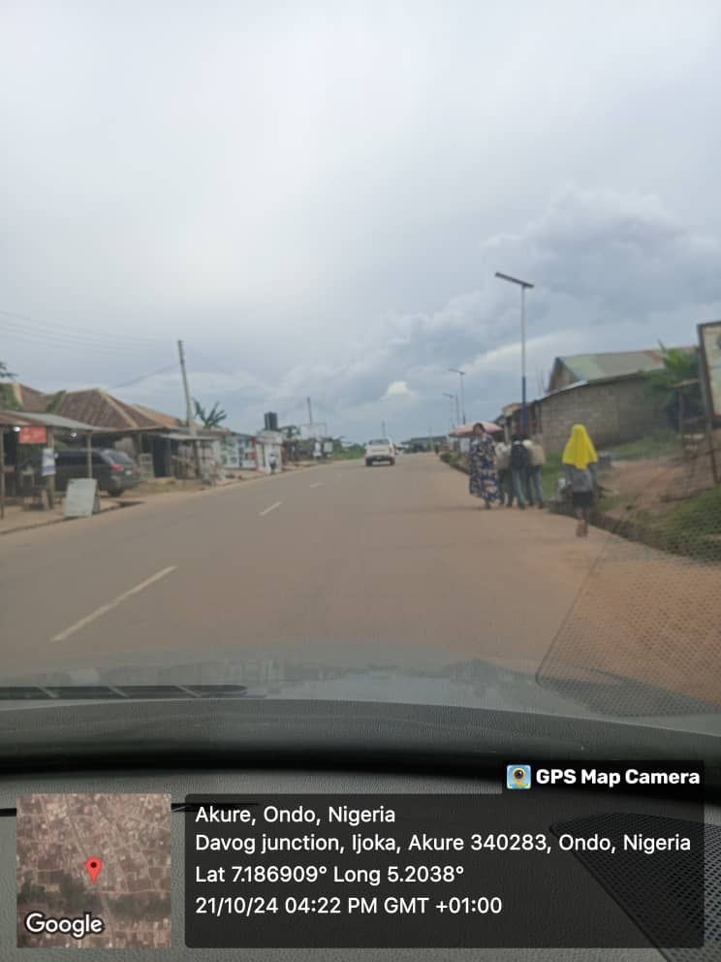
Figure. 2.4: site sight of 15km ijoka-idanre road at Akure, ondo state.

2.2.4 Construction of Treasury House (Accountant General,s Office in Akure)
Project Description:
This project involved the construction of new Accountant General Office in Akure, Ondo State. .
Project Funding:
- Initial Contract Cost (March 2021): N469,296,632.93
- The revised contract cost (June 2022): N576, 922, 482.81
- Loan Component (funded by bond proceeds): N500,000,000.00
Verification Details: The verification exercise included a physical visit to the project site to assess the progress and quality of construction. The project is reported to be 83.34% complete and the work is currently on going in the site.
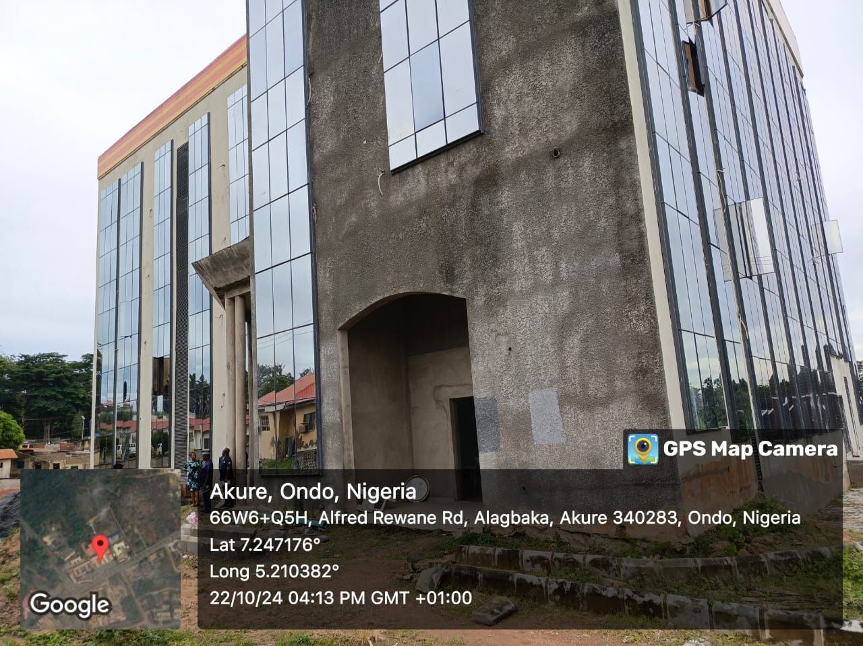

Figure 2.5: the picture of the new office of the Accountant General Akure, Ondo state.

2.2.5 Construction of selected roads in Owo Town
Project Description:
This project involved the construction of selected roads in Owo town. Some of these roads are Adedewe road, Eleduma extension, Egon road
Project Funding: As at the time of inspection, there was no project files, no project briefs and other documents associated with the projects.
Verification Details:
The road projects are reported to be 100% completed at the time of inspection, the roads are be put to use and operational.

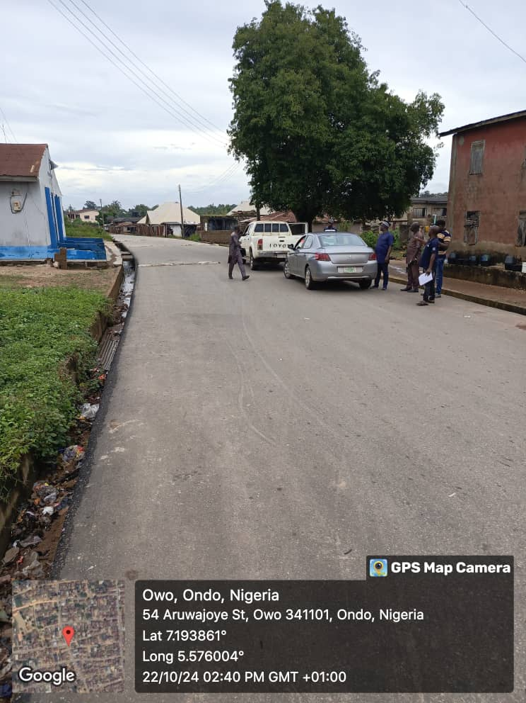
Figure 2.6: this is sight picture of Adedewe road in Owo, Ondo State

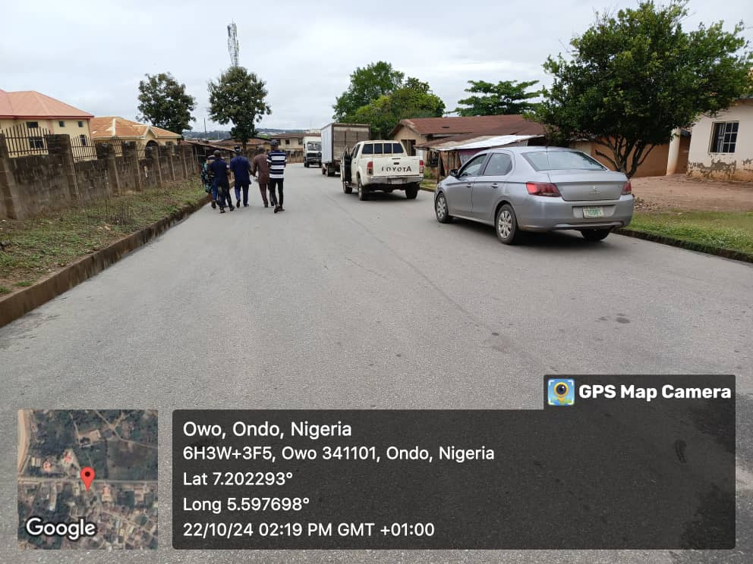

Figure: 2.7 the sight picture of Egon road in Owo town, Ondo State

OBSERVATIONS/ FINDINGS AND RECOMMENDATIONS
Observations/ Findings: the following are the observations and findings:
- The Ondo state Government requested for a N50 billion bond and approval was given by both State Executive Council and the State House of Assembly for the bond to be obtained in two tranches.
- The first tranche was N30 billion and the second tranche was N20 billion respectively.
- The Ondo State Government requested for approval in respect of ISPO from the Federal Ministry of Finance and the Fed Min of Finance granted the approval for the N30 billion bond in December, 2019.
- The FMF approved ISPO as follows:
Amount: N30 billion
Interest Rate: 17%
Tenor: 84 months
Installment: N644,284,762.92
Start Date: December, 2019
Source of Repayment: FAAC allocation to Ondo State
- The Ondo State Government obtained a favourable rating from the Global Credits Rating Co. Ltd.
- The Securities and Exchange Commission raised objection to the N30 billion bond due to debt sustainability issues and only gave approval for N14.8 billion bond at 13% which is lower than the initial 17%.
- The Ondo State Government obtained N15.2 billion private bond with no evidence of regulatory approval.
- The 2019 Audited Financial Statement of Ondo state Government captured only the N14.8 billion bond.
- A repayment plan was sighted containing the following information:
Principal repayment: N30,000,000,000.00
Coupon repayment: N22,433,824,026.16
Trustees fees N220,500,000.00
Management fees N103,763,444.61
Other charges N532,875,000.00
Total N53,290,962,470.77
To be financed by
ISPO / IGR N52,831,350,559.63
- Fund investment income N459,611,911.15
At the installment of N644,284,762.92 per month over 82 months.
- The outstanding repayment based on deductions, stood at N10,352,142,856.82 as at June, 2024.
Xiii. The actual amount paid to the investors was not clearly indicated in the repayment plan.
- The outstanding balance is in the sinking fund account of Ondo State Government.
- The construction works in the hospital projects were commendable, though, there were some delays as a result of increase in price of materials.
- The construction of 15km Ijoka–Idanre road was commissioned in 2021 and is under defect liability period at the time of team visit. However 100% payment was made to the contractor without withholding the 5% retention fee required to fund the defect liabilities.
- There was no evidence of certificate of completion for Ijoka-Idanre road that was commissioned in 2021 (That is, assuming that the project was indeed funded by the bond)
- The total amount spent on the nine (9) projects shown to the FRC team was N34,113,152,388.66 which exceeded the N30 billion bond by N4,113,152,388.66. This indicates that Ondo State Government did not fully explain to FRC team the real source of the additional N4, 113, 152,388.66. Moreover, there was no indication that the listed projects were indeed paid for from proceeds of the bond alone.
- Ondo State Government did not avail the FRC team any Cost-Benefit Analysis (CBA) detailing the economic and social benefits of the purpose to which the intended borrowing was to be applied.
- The project files were not provided for examination of project documents and records, hence the team did not get the necessary information for its set objectives.
- There was no evidence that proof of Compliance with the provisions of FRA, was obtained in line with Section 45 of the FR, 2007.
- Ondo State Government’s debt limits had exceeded 50% of its total revenue for the previous 12 months before the bond was contracted. It was therefore not qualified for the bond at the time.
- The State’s outstanding judgment debts was not availed the Commission. These are to constitute part of the State’s total debt stock in line with Section 42 (2) of FRA 2007. Hence the real size of the State’s debt stock remains unknown to the FRC team.
- The files containing the State procurement processes such as advert, bidding, selection of qualified bidders for interview etc, in line with public procurement procedure were not provided for sighting. Hence, it remains unknown to the FRC team, if the projects executed with the proceeds of the bond were transparent and properly awarded
- The payment voucher and receipts to indicate how much was paid for each project were not provided for sighting, hence creating uncertainty as to the true amount expended on the projects.
- The documents for the disbursement of the bond such as payment vouchers and certificates raised for the projects were not provided for sighting by the team, thus raising doubt about the real use of the proceeds of the N30 billion bond.
- The project briefs for selected roads at Owo town were not provided for sighting, thus making it difficult to indicate the name of the contractors, the actual amount the project was award, the year of award, the duration and the status of the projects.

Recommendations:
- The Commission should emphasize to Ondo State Government that it should be mindful of Section 45 of the FRA, 2007 relating to proof of compliance with provisions of the FRA, when it comes to public borrowing/ lending
- The Ondo State Government should be required to furnish FRC with the evidence of regulatory approval for the N15.2 billion bond obtained from the private bond.
- The Ondo State Government should be asked to conduct a reconciliation of the sinking fund account with the Securities and Exchange Commission to ascertain the actual status of the bond repayment and furnish FRC with the report of the reconciliation.
- FRC should engage with the Securities and Exchange Commission on the implications of the discrepancy between the letter of objection for N30 billion bond to Ondo State referenced SEC/MON/POS/FMF/VLO1/02/22 dated 26th February, 2021, and the ISPO approved by the Federal Ministry of Finance on the N30 billion bond.
- The Ondo State Government should be told to prepare and present Cost-Benefit Analysis (CBA) detailing the economic and social benefits of the purpose to which any intended borrowing is to be applied before obtaining any loans from any source in line with relevant sections of FRA, 2007.
- The Ondo State Government should be cautioned by FRC not to make any further complete payment for any project funded with loans and bonds that is under defect liability period without retention of 5% required fee to fund the defect liabilities.
- The Ondo State Government should make available to FRC the project files for proper examination of the needed documents and records to ascertain the level of compliance with the Fiscal Responsibility law and regulations
- The documents for the disbursement of the bond such as payment vouchers, certificate of completion, certificate raised for the projects etc, should be provided to FRC.
- The State Government should explain to FRC in clear term, where and how the additional funds of N4,133,152,388.66 was sourced from, the authorization and the evidence of disbursement and payments.
- The Ondo State Government should make available the project briefs of all the selected road projects at Owo town.
- Given the paucity of documents availed the FRC team at the time of their visit, the Ondo State Government should be requested to put together the documents and send copies to FRC, along with its officials that may provide additional explanations as may be required. For avoidance of doubt, the required documents are:
(a) All the project files and briefs
(b) Files containing procurement processes under taken with proceeds of the bond.
(c) Evidence of payment and disbursement of the bond.
(d) Authorization for N15.2 billion bond contracted from the private source.
(e) Evidence of proof of compliance from FRC before the said bond was contracted.
(f) The document authorizing the additional N4.133 billion and its sources.
(g) The cost-benefit analysis of the projects said to have been executed with the proceeds of the bond.
As an alternative to (xi) above, an FRC team may visit the State, at the expense of the State to re-verify the full utilization of the N30 billion bond obtained from Capital Market in 2019 by Ondo State Government to determine the level of compliance with FRA, 2007 and relevant regulations.The State Government must be sure that the necessary documents are available before this option can be considered

CHAPTER THREE

NORTH-EAST GEO-POLITICAL ZONE: BAUCHI STATE

3.1 Verification of Loan Utilization: N15 Billion Loan from FIDELITY Bank Plc (2023)
This section details the verification exercise conducted to assess the utilization of a N15 billion loan obtained by the Bauchi State Government from Fidelity Bank Plc in 2023. The loan was reportedly allocated for infrastructural development projects within the state. The highlights are presented in Table 3.1.
Table 3.1: Summary of Loan Obtained for Infrastructure (Bauchi State)
Borrowing State | Amount Borrowed | Lending Bank | Date loan granted | Interest Rate | Tenor | Amount Drawn | Purpose | Type of Facility
Bauchi | N15 billion | FidelityBank PLC | January 2023 | 11% | 12 months | N15 billion | infrastructural development | FACC backed loan

The verification exercise conducted in Bauchi State was to assess the full utilization of a N15 billion loan obtained by the State Government from Fidelity Bank in January, 2023 for infrastructural development in the State.
Table 3.2 Selected projects funded by N15 billion obtained by Bauchi State
S/N | PROJECT DESCRIPTION | NAME OF CONTRACTOR | AMOUNT N
1 | Construction of Tambar-Sabon Kaura Road | Habibu Engineering | N5, 442,783.00
2 | Construction of Bogoro lusa Road | Habibu Engineering | N733,855,934.91
3 | Construction of new Government House | Architechtronics | N1,000,000,000.00
4 | Construction and Rehabilitation of Healthcare facilities in the state | Various Contractors | N1,500,000,000.00
5 | Construction of Bakari-Kafin Larabawa Road | Mothercat | N189,456,282.59

3.2 Physical verification of the utilization of the proceeds of N15 billion loan
3.2.1 Construction of Tambar-Sabon Kaura Jos Road (6.2 km)
Project Description: this project involved the construction of Tambar-Sabon Kaura Jos 6.2 km road, located in Bauchi State.
Project Funding: The project was awarded to Habibu Engineering Nig Ltd at the contract sum of N2,230,774,265.29 at the initial payment of N2,179,168,646.05, within a period of 18 months in the year 2019.
Verification Details: The verification exercise involved a site visit to assess the quality of the work done and the current status of the project. The project is fully completed with the road currently in good condition and be put to use.
3.2.2. Construction of Bogoro-lusa-maillar 11.5km road
Project Description: the project involved the construction of 11.5km Bogoro-lusa-maillar road in Bauchi State.
Project Funding: The project was awarded to Habibu Engineering Nig Ltd at the sum of N7,357,784,242.60 at the initial payment of N2,307,641,379.76,within a period of 18 months in the year 2020.
Verification Details: The verification exercise involved a site visit to authenticate the quality of the work done and the current status of the project. The project is fully completed (100%) with the road currently in good condition and be put to use
3.2.3. Construction of Bakari-Kafin Larabawa 11km road in Bauchi State.
Project Description: The project is the construction of 11km Bakari-kafin larabawa road in the State.
Project Funding: The project was awarded to Mothercat Nig Ltd at the contract sum of N1, 663, 367,409.00 at the initial payment of N1, 632,015,218.70 within a period of 18 months in the year 2023.
Verification Details: The exercise involved a site visit to determine the authentication and the full utilization of the proceeds of the loan and the current status of the project. The project is fully completed (100%) and be put to use.

3.5 Completion of Specialist Hospital, Bauchi
i. Brief Description and Purpose of the Project
The project was for the construction of standard new specialist hospital and equipping with standard facilities in Bauchi State.
The purpose of the project is to build a standard hospital to serve as a referral hospital to provide first class medical services to the people of Bauchi States and its neighbourhood.
Project scope include;
- Administrative block
- Physiotherapy unit
- Medical Record Library
- Renal Dialysis unit
- Laboratory
- Radiology unit
- Amenity Ward
- Male and Female Surgical wards
- Gynaecology unit
- Special Baby care unit
- Maternity ward
- Pharmacy unit Accident and Emergency unit
- Maintenance dept.
- Road network within the hospital
- Etc.
The project was awarded to Messrs Current Mec. Engineering Ltd on 18th September, 2012 in the sum of N4,032,767,254.52; for a duration of 74 (seventy four) weeks
ii. Status of the Project
The project has attained 100% completion and since been put to use.
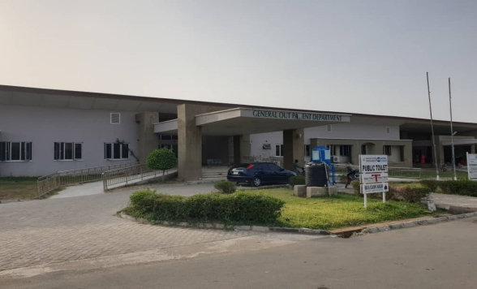
Fig. Front view of the Specialist Hospital, Bauchi

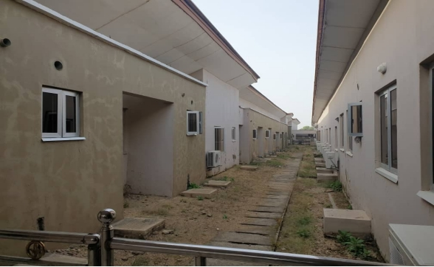
Fig. Male surgical ward at Specialist hospital, Bauchi

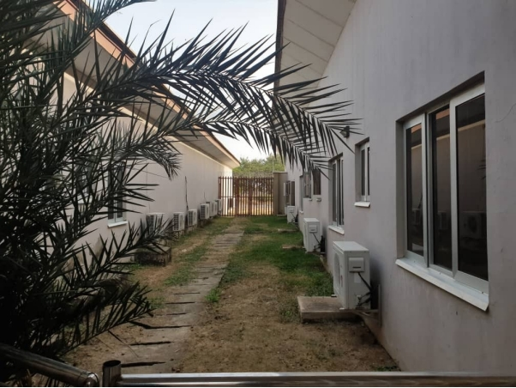
Fig. Amenity ward of Specialist Hospital, Bauchi

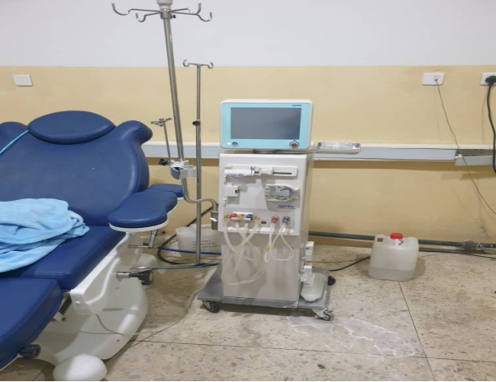
Fig. Dialysis machine at Specialist hospital Bauchi

3.2.4. Observations/ Findings (Bauchi State)
The verification exercise identified the following:
Compliance with project use: the loan proceeds were applied to capital projects as documented in Bauchi State Government’s correspondence with the Commission and project documents presented during verification.
Project Quality: All inspected projects funded with the loan were physically located and found to be of good quality.
Missing Cost-Benefit Analysis: No evidence of cost- benefit analysis, as required by section 44 (1) of the Fiscal Responsibility Act (FRA) 2007, was found before the said loan was obtained.
Compliance verification omission: No evidence that the Bauchi State Government sought or obtained compliance verification from the Fiscal Responsibility Commission before acquiring the said loan, as mandated by Section 45 of the FRA 2007.

3.2.5. Recommendations:
To address the identified observations and promote responsible borrowing practices, the following recommendations are made:
- Compliance verification prior to borrowing: The State Government should consistently obtain proof of compliance from the Fiscal Responsibility Commission Abuja, before obtaining any loan from any financial institutions in the country.
- Cost-Benefits Analysis Requirement: Bauchi State Government’s future loans application should be accompanied by cost-benefit analysis, as mandated by Section 44 (1) of the FRA 2007. These analyses will assist in objectively evaluating project viability before loan acquisition.
- Domesticate Fiscal Responsibility Act: The Bauchi State Government should prioritize domesticating the Fiscal Responsibility Act to ensure prudence and transparent management of public resources to better the lives of people in the State.
Staff Development: The State Bauchi Government through the State Civil Service Commission should invest in human capacity development programs to equip public service staff, especially those handling records of loans, with the skills and knowledge to meet current trends, enhance productivity, and improve service delivery
CHAPTER FOUR
NORTH-WEST GEO-POLITICAL ZONE: KANO STATE

4.1 Verification of loan utilization: N18.425 Billion Loan from Capital Market (2021)
This section details the verification exercise conducted to assess the utilization of a N18.425 billion loan obtained by the Kano State Government from Capital Market in 2021. The loan was reportedly allocated for infrastructural development projects within the state. The highlights are presented in Table 4.1.
4.1 TABLE: SUMMARY OF THE SELECTED PROJECTS EXECUTED AND PHYSICALLY VERIFIED BY THE TEAM

S/N | Project | Name of Contractor | Project Location | Contract Sum  N | % of completion
1. | Construction of Cancer treatment centre at MBSH | Messrs, BICO Nig, Ltd | Giginyu, Kano | 1,641,049,781.7 | 100%
2. | Supplies and Installation of Equipment at MBSH | Messrs, BICO Nig, Ltd | Giginyu, Kano | 2,076,498,509.70 | 100%
3. | Construction of Flyover, Kofar Mata – I. Taiwo Rd | TEC Engineering Nig. Ltd. | Fagge & MunicipalLGAs | 1,211,405,691.95 | 100%
4 | Contruction of Dala inland Dry Port | FRI, Construction Company Ltd | Zawaciki, Kano | 2,243,515,185.32 | 100%
5 | Construction of Faculty block at Yusuf Maitama Sule University | Messrs, Eagle Construction Ltd and Messrs, SARB &GLENMAN | Gwale LGA, Kano | 530,000,000.00 | On-going

4.2 PHYSICAL VERIFICATION OF THE PROJECTS EXECUTED WITH THE PROCEED OF N18.425b BOND
4.2.1 Construction of Cancer Treatment Centre and Supplies and Installation of Medical Equipment at MBSH Giginyu, Kano

Project Description: The project is the construction of Cancer Treatment Center, the project comprises of construction of ground, first and second floor, Laboratories, Chemotherapy, Brachytherapy and 2 No. Bunkers for Radiotherapy and external works. The second segment of the project is supplies and Installation of medical equipment in the Centre
Project Funding:
- Loan provider: Capital Market (2021)
- Contractor: Messrs, BICO, Nig Ltd (awarded November,2018)
- Initial cost: N2,390,836,241.18
- Revised cost: N4,117,719,663.40 for the period of 30 weeks
Verification Details: The verification exercise involved a site visit to assess the construction progress, the quality of the work done and status of the project. The project was nearing completion, at 98% at the time of inspection.

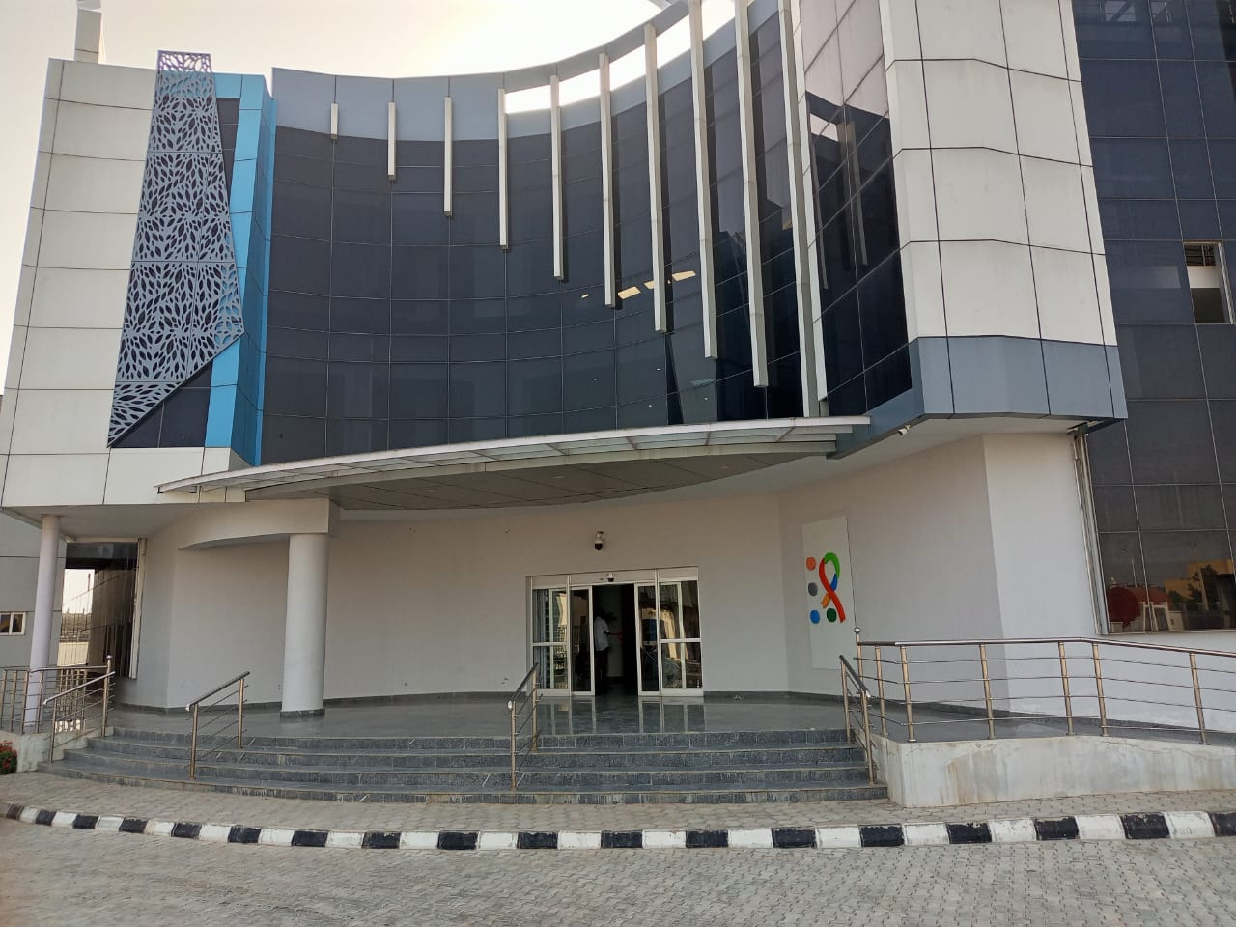
Figure 4.1: The Completed Cancer Treatment Centre at Giginyu, Kano

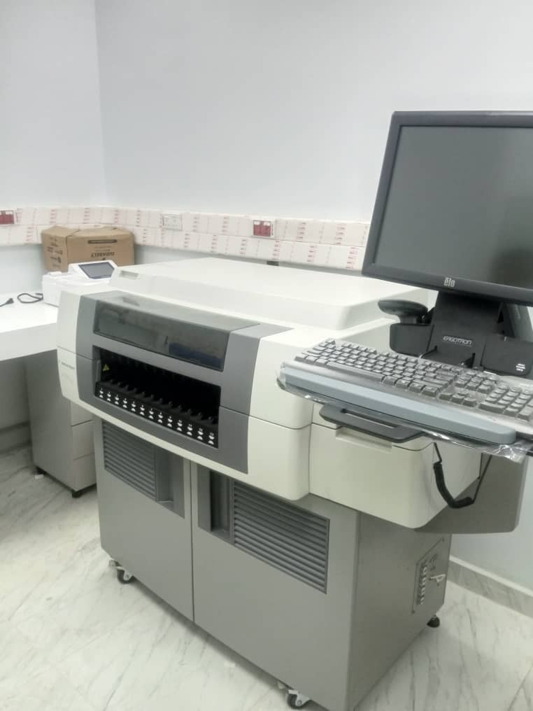
Figure4.2: The Immune Analyser Machine at Cancer Treatment Center , kano

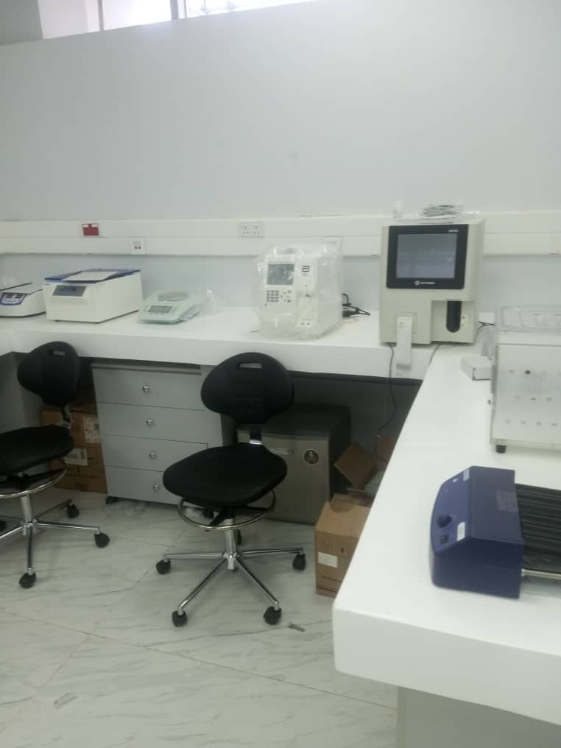
Figure 4.3: Microbiology Laboratory at Cancer Treatment Centre , Kano

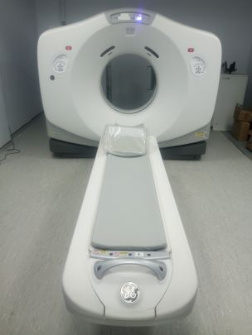
Figure 4.4: City Scan Machine

4.2.2: Construction of Flyover from Kofar Mata – Ibrahim Taiwo Road, Kano
Project Description:
The project was the construction of 800m length flyover bridge comprises of 27 spans (20m each), and 2No. ramps 130m each and Slip road from Kofar Mata to Ibrahim Taiwo road in Kano State.
Project Funding: The contract was awarded to TEC Engineering Nigeria Ltd on March, 2020 in the sum of N6,604,623,064.38 for a duration of 20 (Twenty) months.
Verification Details: The verification involved a site visit to assess the construction progress, the quality of the work done and status of the project. The project has attained 100% completion status and be put to use.
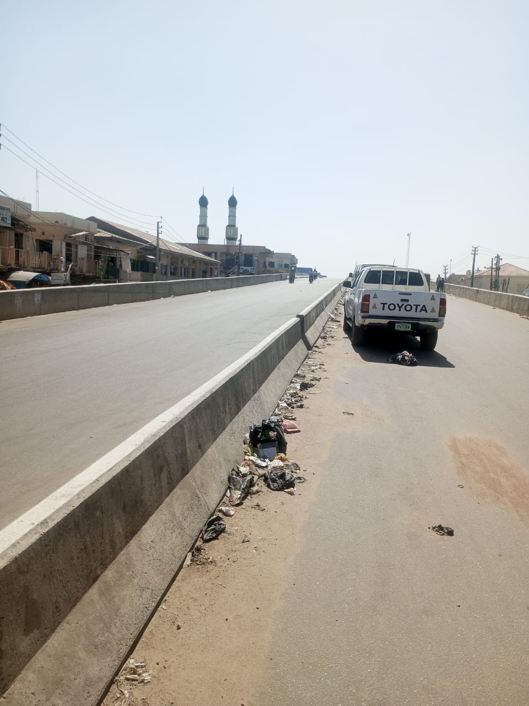

4.2.3: Construction of Dala Inland Dry port
- Project description: The project comprises of construction of dual carriage access road, internal roads, perimeter fencing and Security gate, provision of street lights, water reticulation and supply.
- Project Funding: The contract was awarded to FRI Construction Company Ltd on 7th July, 2020 at the initial contract sum of N2,300,000,684.24 for a duration of 6 (Six) months
- Verification Details: The exercise involved a site visit to assess the quality of construction and the project’s current condition. The project was confirm to be 100% completed and operational.

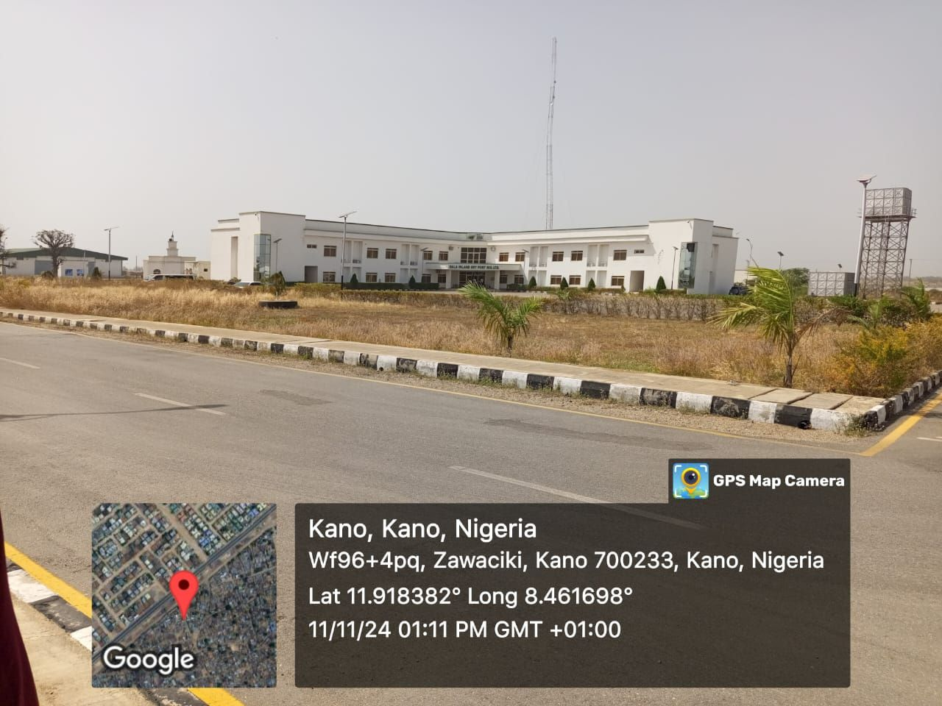

Figure 4.6: Completed Dala Inland Dry Port, Zawachiki, Kano, Kano State

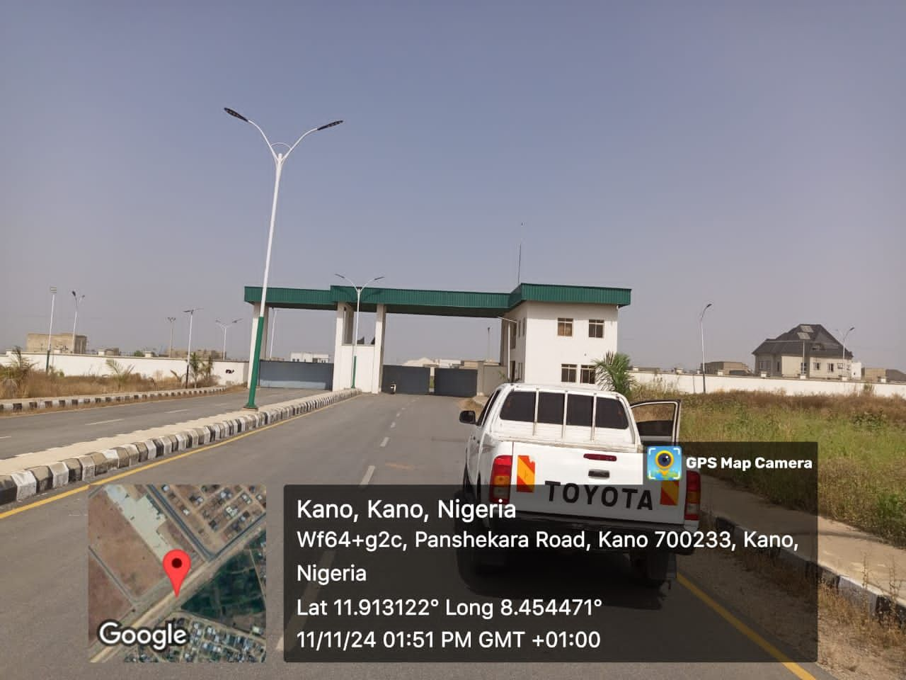

Figure 4.7: Completed internal roads, Perimeter fencing and Security gate at Dala Inland Dry Port, Zawachiki, Kano

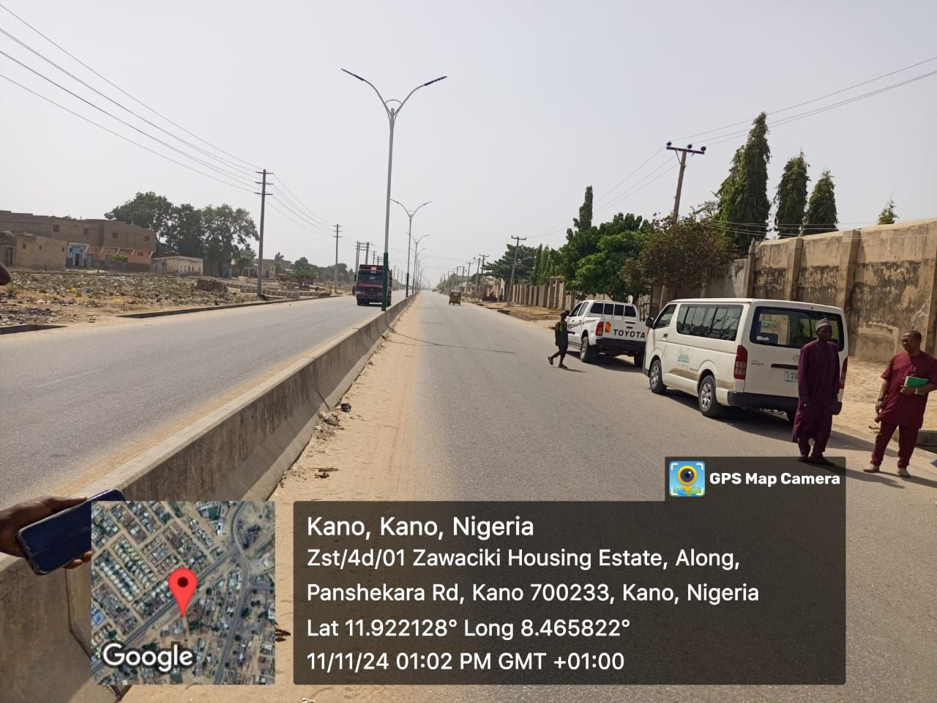
Figure 4.8: Completed dual carriage access road with street lights to Dala Inland Dry Port, Zawachiki, Kano, Kano State

4.2.4 Construction of Faculty Blocks at Yusuf Maitama Sule University, Kano
Project Description: The project was the construction of 2 No. of faculty blocks (Science and Art), each block contains wing A & B,within the wings. There is Administrative offices, Laboratories, Staff offices and Lecture Theatres
The contract for construction of faculty of Art complex was awarded to SARB & GLENMAN on 14th February, 2012 at the initial contract sum of N1,004,225,180.70 for a duration of 48 (forty eight) months
Project Funding:
The contract for the construction of Faculty of Science complex
- Contract Award Date: 14th February, 2012
- Contractor: : Eagle Constructions Ltd
- Contract sum: N1,004,225,180.70
- Completion period: 48 (forty eight) months
Verification Details:
The contract for the construction of Faculty of Art complex
- Contract Award Date: 14th February, 2012
- Contractor: SARB & GLENMAN
- Contract sum: N1,004,225,180.70
- Completion period: of 48 (forty eight) months

- Verification Details: The physical visit to the project site was conducted to assess the final outcome of the project. The project for the construction of faculty of Science, wing A & B has been completed, the theatre section has not been completed.
- The project for the construction of faculty of Art has not been completed in all the sections of the complex.

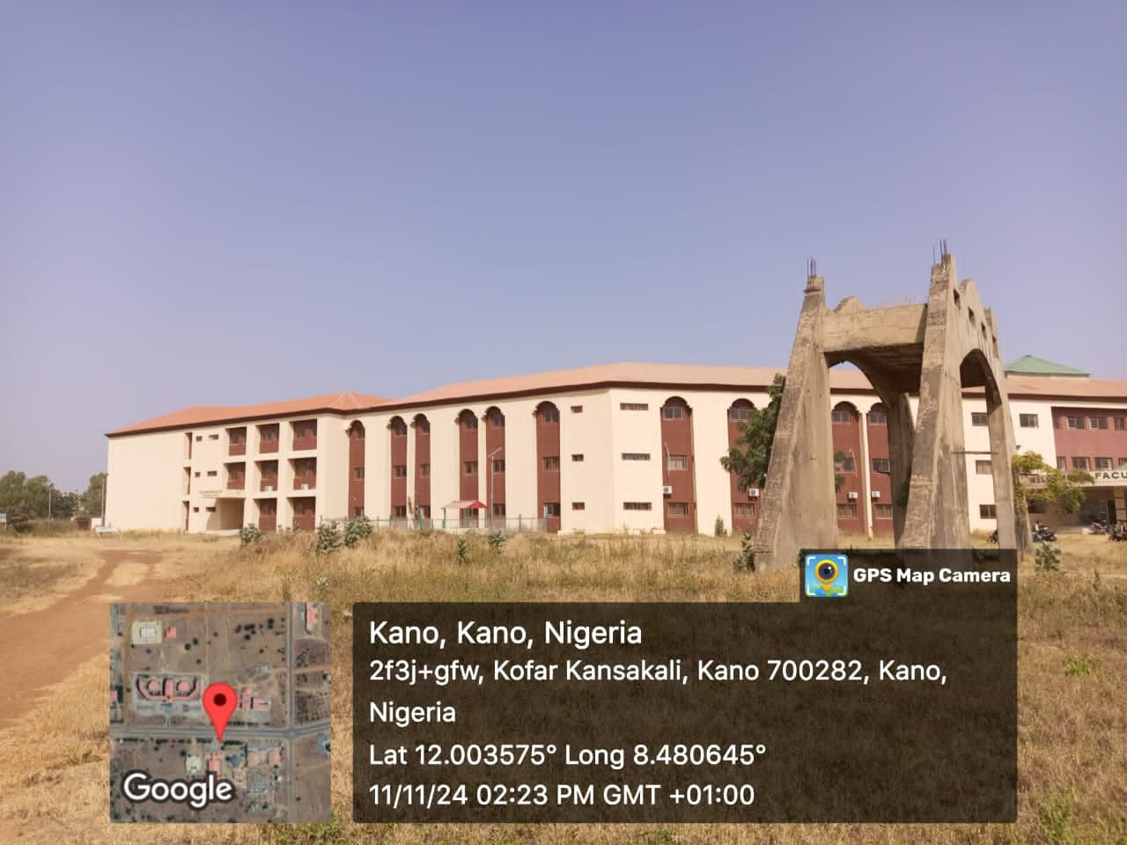
Figure 4.9: Completed part of the Faculty of Science Complex at Yusuf Maitama Sule University, Kano, Kano State

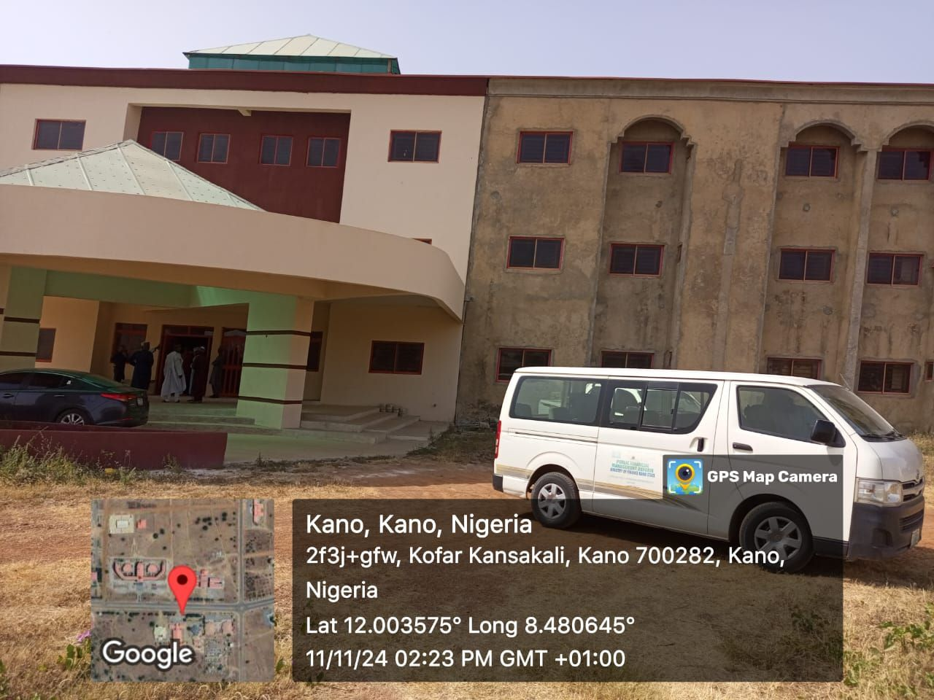
Figure 4.10:The front view of the Ongoing Construction of faculty of Art Complex at Yusuf Maitama Sule Universit

4.2.5 Observations/Findings
i. It was revealed during the exercise that all the projects selected for inspection and eventually inspected by the FRC officials, were part funded from the proceed of the N18.425bn bond raised from the Capital Market.
ii. Majority of the Projects verified have been duly completed and put to use by the Kano State Government.
iii. There was no evidence that a cost-benefit analysis, detailing the economic and social benefits of any of the projects verified, was produced prior to project approval and commencement.
iv. Officials of Kano State Ministry of Finance exhibited very good record keeping and retrieval in respect of the document requested from them.
v. All projects executed with the proceed of the bond are capital in nature and it will immensely contribute to the economic development of the State if properly operates.
vii. The medical equipment supplied and installed at the Cancer centre are under-utilised, lack of patronage from and outside the kano State

4.2.6. General Recommendations
i. The Kano State Government should ensure that for any subsequent borrowing, it will seeks and obtains proof of compliance with Fiscal Responsibility Act (FRA), 2007, particularly part IX and X of the Act.
ii. Going forward, Kano State Government, if desirous of borrowing, should specify the purpose for which the borrowing is intended and present cost-benefits analysis, detailing the economic and social benefits of the purpose to which the intended borrowing is to be applied.
Iii Kano State Ministry of Works and Ministry of Finance should ensure adequate supervision and regular payment of the work certified to enable the Contractor to complete and handover the project to the State Government to avoid the request for cost variation.
Iv Kano State Government should engage more with the Federal Government to complete the remaining major work at the site, so that full operations and economic activities can commence at the Port.

vi. The Kano State Ministries, Departments and Agencies (MDAs) should, on regular basis, maintain the projects executed under their purview in order to achieve longevity and value for money.
vi. The Kano State Government, Ministry of Health and the Hospital Management should create more awareness to the people within and outside the Kano State on the activities and the services of the Centre, that will increase patronage as well as the revenue generation.

CHAPTER FIVE
NORTH-CENTRAL GEO-POLITICAL ZONE: BENUE STATE

5.1 Verification of loan utilization: N10 billion Loan from UBA Plc, (2020)
This section details with the verification exercise conducted to assess the utilization of a N10 billion loan obtained by the Benue State Government from UBA in 2020. The loan was reportedly allocated for infrastructural development projects within the state. The highlights are presented in table 5.1

Borrowing State | Zone | Amount Borrowing | Lending Bank | Date | Tenor | Amount Drawn | purpose | Type of loan
Benue | North-Central | N10 billion | UBA | 2020 | 3 years | N10 billion | Infrastructural development | Term loan

5.2 Verification of selected projects funded by Benue State in 2020 from the N10 billion loan from UBA plc.
5.2.1 CONSTRUCTION OF IGBOR–IKPA–WANUNE ROAD (Contract no; BNTB154/214)
Project Description: The project involved the construction of 36.732km road with 100m spur along Kpera village. The road serves three Local Governments i.e. Tarka, Gbokos and Gwar. The road links Makurdi – Yandev and Makurdi – Aliade – Otukpo federal roads at Wanune and Igbor respectively.
Project Funding:
- Contractor: to M/S GGGC Global Project Nig Ltd
- Contract cost: of #2,326,603,387.17
- Date of award: on 5th Nov, 2014
- Duration: Project duration not captured in the offer letter
Verification Details:

The site visit was conducted to verify the quality of work done and the completion status of the project. The road project was confirmed to be 100% completed and operational at the time of inspection

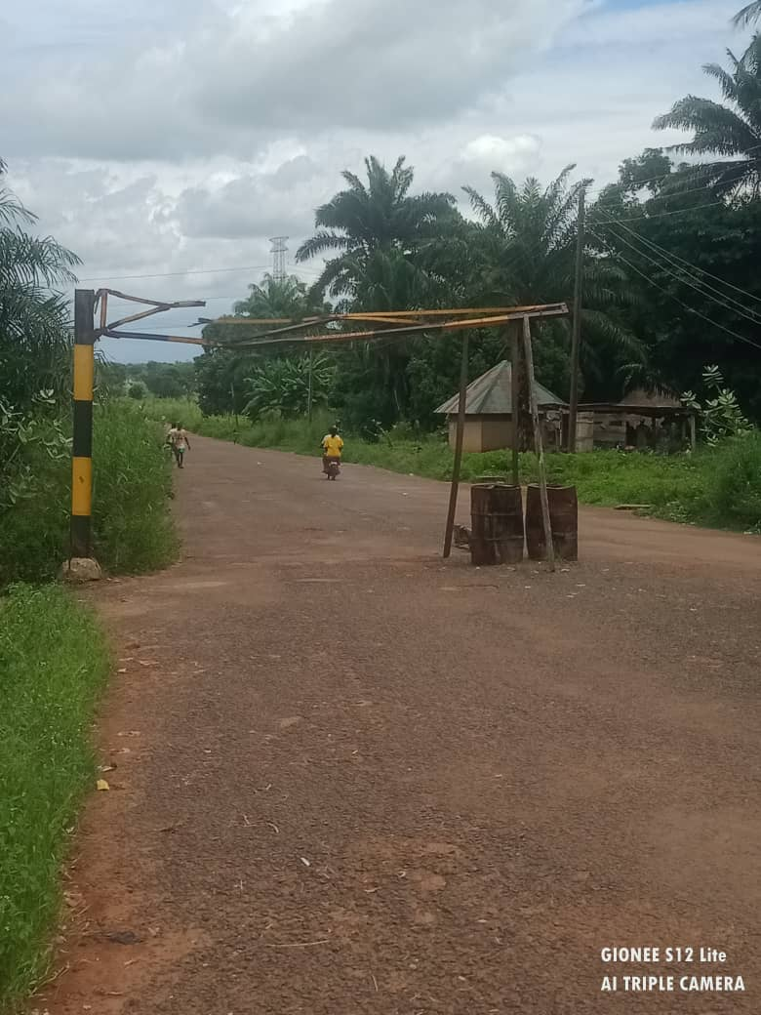
Figure 5.1 Igbor junction of the Ikpa Wanunue Road

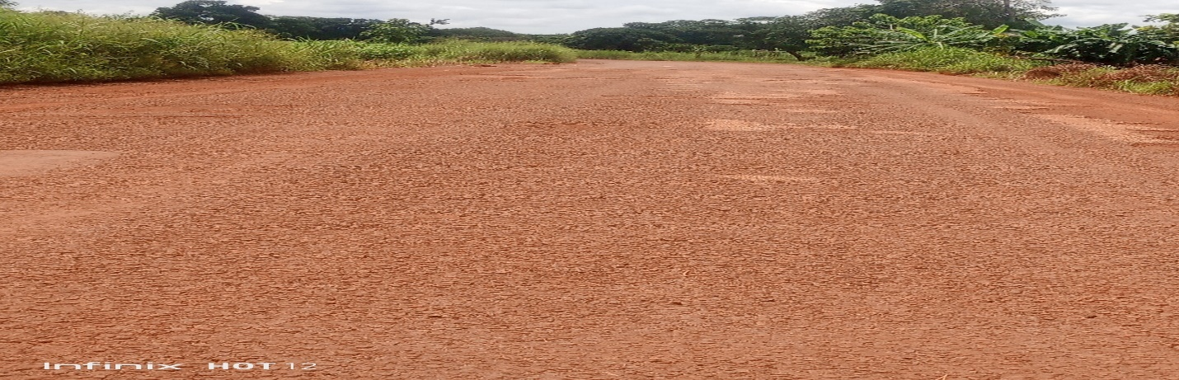
Figure 5.2: Ikpa-Wanunue Road showing signs of failure

5.2.2 Road Construction from Customary Court of appeal to George Akume way Phase II
Project Description: The project involved the construction of road from customary cout of Appeal to George Akume way in Makurdi town.
Project Funding:
- Contractor: Privent Construction Nig. Ltd
- Date of award: February 2020
- Contracts sum: #825,284,919.40
- Duration: project duration was not captured in the offer letter

Verification Details: The site visit was conducted to verify the quality of work done and the completion status of the project. The road project was confirmed to be 100% completed and operational at the time of inspection

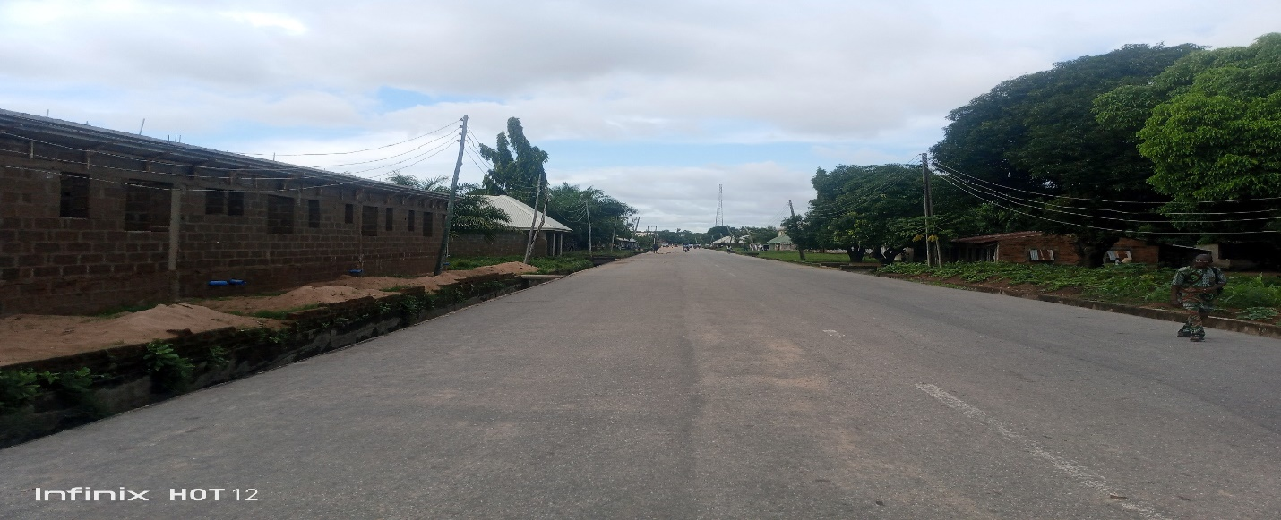
Figure 5.3: George Akume Junction of the Customary Court Road

    - Construction of Female Doctors’ Quarters at Benue State University Teaching Hospital.
Project Description: The project is the construction of a two-storey building, 24 number 2-bedroom apartments located within the premises of the Benue State University Teaching Hospital.
Project Funding:
- Contract Cost: N213,066,006.30
- Contractor: Wende Nigeria Ltd
- Date of award: October, 2011
- Completion status: The project was 100% completed and put to use.
Verification Details: The verification exercise included a physical visit to the project site to assess the progress and the quality of the work done. The project is reported to be 100% completed and currently operational.

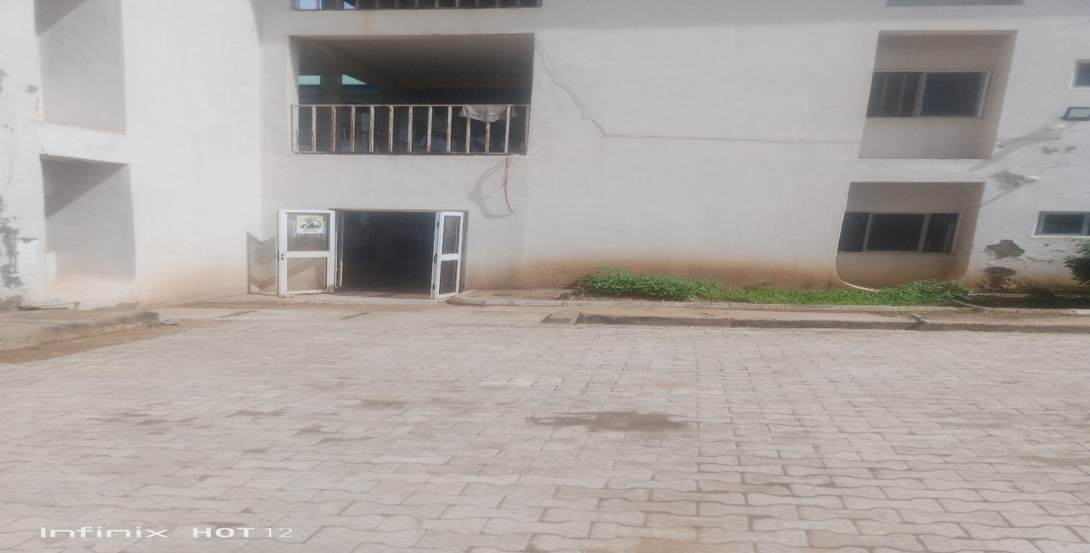
Figure 5.4: Female Doctor’s Quarters at Benue State University Teaching Hospital, Makurdi.

5.2.4 Renovation of Benue Printing and Publishing Corporation Complex, Makurdi, Benue State
Project Description: The project is the renovation of Benue Printing and Publishing Corporation in Makurdi town.
Project Funding:
Contract cost: N 184,730,216.45
Contractor: Capital Project Contractors Nigeria Ltd
Date of award: August 2012
- Project Details: The verification involved the site visit to ascertaining the level of construction work, the quality of the work and the completion status. Though the project was suspended by the State Executive Council by re-awarded to the same contractor with same amount, terms of contract and scope as contained in the initial letter of award. The contract award letter did not capture the contract duration but it was completed and commissioned in 2024.

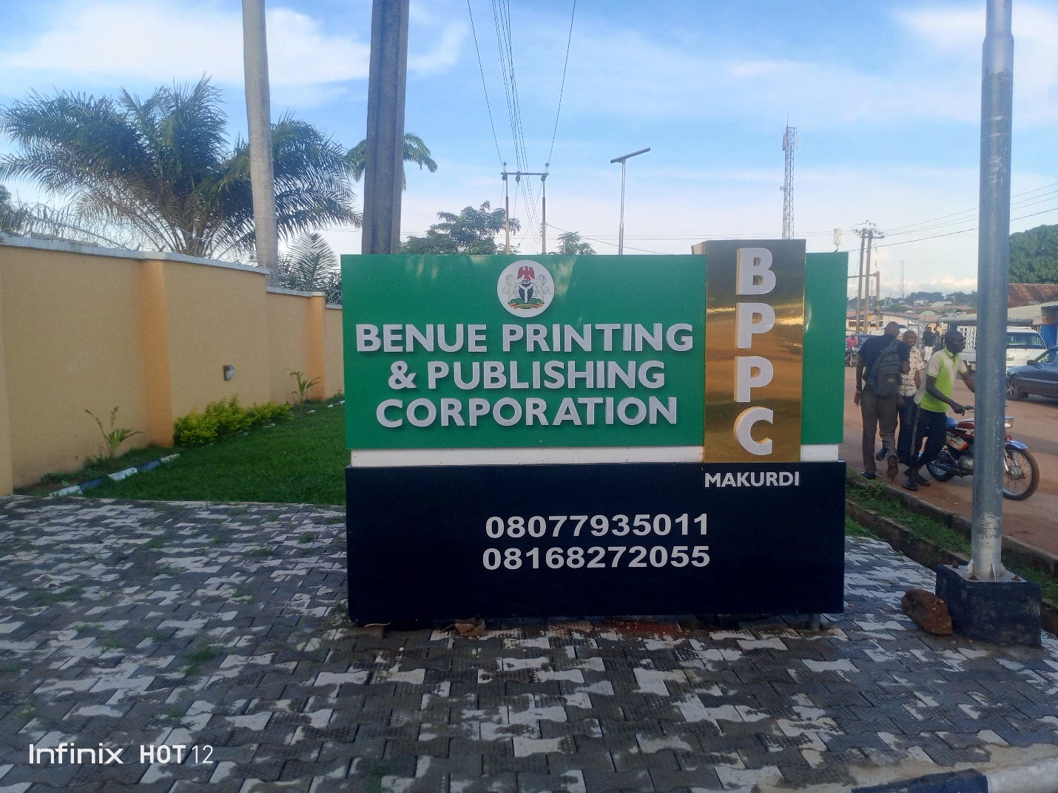
Figure 5.5: Renovation of Benue Printing and Publishing Corporation
5.2.5: Direct Purchase of 20 no. Fairly used Toyota Hilux for Benue State Government
Project Description: The project is the direct purchase of fairly used Toyota Hilux to effectively combat crime due to Insecurity facing the state and to enable government officials carry out their functions effectively. Though the vehicles were not physically sighted by the team.

5.2.6 Observations/Findings
- The offer letter from UBA bank Plc to Benue State Government for the Term Loan of N10 billion states the purpose of the loan as to finance development and infrastructure projects in the state. But part of the loan was used to support burial ceremonies, birthday, and thanksgiving mass and 10th anniversary of a national daily.
- The interest rate of 20% is adjudged to be higher, compared to the ceiling of 3% specified in Section 41(a) FRA, 2007
- The 36 months (3 years) term is not reasonably enough, in line with provisions of Section 41(a) of FRA, 2007
- The state Government provided the Verification team with copies of extracts of decisions of the State Executive Council and those of the Benue State House of Assembly approving that the loan had been taken.
- The cost -benefit Analysis has been sighted.
- Almost all the projects verified were not captured in the 2020 approved budget.
- Bid Evaluation reports were not sighted by the team.
- Significant number of project documents requested for by the team were not available.
- Project Durations were not captured in all the offer letters sighted
5.2.7: Recommendations
- Loans should be sourced with low interest rates. Other sources of funds may be accessed with lower interest rates like Bonds from Capital Market, Sukuk loans, Islamic Development Bank etc
- Internally Generated Revenue should be vigorously pursued as alternative to Term Loans from Banks.
- The State Fiscal Responsibility Commission should be strengthened to ensure timely advice to the Govt for prudent and efficient management of state resources.
- Benue State Govt should request for technical assistance for its staff from the Fiscal Responsibility Commission Abuja.
- Record keeping procedures should be enhanced so as to be able to retrieve the required documents with greater certainty.
- Benue State Government should obtained proof of compliance from FRC Abuja before securing any further loans.

CHAPTER SIX
NORTH-EAST GEO-POLITICAL ZONE: TARABA STATE

6.1 Verification of loan utilization: N15 billion Loan from Fidelity Plc, (2023)
This section details with the verification exercise conducted to assess the utilization of a N15 billion loan obtained by the Taraba State Government from Fidelity in 2023. The loan was reportedly allocated for infrastructural development projects within the state. The highlights are presented in table 6.1
Table 6.1 Summary of loan obtained for infrastructural development(Taraba State)
Borrowing State | Zone | Amount Borrowing | Lending Bank | Date | Tenor | Amount Drawn | purpose | Type of loan
Taraba | North-East | N15billion | Fidelity | 2023 | 4 years | N15 billion | Infrastructural development | Term loan
6.2: Verification of selected projects funded by Taraba State from the loan.
6.2.1: Registration of WAEC by Taraba State Ministry of Education:
Project Description: The project under the compulsory and free education policy in the state involved the payment for registration of WAEC for 20,958 number of Candidates in 143 public secondary schools in the State.
Project Funding:
- Contractor: Ministry of Education
- Date of award:2023
- Contract cost; N654, 833,000.00
- Completion status: The payment was 100% completed
Verification Details: A physical visit to the selected Schools to determine the actual payment of the WAEC fees was conducted. It was reported that, the WAEC fees was paid for those number of Students in 143 public Schools in the State.
6.2.2: Taraba State University (TSU) –Accreditation
Project Description: The project is the payment of N454,950,000 for the full accreditation of (53) academic Programmes/courses by the National University Commission(NUC) at Taraba State University, Jalingo in October/November,2023. With the accredited status valid for a period of five years.
6.2.3: Taraba State University (TSU)- Renovation of Girls Hostel
Project Description: The project is a renovation of Girls Hostel at Tararba State University (TSU) in Jalingo, Taraba State.
Project Funding:
- Contractor: Mssrs Rockstar construction company Lt
- Date of award: 8th January, 2024
- Project cost: of N496,455,523.35
- Completion status: The project is 100% completed

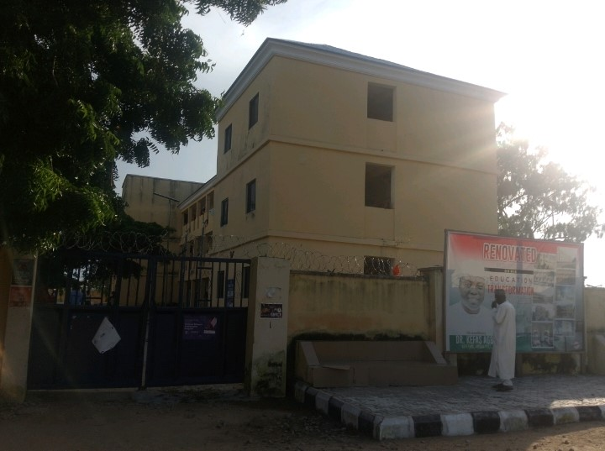
Figure 6.1: Zenith hostel (main campus)Taraba State Uninversity, Jalingo.

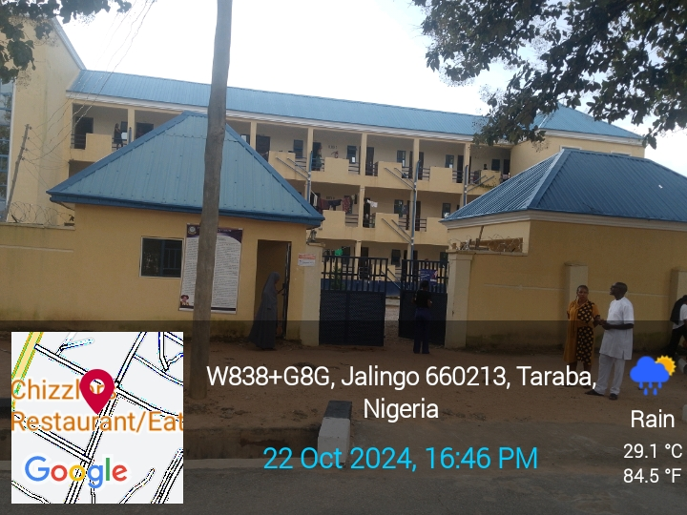 Figure 6.2 Justice Josephine Tuktur hall (Main Campus) Taraba State University, Jalingo

6.2.4: College of Education,(C.O.E) Zing –Accreditation
Project Description: The project is the full accreditation of various academic courses at the College of Education, Zing by the National University Commission (NUC) and the National Commission for Colleges of Education, to further enhance the teaching/ learning of the programme by the National University Commission(NUC) and the National Commission for Colleges of Education (NCCE). The cost of the project was N230,000,000.00 in October/November 2023 with the accredited status valid for a period of five years.
6.2.5: College of Agriculture, (C.O.A) Jalingo –Accreditation
Project Description: The project is for the full accreditation of various academic courses by National Board for Technical Education (N.B.T.E) at the College of Agriculture Jalingo, with the sum of N220,748,451.67 as the cost of the project.
6 .2.6: State Polytechnic, Suntai- Accreditation
Project Description: The project is for the full accreditation of (17) academic Programmes/courses in the State Polytechnic, Suntai, with the contract sum of N151,912,000.00
GENERAL OBSERVATIONS /FINDINGS, AND RECOMMENDATIONS
- All payment documents regarding the said loan were sighted by the visiting team.
- The response from the concerned MDAs as at the time of the visit was quite commendable.
- The bank granted ₦15bn as against the ₦50bn requested and approved by State Executive Council and the State House of Assembly.
- We also observed that the bank’s offer letter was explicit enough in disclosing its terms and conditions to the loan. This is commendable.
- Also, the bank technically modified the purpose of the loan which stated, “for state developmental projects and rehabilitation of dilapidated schools”.
- We observed that the authorization letter from State Executive Council carried ₦50bn approval as loan to be secured from Fidelity bank.
However, it was only ₦15bn that was assessed
- We observed that the interest rate of the facility at 18% with administrative charges of 5% deductible off front are on the high side. This is approximately a sum interest rate of 23%,and the amortization of Four (4) years.
- ₦50bn was applied for but the bank granted ₦15bn credit facility.
- We observed that the lender (Fidelity Bank) did not obtain evidence of proof of compliance with the Fiscal Responsibility Commission, before lending of the said loan.
- We observed that the loan was utilized for the purpose for which it was applied.
- The State is up to date with the preparation of its Audited Financial Statements which is quite commendable
- Three (3) years Audited Financial Statements were made available to the visiting team. The statements were for 2021, 2022 and 2023 fiscal years.
- Main while, we discovered that Taraba State total Domestic Loans/Borrowings as of 31st December 2023 (excluding external borrowings) as depicted in the State Audited Financial Statement amounted to ₦81,329,559,172.29
- The interest rate is adjudged to be on the higher side.
- The tallying of total approved loan from the extract of State Executive Council(SEC) meeting and the budget, is a noble and commendable act, as the State shows prudency in public transaction
- We also met with the respective MDAs that benefited from this loan and cooperation with us was encouraging.

RECOMMENDATIONS
- We recommend that, Taraba State Government should sort for softer loans with low interest rate for instance from SUKUK, Well-meaning Tarabans State indigenes/philanthropies, Multilateral/bilateral loans like World Bank, IMF, etc.
We recommend that, the State Government should embark on a projects that can have a four years duration. So that projects can be finish within its administration to avoid multiple projects abandonment.

- At all point in time, Taraba State should maintain a sustainable debt limit.
- Henceforth, thorough supervision / monitoring should be carried out by the Inspectorate unit of the State Ministry of Finance and even by the Fiscal Responsibility Commission of Taraba State on such projects to ensure prudency, accountability and transparency in the judicious use of this scarce resources.
- Hence, the purpose of any further borrowing should clearly be for capital expenditure and human development to avoid infringement of the FRA, 2007, or any other Act.

CHAPTER SEVEN

SOUTH-WEST GEO-POLITICAL ZONE: OYO STATE

Verification of Oyo State (N26 Billion) from Access Bank

7.1 Verification of Selected Projects Funded by Oyo State Government from Access Bank in 2023
7.2 CONSTRUCTION OF SENATOR RASHEED ADEWOLU LADOJA CIRCULAR ROAD, (LOT 1), LAGOS/IBADAN-JAGUN
Project Description:
This project involved the construction of Senator Rasheed Adewolu Ladoja Circular Road, (lot 1) Lagos/Ibadan-Jagun
Project Funding:
- Loan Provider: Access Bank Plc (2023 loan)
- Contractor: Craneburg Construction Company
- Initial Contract Value:N50bn
- Revised value: N56.89bn
- Completion Period:18 months
- Date of award: 7th December 2023
Verification Details:
A site visit confirmed that, the construction work was 31.64% completion and the length of the road is 15.5km and It is a mega project.

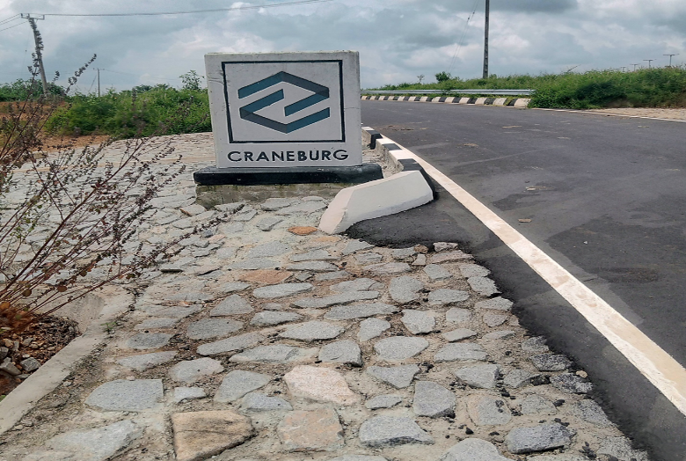
Figure:7.1:Part of construction of Senator Rasheed Adewolu Ladoja circular road(lot1)

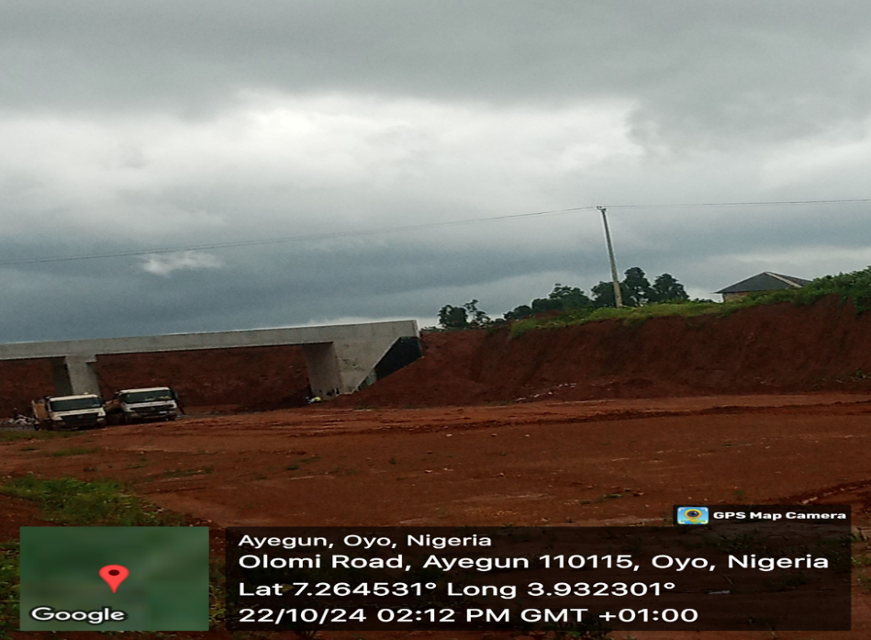
Figure.7.2: CONSTRUCTION OF SENATOR RASHEED LADOJA CIRCULAR ROAD, (LOT 2),

7.3: ASPHATIC CONSTRUCTION/LIMITED REHABILITATION OF AKUFO/IDO JUNTION – ERUWA ROAD (48KM)
Project Description:
This project involved the rehabilitation of 48km Eruwa Road at Akufo/Ido junction. it was awarded on 3rd July 2023.
Project Funding:
- Contractor: H.F.P Engineering Limited
- Contract Value: N6.5bn
- Completion Period: 54.35%,
- Date of award: 3rd July 2023
Verification Details: A site visit confirmed the project's completion of 54.35%, but looking at work done so far, we estimated the percentage completion to be around 30%, which they could not contradict it. The N2bn loan was contractor’s finance facility, which was 30% part-funding of the Road and we were informed that the loan had been liquidated. The loan was attached to IGR of the State.

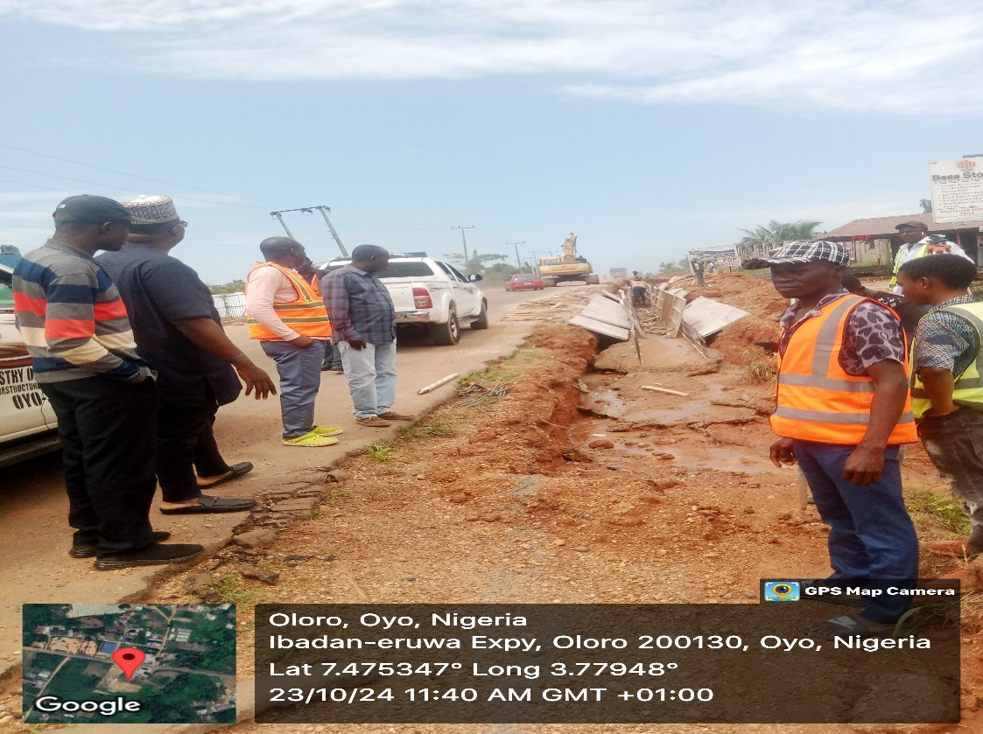
Figure 7. 3 part of the rehabilitation of the road at Ibadan-eruwa expy, oyo state

7.4 THE EXECUTION OF 2020/2021 FGN-UBEC/SUBEB INTERVENTION PROJECTS

Project Description: These projects were executed through counterpart funding of the Federal Government of Nigeria and the Oyo State government. The Federal government and the State government contributed equal amount, N1,510,664,674.26, only each. The Federal government contributed her own part through the 2020 Federal Government statutory Allocation of UBE matching grant to the State, while the State government resort to facility from the First City Monument Bank (FCMB) to match the Federal government contribution in order to access the fund from the Federal government

Project Funding: The project was the counterpart funding of both Federal Government and the Oyo State Government
Verification Details:
A site visit confirmed the 100% project completion and be put to use. The projects were carried out by Oyo State Universal Basic Education Board Agodi, Ibadan and were to address the perennial acute shortage of class rooms, toilets and furniture in public primary and junior secondary schools in Oyo State. The projects were spread across the State.
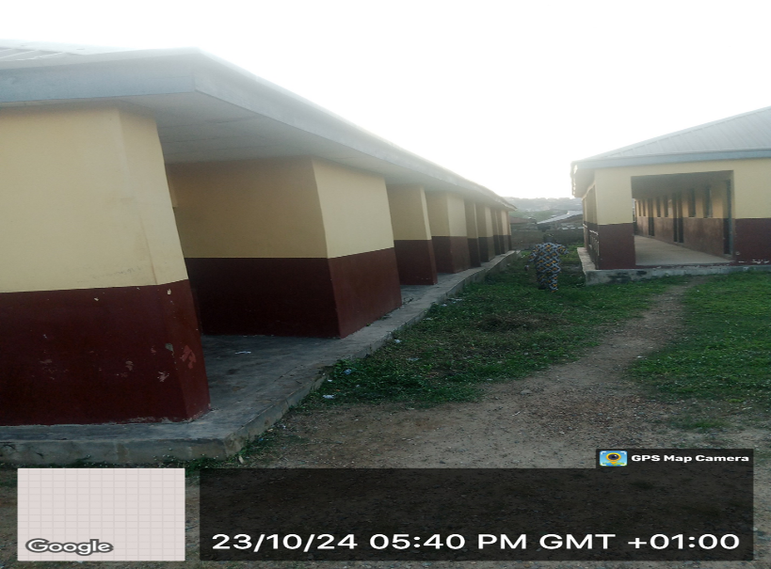
Figure 7.4 part of the2020/2021 FGN-UBEC/SUBEB intervention projects in the state

7.5 Observations/Findings
The verification exercise identified the following key observations regarding Oyo State's 2023 Access Bank loan:
- Compliance with FRA Purpose: The loan proceeds were used for infrastructural and human development, aligning with Section 41(1)(a) of the Fiscal Responsibility Act (FRA) of 2007.
- Debt Ratio Compliance: At the time of the loan acquisition in 2023, Oyo State's total outstanding loans did not exceed 50% of its actual revenue, adhering to Debt Management Office (DMO) guidelines.
- Project Completion: Some inspected projects funded by the loan were not completed and operational at the time of the verification visit.
- Due Process: All relevant project documentation was available and adhered to the state's due process requirements.
- Missing Cost-Benefit Analysis: No evidence of cost-benefit analysis was found, as required by section 44(1) of the FRA 2007, to assess project viability before loan acquisition
- Compliance Verification Omission: There was no indication that the Oyo State Government sought or obtained compliance verification from the FRC, Abuja as mandated by section 45 of the FRA, 2007
- Oyo state Government has not domiciled Fiscal Responsibility Law or Council in the State for effective and efficient financial management

6.4 Recommendations
Based on the observations, the following recommendations are made to strengthen Oyo State's loan management practices:
- Cost-Benefit Analysis: To comply with Section 44(1) of the Fiscal Responsibility Act (FRA) 2007, Oyo State Ministry of Finance (or relevant department responsible for loan applications) should ensure a cost-benefit analysis is prepared before seeking any future loans. This analysis will objectively assess project viability and ensure sound financial decision-making.
- Compliance Verification: As stipulated by Section 45(2) of the FRA 2007, the state should always obtain a proof of compliance from the Fiscal Responsibility Commission (FRC) in Abuja before securing loans.
- Strengthening Internal Controls: The Ministry of Finance (or relevant department responsible for financial management) should implement a system for duly stamping payment vouchers at all levels. This practice enhances internal control mechanisms, promotes transparency, and aligns with international best practices.
- Debt Management Training: Oyo State Ministry of Finance should organize training sessions on debt management and indebtedness for state staff in collaboration with the FRC Abuja. This training will equip staff with the knowledge and skills necessary for responsible borrowing and debt management practices.
- Establishment of Fiscal Responsibility Law: Oyo State Government should endeavor to enact the Fiscal Responsibility law and eventually established Fiscal responsibility Commission in the state for proper management of the state’s financial resources for overall development of the state.

CHAPTER EIGHT

SUMMARY OF OBSERVATIONS/FINDINGS, CONCLUSION, AND RECOMMENDATIONS

8.1 Summary of Observations/Findings
This section summarizes the key observations and findings from the verification exercise focused on loan utilization by several Nigeria’s Subnational Governments (States). The verification aimed to assess compliance with the Fiscal Responsibility Act (FRA) of 2007, particularly regarding loan acquisition procedures and project execution. The key observations/findings are presented below:
- Loan Purpose: Most states applied loan proceeds for their intended purposes, primarily infrastructural development and human capital projects (compliant with Section 41(1)(a) of the FRA).
- Compliance with Borrowing Conditions: None of the verified states obtained a "Proof of Compliance" certificate from the Fiscal Responsibility Commission (FRC) before acquiring loans, as mandated by Section 45(1) of the FRA.
- Project Completion: A significant number of projects funded by the loans were completed or nearing completion at the time of verification.
- Due Process: Some states demonstrated adherence to due process for loan approvals, involving relevant government bodies and the Debt Management Office (DMO)
- Cost-Benefit Analysis: A critical shortcoming identified across all states was the lack of cost-benefit analysis conducted before acquiring loans. This omission violates Section 44(1) of the FRA, which necessitates such assessments to evaluate project viability.
- FRC Compliance Verification: All states failed to obtain the mandatory "Proof of Compliance" from the Fiscal Responsibility Commission (FRC) before securing loans, as mandated by Section 45(1) of the FRA. This raises concerns about adherence to established loan approval procedures.
- Loan Terms: Benue and Taraba States secured a loan with a significantly shorter repayment period than allowed by the FRA, potentially increasing financial strain.
- Budget Transparency: Adamawa State lacked transparency in its budget allocation for internal sources, contrasting with the detailed project breakdown for the external loan.
- High Interest Rates: The interest rates for most of the loans exceeded 10%, which conflicts with Section 41(1a) of the FRA, which encourages concessionary interest rates.
- Unsustainable Debt Practices: All states borrowed for infrastructure projects, which typically require long-term financing. However, only one state utilized the capital market, a suitable source for such loans. The remaining states relied on commercial banks, which offer shorter-term loans with higher interest rates. This raises concerns about the long-term affordability of these states' debt.

8.2 Conclusion
This nationwide verification exercise served two key purposes. Firstly, it raised awareness among state government officials about the federal government's role in managing and monitoring debt on behalf of all governmental tiers. Secondly, it revealed valuable insights into loan utilization practices across subnational governments in Nigeria. The verification identified both positive aspects and areas for improvement regarding compliance with the Fiscal Responsibility Act (FRA) of 2007. While most states fulfilled borrowing conditions, two critical contraventions emerged:
- Missing Cost-Benefit Analyses: No state presented a cost-benefit analysis demonstrating the economic and social benefits of loan-funded projects.
- Lack of FRC Consent: None of the visited states obtained consent from the Fiscal Responsibility Commission (FRC) or provided proof of compliance to relevant provisions of the FRA (2007) before acquiring loans.
To strengthen fiscal management, further verification exercises are recommended. Although some states have established their own fiscal responsibility commissions, the FRC’s approval and issuance of “Proof of Compliance” with Part X of the FRA (2007) remain mandatory before any state government borrows from domestic banks or institutions.

8.3 Recommendations

8.3.1 FRC Compliance and Loan Acquisition:
- Proof of Compliance: State governments and lending institutions should obtain "Proof of Compliance" from the Fiscal Responsibility Commission (FRC) before acquiring loans, adhering to Section 45(1) of the FRA.
- Cost-Benefit Analyses: All states should conduct cost-benefit analyses for loan applications, as mandated by Section 44(1) of the FRA, to ensure project viability. This practice ensures objective evaluation of project viability and prioritizes investments with the highest returns.
- Loan Tenor: States should negotiate loan repayment periods that align with Section 41(1) of the FRA to avoid excessive financial strain.
- Loan Purpose: Loan proceeds should be used exclusively for capital projects that promote economic development, complying with Section 41(1) of the FRA (2007) and its amendments.
- Education and Awareness: Representatives from state governments need to be educated on FRC compliance requirements for borrowing.

8.3.2 Project Management and Financial Management:
- Enhanced Project Management: State governments and other relevant stakeholder should improve necessary project management practices to avoid delays and ensure efficient project completion.
- Transparent Budgeting: Budgetary allocations from all sources (internal and external) should be presented transparently with detailed project breakdowns.
- Strengthen Internal Controls: States should implement robust internal control systems to safeguard public funds, prevent financial mismanagement, and enhance transparency (e.g., Ondo State). This can involve measures like proper stamping of payment vouchers and improved payment system security.
- Debt Management: States with high debt burdens should explore strategies to reduce their liabilities (e.g., Ondo, Benue and Bauchi ). This might involve refinancing or renegotiating loan terms.
- Domesticate FRA: States that have not adopted the FRA (e.g., Oyo) should prioritize its domestication to establish a legal framework for responsible management of public resources.

8.3.3 Others:
- Alternative Funding Mechanisms: States should explore alternative funding sources for infrastructure development (Public-Private Partnerships (PPPs).
- Staff Development: Invest in training programs for public service staff to equip them with the skills and knowledge to manage loan projects effectively (e.g., Oyo).
- Facility Maintenance: Develop plans for regular maintenance of loan-funded facilities to ensure their long-term functionality and value for money (e.g., Bauchi, Benue).

